SECURITIES AND EXCHANGE COMMISSION
Washington, D.C. 20549

SCHEDULE TO
Tender Offer Statement Under Section 14(d)(1) or 13(e)(1)
of the Securities Exchange Act of 1934

RXSIGHT, INC.
(Name of Subject Company (Issuer) and Filing Person (Offeror))

Options to Purchase Common Stock, $0.001 par value
(Title of Class of Securities)

78349D107
(CUSIP Number of Class of Securities’ Underlying Common Stock)

Aziz Mottiwala
President and Chief Executive Officer
RxSight, Inc.
100 Columbia
Aliso Viejo, California 92656
(949) 521-7830
(Name, address and telephone numbers of person authorized to receive notices and
communications on behalf of filing persons)

Copies to:

Martin J. Waters  Robert L. Wernli, Jr.  Wilson Sonsini Goodrich & Rosati, P.C.  12235 El Camino Real  San Diego, CA 92130  (858) 350-2300 |  | Mark Wilterding  Chief Financial Officer  RxSight, Inc.  100 Columbia  Aliso Viejo, California 92656  (949) 521-7830

☐ | Check the box if the filing relates solely to preliminary communications made before the commencement of a tender offer.
Check the appropriate boxes below to designate any transactions to which the statement relates:
 | ☐ | third-party tender offer subject to Rule 14d-1.
 | ☒ | issuer tender offer subject to Rule 13e-4.
 | ☐ | going-private transaction subject to Rule 13e-3.
 | ☐ | amendment to Schedule 13D under Rule 13d-2.
Check the following box if the filing is a final amendment reporting the results of the tender offer: ☐
If applicable, check the appropriate box(es) below to designate the appropriate rule provision(s) relied upon:

 | ☐ | Rule 13e-4(i) (Cross-Border Issuer Tender Offer)
 | ☐ | Rule 14d-1(d) (Cross-Border Third-Party Tender Offer)

This Tender Offer Statement on Schedule TO relates to an offer by RxSight, Inc., a Delaware corporation (the “Company”), to exchange (the “Exchange Offer”) certain options to purchase up to an aggregate of 4,083,693 shares of the Company’s common stock, whether vested or unvested, granted under the Company’s 2021 Equity Incentive Plan, as amended (the “2021 Plan”), with a per share exercise price equal to or greater than (i) $6.00 ($10.00 in the case of our named executive officers) and (ii) the closing price of our common stock on the expiration date of this Exchange Offer, that are outstanding at the start of this Exchange Offer and remain outstanding and unexercised through the expiration of this Exchange Offer (the “Eligible Options”).
These Eligible Options may be exchanged for new awards consisting of restricted stock units (“RSUs”) in the case of eligible employees who are not named executive officers, or new options (“options”) in the case of eligible employees who are named executive officers (collectively, the “New Awards”), upon the terms and subject to the conditions set forth in (i) the Offer to Exchange Certain Outstanding Options for New Awards dated August 10, 2026 (the “Offer to Exchange”), attached hereto as Exhibit (a)(1)(A), (ii) the Launch Email to All Eligible Employees from Caroline Vaughn, our Vice President, Global HR & People Operations, dated August 10, 2026, attached hereto as Exhibit (a)(1)(B), and (iii) the Election Terms and Conditions, together with their associated instructions, attached hereto as Exhibit (a)(1)(C). The following disclosure materials were also made available to Eligible Employees (as defined below): (I) the Form of Confirmation Email to Eligible Employees who elect to participate in or withdraw from the Exchange Offer, attached hereto as Exhibit (a)(1)(D), (II) the Form of Reminder Email to Eligible Employees, attached hereto as Exhibit (a)(1)(E), (III) the Screenshots of the Company’s Offer Website, attached hereto as Exhibit (a)(1)(F), (IV) the Employee Presentation, attached hereto as Exhibit (a)(1)(G), (V) the NEO Employee Presentation, attached hereto as Exhibit (a)(1)(H), and (VI) the Employee Communication from Aziz Mottiwala sent to All Eligible Employees on August 10, 2026, attached hereto as Exhibit (a)(1)(I). These documents, as they may be amended or supplemented from time to time, together constitute the “Disclosure Documents.” An “Eligible Employee” refers to each employee of the Company, including its named executive officers, as of the date the Offer commences who is located in the United States and remains an employee of the Company through the expiration of the Offer and the New Award grant date. Employees who are not located in the United States and the non-employee members of the Company’s board of directors are not eligible employees and may not participate in the Exchange Offer.
The information in the Disclosure Documents, including all schedules and annexes to the Disclosure Documents, is incorporated herein by reference to answer the items required in this Schedule TO.
Item 1. Summary Term Sheet.
The information set forth under the caption “Summary Term Sheet and Questions and Answers” in the Offer to Exchange is incorporated herein by reference.
Item 2. Subject Company Information.
(a) Name and Address.
RxSight, Inc. is the issuer of the securities subject to the Exchange Offer. The address of the Company’s principal executive office is 100 Columbia, Aliso Viejo, CA 92656, and the telephone number at that address is (949) 521-7830. The information set forth in the Offer to Exchange under the caption “The Offer” titled “10. Information concerning RxSight” is incorporated herein by reference.
(b) Securities.
The subject class of securities consists of the Eligible Options. The actual number of shares of common stock subject to the New Awards to be issued in the Exchange Offer will depend on the number of shares of common stock subject to the unexercised options tendered by Eligible Employees and accepted for exchange and

2

cancelled. The information set forth in the Offer to Exchange under the captions “Summary Term Sheet and Questions and Answers,” “Risks of Participating in the Offer,” and the sections under the caption “The Offer” titled “2. Number of new Awards; expiration date,” “6. Acceptance of options for exchange and issuance of new awards,” and “9. Source and amount of consideration; terms of new awards” is incorporated herein by reference.
(c) Trading Market and Price.
The information set forth in the Offer to Exchange under the caption “The Offer” titled “8. Price range of shares underlying the options” is incorporated herein by reference.
Item 3. Identity and Background of Filing Person.
(a) Name and Address.
The filing person is the issuer. The information set forth under Item 2(a) above is incorporated herein by reference.
Pursuant to General Instruction C to Schedule TO, the information set forth on Schedule A to the Offer to Exchange is incorporated herein by reference.
Item 4. Terms of the Transaction.
(a) Material Terms.
The information set forth in the section of the Offer to Exchange under the caption “Summary Term Sheet and Questions and Answers” and the sections under the caption “The Offer” titled “1. Eligibility,” “2. Number of new awards; expiration date,” “3. Purposes of the offer,” “4. Procedures for electing to exchange options,” “5. Withdrawal rights and change of election,” “6. Acceptance of options for exchange and issuance of new awards,” “7. Conditions of the offer,” “8. Price range of shares underlying the options,” “9. Source and amount of consideration; terms of new awards,” “12. Status of options acquired by us in the offer; accounting consequences of the offer,” “13. Legal matters; regulatory approvals,” “14. Material income tax consequences,” “15. Extension of offer; termination; amendment” and Schedule B attached to the Offer to Exchange is incorporated herein by reference.
(b) Purchases.
The information set forth in the section of the Offer to Exchange under the caption “The Offer” titled “11. Interests of directors and executive officers; transactions and arrangements concerning the options” is incorporated herein by reference.
Item 5. Past Contacts, Transactions, Negotiations and Arrangements.
(a) Agreements Involving the Subject Company’s Securities.
The information set forth in the section of the Offer to Exchange under the caption “The Offer” titled “11. Interests of directors and executive officers; transactions and arrangements concerning the options” is incorporated herein by reference. The 2021 Plan and related agreements attached hereto as Exhibit (d), are incorporated herein by reference.
Item 6. Purposes of the Transaction and Plans or Proposals.
(a) Purposes.
The information set forth in the section of the Offer to Exchange under the caption “Summary Term Sheet and Questions and Answers” and the section under the caption “The Offer” titled “3. Purposes of the offer” is incorporated herein by reference.

3

(b) Use of Securities Acquired.
The information set forth in the sections of the Offer to Exchange under the caption “The Offer” titled “6. Acceptance of options for exchange and issuance of new awards” and “12. Status of options acquired by us in the offer; accounting consequences of the offer” is incorporated herein by reference.
(c) Plans.
The information set forth in the sections of the Offer to Exchange under the caption “The Offer” titled “3. Purposes of the offer” and “9. Source and amount of consideration; terms of new awards” is incorporated herein by reference.
Item 7. Source and Amount of Funds or Other Consideration.
(a) Source of Funds.
The information set forth in the section of the Offer to Exchange under the caption “The Offer” titled “9. Source and amount of consideration; terms of new awards” is incorporated herein by reference.
(b) Conditions.
The information set forth in the section of the Offer to Exchange under the caption “The Offer” titled “7. Conditions of the offer” is incorporated herein by reference.
(d) Borrowed Funds.
Not applicable.
Item 8. Interest in Securities of the Subject Company.
(a) Securities Ownership.
The information set forth in the section of the Offer to Exchange under the caption “The Offer” titled “11. Interests of directors and executive officers; transactions and arrangements concerning the options” is incorporated herein by reference.
(b) Securities Transactions.
The information set forth in the section of the Offer to Exchange under the caption “The Offer” titled “11. Interests of directors and executive officers; transactions and arrangements concerning the options” is incorporated herein by reference.
Item 9. Persons/Assets, Retained, Employed, Compensated or Used.
(a) Solicitations or Recommendations.
Not applicable.
Item 10. Financial Statements.
(a) Financial Information.
The information set forth in Schedule B to the Offer to Exchange and in the sections of the Offer to Exchange under the caption “The Offer” titled “10. Information concerning RxSight,” “17. Additional

4

information” and “18. Financial information” is incorporated herein by reference. The Company’s Annual Report on Form 10-K for the fiscal year ended December 31, 2025 can also be accessed electronically on the Securities and Exchange Commission’s website at http://www.sec.gov.
(b) Pro Forma Information.
Not applicable.
Item 11. Additional Information.
(a) Agreements, Regulatory Requirements and Legal Proceedings.
The information set forth in the sections of the Offer to Exchange under the caption “The Offer” titled “11. Interests of directors and executive officers; transactions and arrangements concerning the options” and “13. Legal matters; regulatory approvals” is incorporated herein by reference.
(b) Other Material Information.
Not applicable.
Item 12. Exhibits.

 |  |  |  | Incorporated by Reference
Exhibit  Number |  | Exhibit Description |  | Form |  | File No. |  | Exhibit |  | Filing Date |  | Filed  Herewith
(a)(1)(A) |  | Offer to Exchange Certain Outstanding Options for New Awards, dated August 10, 2026. |  |  |  |  |  |  |  |  |  | X
(a)(1)(B) |  | Launch Announcement. |  |  |  |  |  |  |  |  |  | X
(a)(1)(C) |  | Election Terms and Conditions. |  |  |  |  |  |  |  |  |  | X
(a)(1)(D) |  | Form of Confirmation Email. |  |  |  |  |  |  |  |  |  | X
(a)(1)(E) |  | Form of Reminder Email. |  |  |  |  |  |  |  |  |  | X
(a)(1)(F) |  | Screenshots from Offer Website. |  |  |  |  |  |  |  |  |  | X
(a)(1)(G) |  | Employee Presentation. |  |  |  |  |  |  |  |  |  | X
(a)(1)(H) |  | NEO Employee Presentation. |  |  |  |  |  |  |  |  |  | X
(a)(1)(I) |  | Employee Communication sent on August 10, 2026. |  |  |  |  |  |  |  |  |  | X
(b) |  | Not applicable.
(d) |  | 2021 Equity Incentive Plan, as amended, and forms of agreement thereunder. |  | 10-K |  | 001-40690 |  | 10.3 |  | 2/25/2025
(g) |  | Not applicable.
(h) |  | Not applicable.
107 |  | Filing Fee Table. |  |  |  |  |  |  |  |  |  | X
Item 13. Information Required by Schedule 13E-3.
(a) Not applicable.

5

SIGNATURE
After due inquiry and to the best of my knowledge and belief, I certify that the information set forth in this statement is true, complete and correct.

RXSIGHT, INC.
/s/ Aziz Mottiwala
Aziz Mottiwala
President and Chief Executive Officer
Date: August 10, 2026

6
Exhibit (a)(1)(A)
RXSIGHT, INC.
OFFER TO EXCHANGE
CERTAIN OUTSTANDING OPTIONS FOR
NEW AWARDS
This document constitutes part of the prospectus relating to the securities that have been registered under the Securities Act of 1933, as amended. The prospectus relates to the RxSight, Inc. 2021 Equity Incentive Plan.
August 10, 2026

RXSIGHT, INC.
Offer to Exchange Certain Outstanding Options
for New Awards

This offer and withdrawal rights will expire at 9:00 p.m., Pacific Time,
on September 4, 2026, unless we extend the expiration date.

By this offer, RxSight, Inc. (referred to as “RxSight,” the “Company,” “we,” “our” or “us”) is giving eligible employees of RxSight the opportunity to exchange some or all of their outstanding options under our 2021 Equity Incentive Plan (the “2021 Plan”) with a per share exercise price equal to or greater than $6.00 ($10.00 in the case of our named executive officers) and equal to or greater than the closing price of our common stock on the expiration date, whether vested or unvested, for generally a fewer number of options with a 7-year term (“options”) in the case of our named executive officers or restricted stock units (“RSUs” and together with the options, the “new awards”) in the case of our non-executive employees, each with a different vesting schedule. Options refers to stock options to purchase shares of RxSight’s common stock at a fixed price provided that the vesting criteria are satisfied. RSUs are a promise by RxSight to issue shares of our common stock in the future provided that the vesting criteria are satisfied. Previously, the compensation committee (the “Compensation Committee”) of our board of directors (the “Board”) submitted for approval to the Board a proposal to implement a one-time stock option exchange program. The Board, upon recommendation of the Compensation Committee, approved the program on July 30, 2026.
You are an eligible employee if you are an employee, including a named executive officer, of RxSight as of the start of the offer who is located in the United States and remain an employee of RxSight through the expiration of the offer and the new award grant date. Non-employee members of our Board and employees who are not located in the United States are not eligible to participate in the offer.
If you participate in the offer, the number of new awards you receive will depend on the number of eligible options that you elect to exchange, an exchange ratio based on the per share exercise price of those options, and the type of new award you are eligible to receive.
We will grant the new award on the day following the expiration of the offer, which day is the same U.S. calendar day on which we will cancel the exchanged options. This date is referred to as the “new award grant date.” We expect the new award grant date to be September 5, 2026. If the expiration date of the offer is extended, the new award grant date similarly will be delayed. The new awards will be granted under the 2021 Plan.
The vesting of the new award will depend on your continued service with us through applicable vesting dates as detailed in Section 9 of this Offer to Exchange Certain Outstanding Options for New Awards (the “Offer to Exchange”). No new award will be vested when granted, even if the applicable exchanged option previously was partially or fully vested.
Our common stock is traded on The Nasdaq Stock Market under the symbol “RXST.” On August 6, 2026, the closing price of our common stock was $6.08 per share. You should evaluate the risks related to our business, our common stock and this offer, and review current market quotes for our common stock, among other factors, before deciding to participate in this offer.
See “Risks of Participating in the Offer” beginning on page 15 for a discussion of risks that you should consider before participating in this offer.
IMPORTANT
To participate in the offer, you must submit your election using RxSight’s offer website, by the expiration date, currently expected to be 9:00 p.m., Pacific Time, on September 4, 2026.

-i-

Your delivery of all documents, including elections, is at your own risk. Only elections that are properly completed and actually received by RxSight by the deadline using the offer website will be accepted. Elections submitted by any other means, including email, facsimile, hand delivery, interoffice, U.S. mail (or other post) and Federal Express (or similar delivery service), are not permitted. If you submit your election using the offer website, you should print and keep a copy of the confirmation statement (the “Confirmation Statement”) generated by the offer website at the time that you complete and submit your election. The printed Confirmation Statement will provide evidence that you submitted your election. If you do not receive a confirmation, it is your responsibility to confirm that we have received your election.
Neither the U.S. Securities and Exchange Commission (the “SEC”) nor any state or non-U.S. securities commission has approved or disapproved of these securities or passed judgment upon the accuracy or adequacy of this offer. Any representation to the contrary is a criminal offense.
You should direct questions about this offer and requests for additional copies of this Offer to Exchange and the other offer documents to:
Infinite Equity
Email: rxsight@infiniteequity.com
Offer to Exchange dated August 10, 2026
You should rely only on the information contained in this Offer to Exchange or documents to which we have referred you. We have not authorized anyone to provide you with different information. We are not making an offer to exchange options for new awards in any jurisdiction in which the offer is not permitted. You should not assume that the information provided in this Offer to Exchange is accurate as of any date other than the date as of which it is shown, or if no date is indicated otherwise, the date of this offer. This Offer to Exchange summarizes various documents and other information. These summaries are qualified in their entirety by reference to the documents and information to which they relate.

-ii-

TABLE OF CONTENTS

 |  | PAGE
SUMMARY TERM SHEET AND QUESTIONS AND ANSWERS |  |  | iv
RISKS OF PARTICIPATING IN THE OFFER |  |  | 15
RISKS THAT ARE SPECIFIC TO THIS OFFER |  |  | 15
RISKS RELATING TO OUR BUSINESS GENERALLY |  |  | 17
THE OFFER |  |  | 18
1. Eligibility. |  |  | 18
2. Number of new awards; expiration date. |  |  | 18
3. Purposes of the offer. |  |  | 20
4. Procedures for electing to exchange options. |  |  | 21
5. Withdrawal rights and change of election. |  |  | 23
6. Acceptance of options for exchange and issuance of new awards. |  |  | 25
7. Conditions of the offer. |  |  | 26
8. Price range of shares underlying the options. |  |  | 27
9. Source and amount of consideration; terms of new awards. |  |  | 29
10. Information concerning RxSight. |  |  | 33
11. Interests of directors and executive officers; transactions and arrangements concerning the options. |  |  | 35
12. Status of options acquired by us in the offer; accounting consequences of the offer. |  |  | 36
13. Legal matters; regulatory approvals. |  |  | 37
14. Material income tax consequences. |  |  | 37
15. Extension of offer; termination; amendment. |  |  | 39
16. Fees and expenses. |  |  | 40
17. Additional information. |  |  | 40
18. Financial information. |  |  | 41
19. Miscellaneous. |  |  | 42
LIST OF SCHEDULES
SCHEDULE A. Information Concerning the Named Executive Officers and Directors of RxSight, Inc. |  |  | 43
SCHEDULE B. Summary Financial Information of RxSight, Inc. |  |  | 44

-iii-

SUMMARY TERM SHEET AND QUESTIONS AND ANSWERS
The following are answers to some of the questions that you may have about this offer. You should read carefully this entire Offer to Exchange, the accompanying launch email announcing this offer dated August 10, 2026, and the election terms and conditions, together with its associated instructions. This offer is made subject to the terms and conditions of these documents as they may be amended. The information in this summary is not complete. Additional important information is contained in the remainder of this Offer to Exchange and the other offer documents. We have included in this summary references to other sections in this Offer to Exchange to help you find more complete information with respect to these topics.

Q1. |  | What is the offer? |  | 1
Q2. |  | How do I participate in this offer? |  | 2
Q3. |  | What will I receive for the options that I exchange? |  | 5
Q4. |  | How many options or RSUs will I receive for the options that I exchange? |  | 5
Q5. |  | How were the exchange ratios determined?
Q6. |  | What are the differences between stock options and RSU awards?

iv

Q7. |  | Who may participate in this offer? |  | 6
Q8. |  | Why is RxSight making this offer? |  | 6
Q9. |  | Which of my options are eligible? |  | 7
Q10. |  | Are there circumstances under which I would not be granted new options or RSUs? |  | 7
Q11. |  | Am I required to participate in this offer? |  | 8
Q12. |  | Are you making any recommendation as to whether I should exchange my eligible options? |  | 8
Q13. |  | Do I have to pay for my new options or RSUs? |  | 8
Q14. |  | When will my new options or RSUs vest? |  | 8
Q15. |  | If I participate in this offer, do I have to exchange all of my eligible options? |  | 9
Q16. |  | What happens if I have an eligible option grant that is subject to a domestic relations order or comparable legal document as the result of the end of a marriage? |  | 10
Q17. |  | When will my exchanged options be canceled? |  | 10
Q18. |  | When will I receive new options or RSUs? |  | 10
Q19. |  | Once my exchanged options are canceled pursuant to the offer, is there anything I must do to receive the new options or RSUs? |  | 10
Q20. |  | Do I need to exercise my new options or RSUs in order to receive shares? |  | 11
Q21. |  | May I exchange RxSight common stock that I acquired upon a prior exercise of RxSight options? |  | 11
Q22. |  | Will I be required to give up all of my rights under the canceled options? |  | 11
Q23. |  | Will the terms and conditions of my new options or RSUs be the same as my exchanged options? |  | 11
Q24. |  | What happens to my options if I choose not to participate or if my options are not accepted for exchange? |  | 12
Q25. |  | How does RxSight determine whether an option has been properly tendered? |  | 12
Q26. |  | Will I have to pay taxes if I participate in the offer? |  | 12
Q27. |  | What if RxSight is acquired by another company? |  | 13
Q28. |  | Will I receive a new option or RSU award agreement? |  | 13
Q29. |  | Are there any conditions to this offer? |  | 14
Q30. |  | If you extend or change the offer, how will you notify me? |  | 14
Q31. |  | Can I change my mind and withdraw from this offer? |  | 14
Q32. |  | May I change my mind about which options I want to exchange? |  | 14
Q33. |  | How do I change my election and add or withdraw some or all of my eligible option grants? |  | 15
Q34. |  | What if I withdraw my election and then decide that I do want to participate in this offer? |  | 16
Q35. |  | Will my decision to participate in the offer have an impact on my ability to receive options or other equity awards in the future? |  | 16
Q36. |  | Whom can I contact if I have questions about the offer, or if I need additional copies of the offer documents? |  | 16

v

Q1. | What is the offer?

A1. | This offer is a one-time voluntary opportunity for eligible employees to exchange certain outstanding “at the money” or “underwater” options granted with a per share exercise price equal to or greater than $6.00 ($10.00 in the case of our named executive officers) and equal to or greater than the closing price of our common stock on the expiration date, for generally a fewer number of options or restricted stock units with a different vesting schedule.
The following are some terms that are frequently used in this Offer to Exchange.
Terms Used in This Offer to Exchange

 |  |  | “2021 Plan” refers to the RxSight, Inc. 2021 Equity Incentive Plan.

 |  |  | “cancellation date” refers to the U.S. calendar day immediately following the expiration date which is the date when exchanged options will be canceled. This cancellation of exchanged options will occur after the offer expires. We expect that the cancellation date will be September 5, 2026. If the expiration date of the offer is extended, then the cancellation date similarly will be delayed.

 |  |  | “common stock” refers to RxSight, Inc. voting common stock.

 |  |  | “eligible employee” refers to an employee, including named executive officers, of RxSight as of the start of the offer who is located in the United States and who remains an employee of RxSight through the expiration of the offer and the new award grant date. However, non-employee members of our board of directors and employees who are not located in the United States are not eligible employees and therefore may not participate in the offer.

 |  |  | “eligible option grant” refers to all of the eligible options issued by RxSight to an individual that is part of the same grant and subject to the same award agreement.

 |  |  | “eligible options” refers to options to purchase shares of RxSight’s common stock that have a per share exercise price equal to or greater than $6.00 ($10.00 in the case of our named executive officers), that remain outstanding and unexercised as of the expiration date, that have a per share exercise price equal to or greater than the closing price of our common stock on the expiration date, and that were granted under the 2021 Plan.

 |  |  | “exchanged options” refers to options to purchase shares of RxSight’s common stock that are exchanged pursuant to this offer.

 |  |  | “expiration date” refers to the date that this offer expires. We expect that the expiration date will be September 4, 2026, at 9:00 p.m., Pacific Time. We may extend the offer at our discretion. If we extend the offer, the term “expiration date” will refer to the time and date at which the extended offer expires.

 |  |  | “new awards” refer to the options or restricted stock units issued pursuant to this offer that replace your exchanged options.

 |  |  | “non-voting common stock” refers to RxSight, Inc. non-voting common stock.

 |  |  | “offer period” or “offering period” refers to the period from the start of this offer to the expiration date. This period will commence on August 10, 2026, and we expect it to end at 9:00 p.m., Pacific Time, on September 4, 2026.

 |  |  | “Offer to Exchange” refers to this Offer to Exchange Certain Outstanding Options for New Awards.

 |  |  | “options” refers to stock options to purchase shares of RxSight’s common stock at a fixed price provided that the vesting criteria are satisfied. Options may refer to either the eligible options you own that will be exchanged pursuant to this offer, or the options that replace your exchanged options. Options granted in connection with this offer will be granted on the new award grant date under the 2021 Plan and subject to the terms and conditions of an option award agreement, between you and RxSight.

 |  |  | “restricted stock units” or “RSUs” refers to the restricted stock units issued pursuant to this offer that replace your exchanged options. RSUs are promises by RxSight to issue shares of our common stock in the future provided that the vesting criteria are satisfied. RSUs granted in connection with this offer will be granted on the new award grant date under the 2021 Plan and subject to the terms and conditions of an RSU award agreement, between you and RxSight.

1

 |  |  | “new award grant date” refers to the date when restricted stock units or options will be granted pursuant to this offer. The new award grant date will be the first U.S. calendar date following the expiration date and will be the same U.S. calendar date as the cancellation date. We expect that the new award grant date will be September 5, 2026. If the expiration date of the offer is extended, then the new award grant date similarly will be delayed.

Q2. | How do I participate in this offer?

A2. | Participation in this offer is voluntary. If you are an eligible employee, at the start of the offer you will receive a launch email dated August 10, 2026, announcing this offer. If you want to participate in the offer, you must complete the election process outlined below by the expiration date, currently expected to be 9:00 p.m., Pacific Time, on September 4, 2026. If you do not want to participate, then no action is necessary.
All eligible employees can access the offer website www.myoptionexchange.com and view information with respect to the offer, the offer documents, and their eligible options.
Elections using the Offer Website

 | 1. | Click on the link to the Offer website in the Launch Email dated August 10, 2026, or go to the Offer website at www.myoptionexchange.com. Log in to the Offer website using the login instructions provided to you in the Launch Email (or if you previously logged into the Offer website, your updated login credentials).

 | 2. | After logging in to the Offer website, review the information and proceed through to the Election Form page. You will be provided with personalized information regarding each eligible option grant you hold, including:

 |  |  | the grant date of the eligible option grant;

 |  |  | the per share exercise price of the eligible option grant; and

 |  |  | the number of vested and unvested shares of our common stock subject to the eligible option grant as of September 4, 2026 (assuming vesting in accordance with the applicable vesting schedule, and no exercise or early termination occurs, through such date).

 | 3. | On the Election Form page, make your selection next to each of your eligible option grants to indicate which eligible option grants you choose to exchange in the Offer by selecting “Exchange” or choose not to exchange in the Offer by selecting “Do not exchange.”

 | 4. | Proceed through the Offer website by following the instructions provided. Review your election and confirm that you are satisfied with your election. After reviewing, acknowledging and agreeing to the terms and conditions stated on the Confirm Election page and in the Offer documents, submit your election. If you do not acknowledge and agree to the terms and conditions, you will not be permitted to submit your election.

 | 5. | Upon submitting your election, a Confirmation Statement will be generated by the Offer website and sent to you at your current email address. Please print and keep a copy of the Confirmation Statement for your records. At this point, you will have completed the election process using the Offer website.
We must receive your properly completed and submitted election by the expiration of the Offer, currently expected to be 9:00 p.m., Pacific Time, on September 4, 2026.
If you elect to exchange any eligible option grant in this offer, you must elect to exchange all shares subject to that eligible option grant. If you hold more than one eligible option grant, however, you may choose to exchange one or more of such eligible option grants without having to exchange all of your eligible option grants. If you are unable to access your grant information, you may contact:
Infinite Equity
Email: rxsight@infiniteequity.com

2

This is a one-time offer, and we will strictly enforce the offering period. We reserve the right to reject any option tendered for exchange that we determine is not in the appropriate form or that we determine is unlawful to accept. Subject to the terms and conditions of this offer, we will accept all properly tendered options promptly after the expiration of this offer. (See Section 4, “Procedures for electing to exchange options,” below.)
We may extend this offer. If we do so, we will issue a press release, email or other communication disclosing the extension no later than 6:00 a.m., Pacific Time, on the U.S. business day following the previously scheduled expiration date.
Your delivery of all documents, including elections, is at your risk. When you submit your election using the offer website, you should print and keep a copy of the Confirmation Statement generated by the offer website at the time that you complete and submit your election. The printed Confirmation Statement will provide evidence that you submitted your election. If you do not receive a confirmation, it is your responsibility to confirm that we have received your election. Only elections that are properly completed and actually received by RxSight by the deadline using the offer website will be accepted. Elections submitted by any other means, including email, facsimile hand delivery, interoffice, U.S. mail (or similar post) and Federal Express (or similar delivery service), are not permitted.
(See Section 4, “Procedures for electing to exchange options,” below.)

Q3. | What will I receive for the options that I exchange?

A3. | Except as specified in Question and Answer 10 below, all eligible employees who properly tender eligible options pursuant to this offer will receive new options or RSUs. Options are stock options to purchase shares of RxSight’s common stock at a fixed price provided that the vesting criteria are satisfied. RSUs are promises by RxSight to issue shares of RxSight’s common stock in the future once the vesting requirements are satisfied. You must make a cash payment of your exercise price to RxSight to exercise your options upon vesting. You do not have to make any cash payment to RxSight to receive your RSUs or the common stock upon the vesting of your RSUs. However, to the extent that we have a tax withholding obligation in connection with the exercise or vesting of the new awards and issuance of shares thereunder or otherwise, the tax withholding obligations will be satisfied in the manner specified in the option or RSU award agreement. (See Section 9, “Source and amount of consideration; terms of new awards,” below.)

Q4. | How many options or RSUs will I receive for the options that I exchange?

A4. | This offer is generally not a one-for-one exchange of your eligible options for new options or RSUs. Eligible options canceled pursuant to the offer will be exchanged for generally a fewer number of options or RSUs on the basis of an exchange ratio applied to exchanged options on a grant-by-grant basis. If you participate in the offer, you will generally receive such fewer number of new options or RSUs.
The following table shows the exchange ratios that will be applied to your exchanged options to determine the number of shares subject to the new award you would receive pursuant to the offer:

3

Per Share Exercise Price of Eligible Options |  | Option to Option Exchange Ratio  (the number of shares subject to the eligible option grant  exchanged for one share subject to the new option)
$10.00-$11.99 |  | 1.00 to 1
$12.00-$14.99 |  | 1.15 to 1
$15.00-$29.99 |  | 1.33 to 1
Greater than or equal to $30.00 |  | 1.55 to 1
Per Share Exercise Price of Eligible Options |  | Option to RSU Exchange Ratio  (the number of shares subject to the eligible option grant  exchanged for one RSU)
$6.00-$8.99 |  | 1.55 to 1
$9.00-$11.99 |  | 1.70 to 1
$12.00-$29.99 |  | 2.20 to 1
Greater than or equal to $30.00 |  | 2.70 to 1
The exchange ratios apply to each of your eligible option grants separately based on the per share exercise price of each such eligible option grant and the type of new award you are eligible to receive. This means that the various eligible option grants you hold may be subject to different exchange ratios. Your eligible options that are canceled pursuant to the offer will be exchanged for a new award covering generally a fewer number of shares equal to: (a) the number of shares of our common stock underlying the grant of exchanged options, divided by (b) the exchange ratio, with any fractional shares rounded down to the nearest whole share.
Example 1
Assume that you hold an eligible option grant to purchase 1,000 shares with an exercise price of $20.00 per share. If you exchange this eligible option grant pursuant to the offer, then on the new award grant date you will receive 454 RSUs. This is equal to the 1,000 shares divided by 2.20 (the exchange ratio for this eligible option grant), rounded down to the nearest whole share.
Example 2
Assume that you hold an eligible option grant to purchase 2,000 shares with an exercise price of $40.00 per share. If you exchange this eligible option grant pursuant to the offer, then on the new award grant date you will receive 740 RSUs. This is equal to the 2,000 shares divided by 2.70 (the exchange ratio for this eligible option grant), rounded down to the nearest whole share.
For purposes of this offer, including the exchange ratios, the term “option” generally refers to an option to purchase one share of our common stock. (See Section 2, “Number of new awards; expiration date,” below.)

Q5. | How were the exchange ratios determined?
The exchange ratios were determined by our board of directors. Each exchange ratio was generally established by starting with the approximate fair value of the applicable eligible options under generally accepted accounting principles, and estimating the number of shares that would be subject to a new award to generate an equivalent (but not necessarily identical) fair value on the date of grant. As RSUs are full value awards that don’t require the payment of an exercise price to receive the shares subject to the RSUs, an RSU award generally covers fewer shares than a stock option with an equivalent fair value, and accordingly, the exchange ratios for eligible options being exchanged for RSUs are higher than for eligible options being exchanged for new options.

4

To help you make an informed decision, please refer to the grant information available via the offer website, which includes a “Value Calculator”. The Value Calculator has been provided to you as a convenience for purposes of making limited mathematical calculations regarding the potential amount that could be received from the new awards to be granted pursuant to the Offer to Exchange if you choose to exchange your eligible options. The Value Calculator also does not take into account all of the factors that you should consider in deciding whether to participate in the Offer to Exchange. For example, the Value Calculator does not account for vesting or the remainder of the term of the eligible options. Note that you will be able to profit from the new awards only if they actually vest. Therefore, even if the Value Calculator shows that the potential profit on the new awards is greater than for an eligible option at the assumed prices you enter, you would be able to profit from the new awards only if they actually vest. Note also that because of the rounding resulting from fractional shares, the values shown could be higher or lower than the actual result.

Q6. | What are the differences between stock options and RSU awards?

A6. | RSU awards are a form of equity compensation that provide a right to receive shares of the Company after they vest. Unlike stock options, employees do not need to purchase RSUs; once vested, the employee automatically receives the shares subject to the RSUs on the settlement date.
RSU awards have different tax consequences than stock options. See Question and Answer 26 below.

Q7. | Who may participate in this offer?

A7. | You may participate in this offer if you have eligible options, you are an eligible employee, including a named executive officer, at the time of this offer and you remain an eligible employee through the expiration of the offer and the new award grant date. However, non-employee members of our board of directors and employees who are not located in the United States cannot participate in the offer. (See Section 1, “Eligibility,” below.)

Q8. | Why is RxSight making this offer?

A8. | We believe that this offer will foster retention of valuable employees of RxSight, provide meaningful incentive to them and restore the intended purpose of equity compensation, and better align the interests of employees with the interests of our stockholders to maximize stockholder value. Previously, our Compensation Committee submitted for approval to the Board a proposal to implement a one-time stock option exchange program. The Board, upon recommendation of the Compensation Committee, approved the program on July 30, 2026.
We rely on a skilled and educated, technical, and managerial workforce to execute our business plan, support customers, advance our technology, scale operations, and earn market confidence through performance. Competition for these types of employees is intense. Equity awards have been, and continue to be, a key part of our incentive compensation and retention program. We believe that to develop and market our products, we need to maintain competitive compensation and incentive programs. We issued the currently outstanding options to attract and retain the best available personnel and to provide incentive to employees.
As a result of our stock price decline, most of our employees who hold outstanding stock options are holding options that are substantially at the money or underwater (meaning the exercise prices per share of the options are equal to or higher than the current market price of our common stock).
The weighted average exercise price per share of options held by our U.S. employees (other than our non-employee directors) was $22.82 compared to a $6.01 closing price on July 31, 2026, for our common stock. Consequently, as of July 31, 2026, approximately 99% of the outstanding options held by U.S. employees (other than our non-employee directors) were at the money or underwater.

5

These stock options have become less effective in retaining and motivating our employees, who may view their at the money or underwater options as having lesser value due to the difference between the per share exercise price and the current market price of a share of our common stock. At the same time, the labor market remains extremely competitive. The failure to address the at the money or underwater option issue in the near to medium term could make it more difficult for us to retain our key employees. If we cannot retain these individuals, our business, results of operations and future stock price could be adversely affected. We believe that it is essential to continue to retain and motivate our best employees and that the inherent value of the new awards and extended vesting periods of the new awards may be more effective in retaining and incentivizing employees than the existing at the money or underwater options. (See Section 3, “Purposes of the offer,” below.)

Q9. | Which of my options are eligible?

A9. | Your eligible options are those options to purchase shares of common stock of RxSight under the 2021 Plan, have a per share exercise price equal to or greater than $6.00 ($10.00 in the case of our named executive officers), whether vested or unvested, remain outstanding and unexercised as of the expiration date, currently expected to occur on September 4, 2026, and have a per share exercise price equal to or greater than the closing price of our common stock on the expiration date, currently expected to occur on September 4, 2026.
To help you make an informed decision, please refer to the grant information available using the offer website, that lists your eligible option grants, the grant date and per share exercise price of each of your eligible option grants, the number of shares subject to each of your eligible option grants scheduled to be vested as of September 4, 2026, the number of shares subject to each of your eligible option grants as of September 4, 2026 (assuming you have not exercised all or any portion of your eligible option grants during the offering period), the exchange ratio applicable to each eligible option grant, the type and number of new awards that would be issued in exchange for each eligible option grant, and the vesting schedule applicable to each new award. If you are unable to access your eligible option information, you may contact:
Infinite Equity
Email: rxsight@infiniteequity.com
(See Section 2, “Number of new awards; expiration date,” below.)

Q10. | Are there circumstances under which I would not be granted new options or RSUs?

A10. | Yes. If, for any reason, you no longer are an employee of RxSight on the new award grant date, you will not receive any new options or RSUs. Instead, you will keep your current eligible options and those options will vest and expire in accordance with their original terms. Except as provided by applicable law and/or any employment or other service agreement between you and RxSight, your employment or other service with RxSight will remain “at-will” regardless of your participation in the offer and can be terminated by you or your employer (or entity with which you engage to provide services) at any time with or without cause or notice. (See Section 1, “Eligibility,” below.)
Moreover, even if we accept your eligible options, we will not grant new awards to you if we are prohibited from doing so by applicable laws. For example, we could become prohibited from granting the new awards as a result of changes in the SEC or Nasdaq Stock Market rules. We do not anticipate any such prohibitions at this time.
In addition, if you hold an option that expires after the start of, but before the cancellation of, options under this offer, that particular option is not eligible for exchange. As a result, if you hold options that expire before the currently scheduled cancellation date or, if we extend the offer such that the cancellation date is a later date and you hold options that expire before the rescheduled cancellation date, those options will not be eligible for exchange and such options will continue to be governed by their original terms. (See Section 15, “Extension of offer; termination; amendment,” below.)

Q11. | Am I required to participate in this offer?

A11. | No. Participation in this offer is completely voluntary. (See Section 2, “Number of new awards; expiration date,” below.)

Q12. | Are you making any recommendation as to whether I should exchange my eligible options?

A12. | No. We are not making any recommendation as to whether you should accept this offer. We understand that the decision whether or not to exchange your eligible options in this offer may require consideration of various factors for many employees.

6

The program does carry risk (see “Risks of Participating in the Offer” beginning on page 15 for information regarding some of these risks), and there are no guarantees regarding whether you ultimately would receive greater value from your eligible options or from the new awards you will receive in exchange. You must make your own decision as to whether or not to participate in this offer. For questions regarding personal tax implications or other investment-related questions, you should talk to your personal legal counsel, accountant, and/or financial adviser. (See Section 3, “Purposes of the offer,” below.)

Q13. | Do I have to pay for my new options or RSUs?

A13. | You do not have to make any cash payment to RxSight to receive your RSUs or the common stock upon the vesting of your RSUs. You must make a cash payment of the exercise price of your new options to RxSight in order to exercise the options. However, to the extent that we have a tax withholding obligation at the time of issuance of the shares underlying the new awards after the awards vest, the tax withholding obligations will be satisfied in the manner specified in the option or RSU award agreement. (See Section 9, “Source and amount of consideration; terms of new awards,” below.)

Q14. | When will my new options or RSUs vest?

A14. | Each option represents a right to purchase one share of our common stock at a fixed price and each RSU represents a right to receive one share of our common stock on a specified future date, in each case if the new award vests according to the following vesting schedule, but only if you remain an employee of RxSight through each relevant vesting date:

 |  |  | None of the new awards will be vested on the new award grant date (even if the corresponding eligible option was fully or partially vested).

 |  |  | 25% of the shares subject to the new awards received in exchange for vested eligible options will vest on February 28, 2027 and the remaining 75% of the shares subject to the new awards will vest on August 31, 2027, in each case subject to continued service to us through the applicable vesting date.

 |  |  | 25% of the shares subject to the RSUs received in exchange for unvested eligible options will vest on February 28, 2027, August 31, 2027, February 29, 2028, and August 31, 2028, in each case subject to continued service to us through the applicable vesting date.

 |  |  | 1/24th of the shares subject to the option received in exchange for unvested eligible options will vest on February 28, 2027 and in equal monthly installments thereafter, in each case subject to continued service to us through the applicable vesting date.

 |  |  | If your service with us terminates for any reason before part or all of your new award grant vests, the unvested portion of your new award grant will expire unvested and you will not be entitled to any shares of common stock from that portion of your new award grant. (See Section 1, “Eligibility,” below.)

 |  |  | Minor modifications may be made to the vesting schedule of any new award to eliminate fractional vesting (such that a whole number of shares subject to the new award will vest on each vesting date).
Example
Assume that an eligible employee elects to exchange an eligible option covering 2,700 shares with a per share exercise price of $40.00 and 50% of the shares subject to the eligible option grant are vested and 50% of the shares subject to the eligible option grant are unvested. Assume that on September 5, 2026 (the expected new award grant date), the eligible employee surrenders the eligible option grant. In accordance with the exchange ratios described above, the eligible employee receives 1,000 RSUs. None of the RSUs will be vested on the new award grant date. 125 RSUs received in exchange for vested eligible options will vest on February 28, 2027 and the remaining 375 RSUs will vest on August 31, 2027, in each case subject to continued service to us through the applicable vesting date. 25% of the 500 RSUs received in exchange for unvested eligible options will vest on February 28, 2027, August 31, 2027, February 29, 2028, and August 31, 2028, in each case subject to continued service to us through the applicable vesting date.

7

RSUs that do not vest will be forfeited to RxSight at no cost to us. (See Section 9, “Source and amount of consideration; terms of new awards,” below.)

Q15. | If I participate in this offer, do I have to exchange all of my eligible options?

A15. | No. You may pick and choose which of your outstanding eligible options you wish to exchange. However, if you decide to participate in this offer and to exchange an eligible option grant, you must elect to exchange all shares subject to that eligible option grant.
For example, if you hold (1) an eligible option grant to purchase 1,000 shares, 700 of which you have already exercised, (2) an eligible option grant to purchase 1,000 shares, and (3) an eligible option grant to purchase 3,000 shares, you may choose to exchange all three eligible option grants, or any two of the three eligible option grants, or any one of the three eligible option grants, or none at all.
You should note that we are not accepting partial tenders of options, except that you may elect to exchange the entire remaining portion of an eligible option grant that you previously exercised partially. For example, you may not elect to exchange a partial amount under any eligible option grant (such as an election to exchange only 150 shares of the remaining 300 shares under the first eligible option grant in the example above). (See Section 2, “Number of new awards; expiration date,” below.)

Q16. | What happens if I have an eligible option grant that is subject to a domestic relations order or comparable legal document as the result of the end of a marriage?

A16. | If you have an eligible option grant that is subject to a domestic relations order (or comparable legal document as the result of the end of a marriage) and a person who is not an eligible employee beneficially owns a portion of that eligible option grant, you may accept this offer only with respect to the entire portion of the eligible option grant. Acceptance of the offer as to only the portion of an eligible option beneficially owned by you will not be permitted.
For example, if you are an eligible employee and you hold an eligible option grant covering 3,000 shares that is subject to a domestic relations order, 1,000 of which are beneficially owned by your former spouse, and you have exercised 600 of the remaining 2,000 shares not beneficially owned by your former spouse, then you may elect to exchange the 2,400 shares that remain outstanding subject to the eligible option grant, or you may elect not to participate in the offer at all with respect to this eligible option grant. These are your only choices with respect to this eligible option grant. (See Section 2, “Number of new awards; expiration date,” below.)

Q17. | When will my exchanged options be canceled?

A17. | Your exchanged options will be canceled following the expiration of the offer on the U.S. calendar day immediately following the expiration date. We refer to this date as the cancellation date. We expect that the cancellation date will be September 5, 2026, unless the offer period is extended. (See Section 6, “Acceptance of options for exchange and issuance of new awards,” below.)

Q18. | When will I receive the new options or RSUs?

A18. | We will grant the new awards on the new award grant date. The new award grant date will be the U.S. calendar day immediately following the expiration of the offer, which day is the same U.S. calendar day on which we will cancel the exchanged options. We expect the new award grant date will be September 5, 2026. If the expiration date of the offer is extended, the new award grant date similarly will be delayed. You will receive your award agreement promptly after the expiration of the offer. (See Section 6, “Acceptance of options for exchange and issuance of new awards,” below.)

8

You will receive the shares subject to the new awards if and when your new awards vest. The new awards will be subject to the terms and conditions set forth in the 2021 Plan and award agreement under which the new award is granted.

Q19. | Once my exchanged options are canceled pursuant to the offer, is there anything I must do to receive the new options or RSUs?

A19. | No. Once your exchanged options have been canceled, there is nothing that you must do to receive your new awards. In order to receive the shares covered by the new award grant, you will need to remain an employee to RxSight through the applicable vesting date, as described in Question and Answer 14. (See Section 1, “Eligibility,” below.)

Q20. | Do I need to exercise my new options or RSUs in order to receive shares?

A20. | After the new options vest in accordance with the vesting schedule set forth in your option agreement, the options must be exercised and the applicable exercise price paid to RxSight in order to receive the underlying shares. However, RSUs do not need to be exercised in order to receive shares. If your RSUs vest in accordance with the vesting schedule set forth in your RSU award agreement, you automatically will receive the shares subject to the RSUs promptly thereafter in accordance with the terms of the 2021 Plan and the applicable RSU award agreement (less any shares used to satisfy any applicable tax withholding). New awards that do not vest will be forfeited to RxSight and you will receive no payment for them. (See Section 9, “Source and amount of consideration; terms of new awards,” below.)

Q21. | May I exchange RxSight common stock that I acquired upon a prior exercise of RxSight options?

A21. | No. This offer relates only to certain outstanding options to purchase shares of RxSight common stock. You may not exchange in this offer any shares of RxSight common stock you acquired upon a prior exercise of options. (See Section 2, “Number of new awards; expiration date,” below.)

Q22. | Will I be required to give up all of my rights under the canceled options?

A22. | Yes. Once we have accepted your exchanged options, your exchanged options will be canceled and you no longer will have any rights under those options. We intend to cancel all exchanged options following the expiration of the offer on the U.S. calendar day immediately following the expiration date. We refer to this date as the cancellation date. We expect that the cancellation date will be September 5, 2026. (See Section 6, “Acceptance of options for exchange and issuance of new awards,” below.)

Q23. | Will the terms and conditions of my new options or RSUs be the same as my exchanged options?

A23. | No. The new options will have different terms and conditions, including a new vesting schedule and exercise price. Your new options will be granted under the 2021 Plan and will be subject to an option award agreement. RSUs are a different type of equity award from options, and so the terms and conditions of your RSUs necessarily will be different from your options. Your RSUs will be granted under the 2021 Plan and will be subject to an RSU award agreement. The forms of option and RSU award agreement are filed as exhibits to the Schedule TO with which this Offer to Exchange has been filed and are available on the SEC website at www.sec.gov. See Section 9 below for more details on the terms and conditions of new awards.
The vesting of the new awards will also differ from the corresponding exchanged options. The new awards will vest as described in Question and Answer 14. Until your new awards vest and you are issued shares upon exercise of vested options or in payment for the vested RSUs, you will not have any of the rights or privileges of a stockholder of RxSight as to the shares associated with such awards. Once you have been issued the shares of common stock, you will have all of the rights and privileges of a stockholder with respect to those shares, including the right to vote and to receive dividends, if any.
The tax treatment of the RSUs will differ from the tax treatment of your options. Please see Question and Answer 26 and the remainder of this Offer to Exchange for further details. Also, the vesting schedule of your new awards will be different from the vesting schedule of your exchanged options. (See Section 9, “Source and amount of consideration; terms of new awards,” below.)

9

Q24. | What happens to my options if I choose not to participate or if my options are not accepted for exchange?

A24. | If you choose not to participate or your options are not accepted for exchange, your existing options will (a) remain outstanding until they are exercised or canceled or they expire by their existing terms, (b) retain their current exercise price, (c) retain their current vesting schedule, and (d) retain all of the other terms and conditions as set forth in the relevant agreement related to such option grant. (See Section 6, “Acceptance of options for exchange and issuance of new awards,” below.)

Q25. | How does RxSight determine whether an option has been properly tendered?

A25. | We will determine, in our discretion, all questions about the validity, form, eligibility (including time of receipt) and acceptance of any options. Our determination of these matters will be given the maximum deference permitted by law. However, you have all rights accorded to you under applicable law to challenge such determination in a court of competent jurisdiction. Only a court of competent jurisdiction can make a determination that will be final and binding upon the parties. We reserve the right to reject any election of any option tendered for exchange that we determine is not in an appropriate form or that we determine is unlawful to accept. We will accept all properly tendered options that are not validly withdrawn, subject to the terms of this offer. No tender of options will be deemed to have been made properly until all defects or irregularities have been cured or waived by us. We are not obligated to give notice of any defects or irregularities in any election and we will not incur any liability for failure to give any such notice. (See Section 4, “Procedures for electing to exchange options,” below.)

Q26. | Will I have to pay taxes if I participate in the offer?

A26. | If you participate in the offer and are a U.S. taxpayer, you generally will not be required under current U.S. law to recognize income for U.S. federal income tax purposes at the time of the exchange or the new award grant date. However, you normally will have taxable income when the shares underlying your RSUs vest and are issued to you. If you are an employee of RxSight, RxSight also typically will have a tax withholding obligation at the time the shares underlying your RSUs vest. You also may have a taxable capital gain when you sell the shares issued to you pursuant to the new awards.
In the case of options, whether you have taxable income upon exercise depends on whether you exercise nonstatutory stock options or incentive stock options. For nonstatutory stock options, you will generally not realize taxable income upon the grant or vesting of the shares, but you will have a taxable income upon exercise to the extent the fair market value of the shares on the date of exercise is greater than the exercise price. For incentive stock options, you will generally not realize taxable income upon the grant, vesting, or exercise thereof, but your alternative minimum taxable income may be affected. Note that the tax treatment of RSUs differs from the tax treatment of your options and, as a result of participating in the offer, your tax liability could be higher than if you had kept your eligible options. We will satisfy tax withholding obligations, if applicable, in the manner specified in your award agreement, including, in the Company’s discretion, by requiring a cash payment rather than through the sale of shares. Please see Section 14 below for a reminder of the general tax consequences associated with your eligible options as well as the “Risks of Participating in the Offer” below.
You should consult with your tax adviser to determine the personal tax consequences to you of participating in this offer. If you are a citizen or a tax resident of, or otherwise are subject to the tax laws of, more than one country, you should be aware that there may be additional or different tax and social insurance consequences that may apply to you.

Q27. | What if RxSight is acquired by another company?

A27. | Although we currently are not anticipating a merger or acquisition, if we merge or consolidate with or are acquired by another entity prior to the expiration of the offer, you may choose to withdraw any options that you tendered for exchange and your options will be treated in accordance with the 2021 Plan under which they were granted and the relevant award agreements. Further, if RxSight is acquired prior to the expiration of the offer, we reserve the right to withdraw the offer, in which case your options and your rights under them will remain intact and exercisable for the time period set forth in your award

10

agreement and you will receive no new awards in exchange for them. If RxSight is acquired prior to the expiration of the offer but does not withdraw the offer, before the expiration of the offer, we (or the successor entity) will notify you of any material changes to the terms of the offer or the new awards, including any adjustments to the number of shares that will be subject to the new awards. Under such circumstances, the type of security and the number of shares covered by your new awards would be adjusted based on the consideration per share given to holders of our common stock in connection with the acquisition. As a result of this adjustment, you may receive new awards covering more or fewer shares of the acquirer’s common stock than the number of shares subject to the eligible options that you tendered for exchange or than the number you would have received pursuant to the new awards if no acquisition had occurred.
If, after the offer, we subsequently are acquired by or merge with another company, your exchanged options might have been worth more than the new awards that you receive in exchange for them.
A transaction involving us, such as a merger or other acquisition, could have a substantial effect on our stock price, including significantly increasing the price of our common stock. Depending on the structure and terms of this type of transaction, option holders who elect to participate in the offer may receive less of a benefit from the appreciation in the price of our common stock resulting from the merger or acquisition. This could result in a greater financial benefit for those option holders who did not participate in this offer and retained their original options.
Further, if another company acquires us, that company, as part of the transaction or otherwise, may decide to terminate some or all of the employees of RxSight before the completion of this offer. Termination of your employment for this or any other reason before the new award grant date means that the tender of your eligible options will not be accepted, you will keep your tendered options in accordance with their original terms, and you will not receive any new awards or other benefit for your tendered options.
If we are acquired after your tendered options have been accepted, canceled, and exchanged for new awards, your new awards will be treated in the acquisition transaction in accordance with the terms of the transaction agreement or the terms of the 2021 Plan and your award agreement. (See Section 9, “Source and amount of consideration; terms of new awards,” below.)

Q28. | Will I receive a new option or RSU award agreement?

A28. | Yes. All new awards will be subject to either an option award agreement or RSU award agreement between you and RxSight, as well as to the terms and conditions of the 2021 Plan. The forms of option and RSU award agreement under the 2021 Plan are incorporated by reference as exhibits to the Schedule TO with which this Offer to Exchange has been filed. In addition, a copy of the 2021 Plan and the forms of the option and RSU award agreement under the 2021 Plan are available on the SEC website at www.sec.gov. (See Section 9, “Source and amount of consideration; terms of new awards,” below.)

Q29. | Are there any conditions to this offer?

A29. | Yes. The completion of this offer is subject to a number of customary conditions that are described in Section 7 of this Offer to Exchange. If any of these conditions is not satisfied, we will not be obligated to accept and exchange properly tendered eligible options, though we may do so at our discretion. (See Section 2, “Number of new awards; expiration date,” and Section 7, “Conditions of the offer,” below.)

Q30. | If you extend or change the offer, how will you notify me?

A30. | If we extend or change this offer, we will issue a press release, email or other form of communication disclosing the extension or change no later than 6:00 a.m., Pacific Time, on the next U.S. business day following the previously scheduled expiration date or the date on which we change the offer, as applicable. (See Section 2, “Number of new awards; expiration date,” and Section 15, “Extension of offer; termination; amendment,” below.)

11

Q31. | Can I change my mind and withdraw from this offer?

A31. | Yes. You may change your mind after you have submitted an election using the website and withdraw some or all of your elected eligible options from the offer at any time before the offer expires (the expiration date currently is expected to be September 4, 2026, at 9:00 p.m., Pacific Time). If we extend the expiration date, you may withdraw your election at any time until the extended offer expires.
You may change your mind as many times as you wish, but you will be bound by the last properly submitted election we receive before the expiration date. Due to certain requirements under U.S. securities laws, an exception to this rule is that if we have not accepted your properly tendered options by 9:00 p.m., Pacific Time, on October 6, 2026 (which is the 40th U.S. business day following the commencement of the offer), you may withdraw your options at any time thereafter but prior to our acceptance. (See Section 5, “Withdrawal rights and change of election,” below.)

Q32. | May I change my mind about which options I want to exchange?

A32. | Yes, but only before the offer expires. You may change your mind after you have submitted an election and change the options you elect to exchange at any time before the offer expires by completing and submitting a new election using the offer website. If we extend the expiration date, you may change your election at any time until the extended offer expires. You may elect to exchange additional eligible options, fewer eligible options, all of your eligible options or none of your eligible options. You may change your mind as many times as you wish, but you will be bound by the last properly submitted election we receive by the expiration date. Please be sure that any completed and new election you submit includes all of the options with respect to which you want to accept this offer and is clearly dated after your last-submitted election. (See Section 4, “Procedures for electing to exchange options,” and Section 5, “Withdrawal rights and change of election,” below.)

Q33. | How do I change my election and add or withdraw some or all of my eligible option grants?

A33. | To change an election you previously made with respect to some or all of your eligible option grants, including an election to withdraw all of your eligible option grants from the offer, you must deliver a valid new election indicating only the eligible option grants you wish to exchange in the offer or a valid new election indicating that you reject the offer with respect to all of your eligible options, by completing the election process outlined below by the expiration date, currently expected to be 9:00 p.m., Pacific Time, on September 4, 2026.
All eligible employees can access the offer website www.myoptionexchange.com and view information with respect to the offer, the offer documents, and their eligible options.

12

Election Changes and Withdrawals using the Offer Website

 | 1. | Click on the link to the Offer website in the Launch Email dated August 10, 2026, or go to the Offer website at www.myoptionexchange.com. Log in to the Offer website using the login instructions provided to you in the Launch Email (or if you previously logged into the Offer website, your updated login credentials).

 | 2. | After logging in to the Offer website, review the information and proceed through to the Election Form page. You will be provided with personalized information regarding each eligible option grant you hold, including:

 |  |  | the grant date of the eligible option grant;

 |  |  | the per share exercise price of the eligible option grant; and

 |  |  | the number of vested and unvested shares of our common stock subject to the eligible option grant as of September 4, 2026 (assuming vesting in accordance with the applicable vesting schedule, and no exercise or early termination occurs, through such date).

 | 3. | On the Election Form page, make your selection next to each of your eligible option grants to indicate which eligible option grants you choose to exchange in the Offer by selecting “Exchange” or choose not to exchange in the Offer by selecting “Do not exchange.”

 | 4. | Proceed through the Offer website by following the instructions provided. Review your election and confirm that you are satisfied with your election. After reviewing, acknowledging and agreeing to the terms and conditions stated on the Confirm Election page and in the Offer documents, submit your election. If you do not acknowledge and agree to the terms and conditions, you will not be permitted to submit your election.

 | 5. | Upon submitting your election, a Confirmation Statement will be generated by the Offer website and sent to you at your current email address. Please print and keep a copy of the Confirmation Statement for your records. At this point, you will have completed the election process using the Offer website.
We must receive your properly completed and submitted election by the expiration of the Offer, currently expected to be 9:00 p.m., Pacific Time, on September 4, 2026.
Your delivery of all documents, including elections, is at your own risk. Only elections that are complete and actually received by the deadline using the offer website will be accepted. If you do not receive a confirmation, it is your responsibility to confirm that we have received your election. Elections submitted by any other means, including email, hand delivery, interoffice, U.S. mail (or other post) and Federal Express (or similar delivery service), are not permitted. If you submit your election using the offer website, you should print and keep a copy of the Confirmation Statement generated by the offer website at the time that you complete and submit your election. The printed Confirmation Statement will provide evidence that you submitted your election. (See Section 5, “Withdrawal rights and change of election,” below.)

Q34. | What if I withdraw my election and then decide that I do want to participate in this offer?

A34. | If you withdraw your election to participate and then again decide to participate in this offer, you may reelect to participate by submitting a new, properly completed election using the offer website before the expiration date, that is signed (electronically or otherwise) and dated after the date of your previously submitted election. (See Question and Answer 33 and Section 5, “Withdrawal rights and change of election,” below.)

Q35. | Will my decision to participate in the offer have an impact on my ability to receive options or other equity awards in the future?

A35. | No. Your election to participate or not to participate in the offer will not have any effect on our making future grants of options, other equity awards, or any other rights to you or anyone else. (See Section 1, “Eligibility,” below.)

13

Q36. | Whom can I contact if I have questions about the offer, or if I need additional copies of the offer documents?

A36. | You should direct questions about this offer and requests for printed copies of this Offer to Exchange and the other offer documents to:
Infinite Equity
Email: rxsight@infiniteequity.com
(See Section 10, “Information concerning RxSight,” below.)

14

RISKS OF PARTICIPATING IN THE OFFER
Participating in the offer involves a number of risks and uncertainties, including those described below. This risk factors set forth below and in Part II, Item 1A (Risk Factors) of our quarterly report on Form 10-Q for the quarter ended June 30, 2026 (the “Q2 2026 Form 10-Q”), filed with the SEC on August 5, 2026, highlight some of the material risks of participating in this offer. You should consider these risks carefully and are encouraged to speak with an investment and tax adviser as necessary before deciding whether to participate in the offer. In addition, we strongly urge you to read the sections in this Offer to Exchange discussing the tax consequences of participating in the offer, as well as the rest of this Offer to Exchange for a more in-depth discussion of the risks that may apply to you.
This offer and our Q2 2026 Form 10-Q include “forward-looking statements” including statements regarding our future results of operations and financial position, business strategy and plans and our objectives for future operations. Generally, the words “believe,” “may,” “will,” “potentially,” “estimate,” “continue,” “anticipate,” “could,” “would,” “project,” “plan,” “intend,” “expect” the plural of such terms, the negatives of such terms, or other comparable terminology and similar expressions identify forward-looking statements. Our actual results could differ materially from those projected in the forward-looking statements as a result of a number of factors, risks and uncertainties, including the risk factors set forth below and in Part II, Item 1A (Risk Factors) of our Q2 2026 Form 10-Q. The safe harbor afforded by the Private Securities Litigation Reform Act of 1995 to certain forward-looking statements does not extend to forward-looking statements made by us in connection with this Offer to Exchange. We caution you not to place undue reliance on the forward-looking statements contained in this offer, which speak only as of the date hereof. Except as required by law, we undertake no obligation to update any forward-looking statements to reflect events or circumstances after the date of such statements.
Risks that are Specific to this Offer
Economic Risks
If the price of our common stock increases after the date on which your exchanged options are canceled, your canceled options might be worth more than the new awards that you receive in exchange for them.
The exchange ratio of this offer is generally not one-for-one with respect to all options. Therefore, it is possible that, at some point in the future, your eligible options would have been economically more valuable than the new awards granted pursuant to this offer. For example, this could occur if the appreciation in our stock price results in a gain over the exercise price of the eligible options that exceeds the value of the new awards granted in exchange for the eligible options. For illustrative purposes only, the following provides an example.
Example
Assume that you exchange a nonstatutory stock option to purchase 2,000 shares with a per share exercise price of $15.00 for 909 RSUs. Assume, for illustrative purposes only, that the price of our common stock increases to $50.00 per share. Under this example, if you had kept your exchanged options and exercised and sold the underlying shares at $50.00 per share, you would have realized ordinary income of $70,000, but if you exchanged your options for RSUs and sold the shares subject to the RSU grant at $50.00 per share, you would realize ordinary income of only $45,450.
If, after the offer, we subsequently are acquired by or merge with another company, your canceled options might have been worth more than the new awards that you receive in exchange for them.
A merger, acquisition or similar transaction involving us could have a substantial effect on our stock price, including significantly increasing the price of our common stock. Depending on the structure and terms of this type of transaction, option holders who elect to participate in the offer might receive less of a benefit from the appreciation in the price of our common stock resulting from the merger or acquisition than they would have received had they not participated. This could result in a greater financial benefit for those option holders who did not participate in this offer and instead had retained their original options.

15

Furthermore, a transaction involving us, such as a merger or other acquisition, could result in a reduction in our workforce. If your employment or other service with us terminates before part or all of your new awards vest, you will not receive any value from your new awards that are unvested as of your termination date.
Your new awards will be completely unvested on the new award grant date.
The new awards will be subject to a new vesting schedule and therefore, none of the new awards will be vested on the new award grant date even if your exchanged options are fully or partially vested. If you do not remain an employee to RxSight through the date your new awards vest, you will not be able to exercise or receive the shares subject to those new awards. Instead, your new awards will expire immediately upon your termination of service. As a result, you may not receive any value from your new awards.
Tax-Related Risks
The U.S. tax treatment of RSUs differs from the U.S. tax treatment of your options.
If you participate in the offer, you generally will not be required under current U.S. law to recognize income for U.S. federal income tax purposes at the time of the exchange and on the new award grant date. However, you generally will have taxable ordinary income when the shares underlying your RSUs vest and are issued to you. If you are an employee of RxSight, then RxSight also typically will have a tax withholding obligation at the time of the vest and issuance of the shares. RxSight will satisfy all tax withholding obligations in the manner specified in your RSU award agreement, including, in the Company’s discretion, by requiring a cash payment rather than through the sale of shares. More information regarding tax withholding is described in the RSU award agreement. The form of RSU award agreement is incorporated by reference as an exhibit to the Schedule TO with which this Offer to Exchange has been filed and is available on the SEC website at www.sec.gov. You also may have taxable capital gains when you sell the shares underlying the RSU. Note that the tax treatment of RSUs differs significantly from the tax treatment of your options and as a result of your participating in this offer, your tax liability could be higher than if you had kept your eligible options. Please see Section 14 of the Offer to Exchange for a reminder of the general tax consequences associated with options. For illustrative purpose only, the following provides an example.
Example
Assume that you hold an eligible option grant to purchase 2,000 shares with a per share exercise price of $15.00. The eligible option is a nonstatutory stock option. If the eligible option was exercised for $15.00 per share while the fair market value of our common stock was $18.00 per share, you would recognize ordinary income on $6,000 at exercise. If you later sold the shares at $20.00 per share, you would have a capital gain of $2.00 per share, which is the difference between the sale price of $20.00 and the $18.00 fair market value at exercise. If you held the shares more than 12 months, this would be taxed at long-term capital gains rates (currently a maximum of 20%), and if you held the shares for 12 months or less, this would be taxed at short-term capital gains rates (currently a maximum of 37%). If, instead, you had exchanged your eligible option grant for 909 RSUs, you would be subject to ordinary income tax (currently taxed at a maximum rate of 37%) on the full fair market value of the shares you receive at the time you receive them (i.e., when they vested). For example, if you vest in the 909 RSUs when the fair market value of our stock is $20.00 per share, you will recognize ordinary income on $18,180. You then would be subject to additional long- or short-term capital gains tax, as applicable (depending on the length of time you have held such shares) on any additional gain when you sell the shares. For example, if you sold the shares at $23.00 per share, you would have a capital gain of $3.00 per share. When analyzing the tax consequences to you, you should keep in mind that you do not pay a purchase price for the RSUs or the shares thereunder, while, you would have paid $15.00 per share of post-tax dollars for the shares subject to your eligible options. Note that this example does not take into consideration an additional 3.8% federal surtax that may be imposed on “net investment income” (generally referred to as the “Medicare Surtax”) that may apply to certain individuals based on annual income, state and local taxes, and other factors.

16

Please note that, depending on where you live, state income taxes also may apply to you and RxSight may have tax withholding obligations with respect to such taxes. You should consult your own tax adviser to discuss these consequences.
The offer currently is expected to remain open for 29 calendar days or less. However, if we extend the offer so that it remains open for 30 or more days, U.S. employees will be required to restart the measurement periods necessary to qualify incentive stock options for favorable tax treatment, even if they choose not to exchange the options in the offer.
Generally, your incentive stock option qualifies for favorable tax treatment if you hold the option for more than two years after the grant date and for more than one year after the date of exercise. We do not expect that the exchange will affect the eligibility of any incentive stock options that are not tendered for exchange for favorable tax treatment under U.S. tax laws. Thus, if you do not tender your option, the holding periods will continue to be measured from your original grant date.
However, if the offer period lasts for 30 days or more, then any eligible options that are incentive stock options that you have not exchanged will be deemed modified, and the holding period for such options will restart. As a result, in order to qualify for favorable tax treatment, you would not be able to sell or otherwise dispose of any shares received upon exercise of such options until more than two years from the date this offer commenced on August 10, 2026, and more than one year after the date you exercise such options, whichever date is later.
If you are a tax resident of multiple countries, there may be tax and social security/insurance consequences of more than one country that apply to you.
If you are subject to the tax laws in more than one jurisdiction, you should be aware that there may be tax and social security/insurance consequences of more than one country that may apply to you. You should be certain to consult your own tax adviser to discuss these consequences.
Risks Relating to Our Business Generally
You should carefully review the risk factors contained in our Q2 2026 Form 10-Q, and also the other information provided in this Offer to Exchange and the other materials that we have filed with the SEC, before making a decision on whether or not to tender your eligible options. You may access these filings electronically at the SEC’s website at www.sec.gov. In addition, we will provide without charge to you, upon your request, a copy of any or all of the documents to which we have referred you. Please see Section 17 of this Offer to Exchange titled, “Additional information,” for instructions on how you can obtain copies of our SEC filings.

17

THE OFFER
1. Eligibility.
An “eligible employee” refers to an employee of RxSight, including named executive officers, as of the start of the offer who is located in the United States and who remains an employee of RxSight through the expiration of the offer and the new award grant date. However, non-employee members of our board of directors and employees who are not located in the United States are not eligible employees and therefore may not participate in the offer.
If you do not satisfy all of the requirements of an eligible employee, including remaining employed by RxSight, from the start of the offer through the new award grant date, you will keep your current eligible options and they will vest and expire in accordance with their existing terms. If we do not extend the offer, the new award grant date will be September 5, 2026. Except as provided by applicable law and/or any employment agreement or other service agreement between you and RxSight, your employment or other service with RxSight will remain “at-will” and can be terminated by you or RxSight, with or without cause or notice. In order to vest in your new awards and receive the shares subject to the new awards, you must remain an employee to RxSight through each relevant vesting date.
2. Number of new awards; expiration date.
Subject to the terms and conditions of this offer, we will accept for exchange options with a per share exercise price equal to or greater than $6.00 ($10.00 in the case of our named executive officers), whether vested or unvested, that were granted under the 2021 Plan, are held by eligible employees, are outstanding and unexercised as of the expiration date of the offer, have a per share exercise price equal to or greater than the closing price of our common stock on the expiration date, are properly elected to be exchanged, and are not validly withdrawn before the expiration date of the offer. In order to be eligible, options must be outstanding on the expiration date of the offer. For example, if a particular option grant expires during the offering period, that option grant is not eligible for exchange.
Participation in this offer is completely voluntary. You may decide which of your eligible option grants you wish to exchange. If you hold more than one eligible option grant, however, you may choose to exchange one or more of such eligible option grants without having to exchange all of your eligible option grants. If you elect to participate in this offer, you must exchange all of the shares subject to any particular eligible option grant that you choose to exchange. We are not accepting partial tenders of eligible option grants. If you elect to participate in this offer with respect to any partially exercised eligible option grant, you must exchange the entire remaining unexercised and outstanding portion of such option grant.
For example, if you hold (1) an eligible option grant to purchase 1,000 shares, 700 of which you have already exercised, (2) an eligible option grant to purchase 1,000 shares, and (3) an eligible option grant to purchase 3,000 shares, you may choose to exchange all three eligible option grants, or any two of the three eligible option grants, or any one of the three eligible option grants, or none at all.
If you have an eligible option grant that is subject to a domestic relations order (or comparable legal document as the result of the end of a marriage) and a person who is not an eligible employee beneficially owns a portion of that eligible option grant, you may accept this offer only with respect to the entire portion of the eligible option grant. For example, you may not elect to exchange a partial amount under any eligible option grant (such as an election to exchange only 150 shares of the remaining 300 shares under the first eligible option grant). If you choose to exchange an eligible option grant that is subject to a domestic relations order (or comparable legal document as the result of the end of a marriage), any portion beneficially owned by a person who is not an eligible employee must be exchanged in this offer.
For example, if you are an eligible employee and you hold an eligible option grant covering 3,000 shares that is subject to a domestic relations order, 1,000 of which are beneficially owned by your former spouse, and you have exercised 600 of the remaining 2,000 shares not beneficially owned by your former spouse, then you may elect to exchange the 2,400 shares that remain outstanding subject to the eligible option grant, or you may elect not to participate in the offer at all with respect to this eligible option grant. These are your only choices with respect to this eligible option grant.

18

All eligible employees who properly tender eligible options pursuant to this offer will receive new options or RSUs (together, “new awards”). Options are stock options to purchase shares of RxSight’s common stock at a fixed price provided that the vesting criteria are satisfied. RSUs are promises by RxSight to issue shares of our common stock in the future provided that the vesting criteria are satisfied. You must make a cash payment of the exercise price of your new options to RxSight in order to exercise the options. You do not have to make any cash payment to RxSight to receive your RSUs or the common stock upon vesting of your RSUs. However, to the extent that we have a tax withholding obligation in connection with the exercise or vesting of the new awards and issuance of shares thereunder or otherwise, the tax withholding obligations will be satisfied in the manner specified in the award agreement.
Exchange Ratios
Subject to the terms of this offer and upon our acceptance of your properly tendered options, your exchanged options will be canceled and you will be granted new awards. This offer is generally not a one-for-one exchange of your eligible options for new options or RSUs. Eligible options canceled pursuant to the offer will be exchanged for generally a fewer number of options or RSUs on the basis of an exchange ratio applied to exchanged options on a grant-by-grant basis. If you participate in the offer, you will generally receive such fewer number of options or RSUs.
The following table shows the exchange ratios that will be applied to your exchanged options to determine the number of shares subject to the new award you would receive pursuant to the offer:

Per Share Exercise Price of Eligible Options |  | Option to Option Exchange Ratio  (the number of shares subject to the eligible option grant  exchanged for one share subject to the new option)
$10.00-$11.99 |  | 1.00 to 1
$12.00-$14.99 |  | 1.15 to 1
$15.00-$29.99 |  | 1.33 to 1
Greater than or equal to $30.00 |  | 1.55 to 1
Per Share Exercise Price of Eligible Options |  | Option to RSU Exchange Ratio  (the number of shares subject to the eligible option grant  exchanged for one RSU)
$6.00-$8.99 |  | 1.55 to 1
$9.00-$11.99 |  | 1.70 to 1
$12.00-$29.99 |  | 2.20 to 1
Greater than or equal to $30.00 |  | 2.70 to 1
The exchange ratios apply to each of your eligible option grants separately based on the per share exercise price of each such eligible option grant and the type of new award you are eligible to receive. This means that the various eligible option grants you hold may be subject to different exchange ratios. Your eligible options that are canceled pursuant to the offer will be exchanged for a new award generally covering a fewer number of shares equal to: (a) the number of shares of our common stock underlying the grant of exchanged options, divided by (b) the exchange ratio, with any fractional shares rounded down to the nearest whole share.

19

Please refer to the grant information available by using the offer website that lists your eligible option grants, the grant date and per share exercise price of each of your eligible option grants, the number of shares vested for each of your eligible option grants scheduled to be vested as of September 4, 2026, the number of shares subject to your eligible option grants as of September 4, 2026 (assuming you have not exercised all or any portion of your eligible option grants during the offering period), the exchange ratio applicable to each of your eligible option grants, the type and number of shares subject to the new award that would be issued in exchange for each eligible option grant, and the vesting schedule applicable to each new award.
If you are unable to access your grant information, you may contact:
Infinite Equity
Email: rxsight@infiniteequity.com
Example 1
Assume that you hold an eligible option grant to purchase 1,000 shares with an exercise price of $20.00 per share. If you exchange this eligible option grant pursuant to the offer, then on the new award grant date you will receive 454 RSUs. This is equal to the 1,000 shares divided by 2.25 (the exchange ratio for this eligible option grant), rounded down to the nearest whole share.
Example 2
Assume that you hold an eligible option grant to purchase 2,000 shares with an exercise price of $40.00 per share. If you exchange this eligible option grant pursuant to the offer, then on the new award grant date you will receive 740 RSUs. This is equal to the 2,000 shares divided by 2.70 (the exchange ratio for this eligible option grant), rounded down to the nearest whole share.
For purposes of this offer, including the exchange ratios, the term “option” generally refers to an option to purchase one share of our common stock. (See Section 2, “Number of new awards; expiration date,” below.).
All new awards will be subject to the terms of the 2021 Plan and either an option award agreement or RSU award agreement between you and RxSight. The forms of option and RSU award agreement under the 2021 Plan are incorporated by reference as exhibits to the Schedule TO with which this Offer to Exchange has been filed and are available on the SEC website at www.sec.gov.
The expiration date for this offer will be 9:00 p.m., Pacific Time, on September 4, 2026, unless we extend the offer. We may, in our discretion, extend the offer, in which event the expiration date will refer to the latest time and date at which the extended offer expires. See Section 15 of this Offer to Exchange for a description of our rights to extend, terminate and amend the offer.
3. Purposes of the offer.
The primary purpose of this offer is to improve the retention and incentive benefits of our equity awards. We believe that this offer will foster retention of valuable employees of RxSight, provide meaningful incentive to them, and better align the interests of employees with the interests of our stockholders to maximize stockholder value. Previously, our Compensation Committee submitted for approval to the Board a proposal to implement a one-time stock option exchange program. The Board, upon recommendation of the Compensation Committee, approved the program on July 30, 2026.
We rely on a skilled and educated, technical, and managerial workforce. Competition for these types of employees is intense. Equity awards have been, and continue to be, a key part of our incentive compensation and retention program. We believe that to develop and market our products, we need to maintain competitive compensation and incentive programs. We issued the currently outstanding options to attract and retain the best available personnel and to provide incentive to employees.
As a result of our stock price decline in the last year, a substantial number of our employees who hold outstanding stock options are holding options that are substantially “at the money” or “underwater” (meaning the exercise price per share of the options are equal to or higher than the current market price of our common stock). The weighted average exercise price per share of options held by our U.S. employees (other than our non-employee directors) was $22.82 compared to a $6.01 closing price on July 31, 2026, for our common stock. Consequently, as of July 31, 2026, approximately 99% of the outstanding options held by U.S. employees (other than our non-employee directors) were at the money or underwater.

20

These stock options have become less effective in retaining and motivating our employees, who may view their at the money or underwater options as having lesser value due to the difference between the per share exercise price and the current market price of a share of our common stock. At the same time, the labor market remains extremely competitive. The failure to address the at the money or underwater option issue in the near to medium term could make it more difficult for us to retain our key employees. If we cannot retain these individuals, our business, results of operations and future stock price could be adversely affected. We believe that it is essential to continue to retain and motivate our best employees, and that the inherent value of the new awards and extended vesting periods of the new awards may be more effective in retaining and incentivizing employees than the existing at the money or underwater options.
Except as otherwise disclosed in this offer or in our SEC filings, we presently have no plans, proposals, or active negotiations that relate to or would result in:

 |  |  | Any extraordinary transaction, such as a merger, reorganization or liquidation, involving RxSight;

 |  |  | Any purchase, sale or transfer of a material amount of our assets;

 |  |  | Any material change in our present dividend rate or policy, or our indebtedness or capitalization;

 |  |  | Any change in our present board of directors or management, including, but not limited to, any plans or proposals to change the number or term of directors or to fill any existing board vacancies or to change any executive officer’s material terms of employment;

 |  |  | Any other material change in our corporate structure or business;

 |  |  | Our common stock being delisted from The Nasdaq Stock Market or not being authorized for quotation in an automated quotation system operated by a national securities association;

 |  |  | Our common stock becoming eligible for termination of registration pursuant to Section 12(g)(4) of the Securities and Exchange Act of 1934 (the “Exchange Act”);

 |  |  | The suspension of our obligation to file reports pursuant to Section 15(d) of the Exchange Act;

 |  |  | The acquisition by any person of an additional amount of our securities or the disposition of an amount of any of our securities; or

 |  |  | Any change in our certificate of incorporation or bylaws, or any actions that may impede the acquisition of control of us by any person.
From time to time, we evaluate acquisition and disposition opportunities. These transactions might be completed in the ordinary course of business consistent with past practice during the period that this offer is open, but there can be no assurance that an opportunity will be available to us or that we will choose to take advantage of an opportunity.
Neither we nor our board of directors makes any recommendation as to whether you should accept this offer, nor have we authorized any person to make any such recommendation. You should evaluate carefully all of the information in this offer and consult your investment and tax advisers. You must make your own decision about whether to participate in this offer.
4. Procedures for electing to exchange options.
Proper election to exchange options.
Participation in this offer is voluntary. If you are an eligible employee, at the start of the offer you will receive a launch email, dated August 10, 2026, announcing this offer. If you want to participate in the offer, you must complete the election process outlined below by the expiration date, currently expected to be 9:00 p.m., Pacific Time, on September 4, 2026.

21

All eligible employees can access the offer website www.myoptionexchange.com and view information with respect to the offer, the offer documents, and their eligible options.
Elections using the Offer Website

 | 1. | Click on the link to the Offer website in the Launch Email dated August 10, 2026, or go to the Offer website at www.myoptionexchange.com. Log in to the Offer website using the login instructions provided to you in the Launch Email (or if you previously logged into the Offer website, your updated login credentials).

 | 2. | After logging in to the Offer website, review the information and proceed through to the Election Form page. You will be provided with personalized information regarding each eligible option grant you hold, including:

 |  |  | the grant date of the eligible option grant;

 |  |  | the per share exercise price of the eligible option grant; and

 |  |  | the number of vested and unvested shares of our common stock subject to the eligible option grant as of September 4, 2026 (assuming vesting in accordance with the applicable vesting schedule, and no exercise or early termination occurs, through such date).

 | 3. | On the Election Form page, make your selection next to each of your eligible option grants to indicate which eligible option grants you choose to exchange in the Offer by selecting “Exchange” or choose not to exchange in the Offer by selecting “Do not exchange.”

 | 4. | Proceed through the Offer website by following the instructions provided. Review your election and confirm that you are satisfied with your election. After reviewing, acknowledging and agreeing to the terms and conditions stated on the Confirm Election page and in the Offer documents, submit your election. If you do not acknowledge and agree to the terms and conditions, you will not be permitted to submit your election.

 | 5. | Upon submitting your election, a Confirmation Statement will be generated by the Offer website and sent to you at your current email address. Please print and keep a copy of the Confirmation Statement for your records. At this point, you will have completed the election process using the Offer website.
We must receive your properly completed and submitted election by the expiration of the Offer, currently expected to be 9:00 p.m., Pacific Time, on September 4, 2026.
If you elect to exchange any eligible option grant in this offer, you must elect to exchange all shares subject to that eligible option grant. If you hold more than one eligible option grant, however, you may choose to exchange one or more of such eligible option grants without having to exchange all of your eligible option grants. If you are unable to access your grant information, you may contact:
Infinite Equity
Email: rxsight@infiniteequity.com
Your election to participate becomes irrevocable after 9:00 p.m., Pacific Time, on September 4, 2026, unless the offer is extended past that time, in which case your election will become irrevocable after the new expiration date. Due to certain requirements under U.S. securities laws, an exception to this rule is that if we have not accepted your properly tendered options by 9:00 p.m., Pacific Time, on October 6, 2026 (which is the 40th U.S. business day following the commencement of the offer), you may withdraw your options at any time thereafter but prior to our acceptance.
You may change your mind after you have submitted an election and withdraw from the offer at any time before the expiration date, as described in Section 5. You may change your mind as many times as you wish, but you will be bound by the last properly submitted election we receive before the expiration date. You also may change your mind about which of your eligible option grants you wish to have exchanged. If you wish to include more or fewer eligible option grants in your election, you must complete and submit a new election before the expiration date by following the procedures described in Section 5. This new election must be properly completed,

22

signed (electronically or otherwise) and dated after any prior elections you have submitted and must list all eligible option grants you wish to exchange. Any prior election will be disregarded. If you wish to withdraw some or all of the eligible option grants you elected for exchange, you may do so at any time before the expiration date by following the procedures described in Section 5.
Your delivery of all documents, including elections, is at your risk. Only responses that are properly completed and actually received by us by the deadline using the offer website will be accepted. Elections submitted by any other means, including email, facsimile, hand delivery, interoffice, U.S. mail (or other post) and Federal Express (or similar delivery service), are not permitted. If you submit your election using the offer website, you should print and keep a copy of the Confirmation Statement generated by the offer website at the time that you complete and submit your election. The printed Confirmation Statement will provide evidence that you submitted your election. If you do not receive a confirmation, it is your responsibility to confirm that we have received your election.
This is a one-time offer, and we will strictly enforce the offering period. We reserve the right to reject any option tendered for exchange that we determine is not in the appropriate form or that we determine is unlawful to accept. Subject to the terms and conditions of this offer, we will accept all properly tendered options promptly after the expiration of this offer.
Our receipt of your election is not by itself an acceptance of your options for exchange. For purposes of this offer, we will be deemed to have accepted options for exchange that are validly elected to be exchanged and are not properly withdrawn as of the time when we give oral or written notice to the option holders generally of our acceptance of options for exchange. We may issue this notice of acceptance by press release, email or other form of communication. Options accepted for exchange will be canceled on the cancellation date, which we presently expect will be September 5, 2026.
Determination of validity; rejection of options; waiver of defects; no obligation to give notice of defects.
We will determine, in our discretion, all questions as to the validity, form, eligibility (including time of receipt) and acceptance of any options. Our determination of these matters will be given the maximum deference permitted by law. However, you have all rights accorded to you under applicable law to challenge such determination in a court of competent jurisdiction. Only a court of competent jurisdiction can make a determination that will be final and binding upon the parties. We reserve the right to reject any election or any option elected to be exchanged that we determine is not in the appropriate form or that we determine is unlawful to accept. We will accept all properly tendered options that are not validly withdrawn. We also reserve the right to waive any of the conditions of the offer or any defect or irregularity in any tender of any particular options or for any particular option holder, provided that if we grant any such waiver, it will be granted with respect to all option holders and tendered options. No tender of options will be deemed to have been made properly until all defects or irregularities have been cured by the tendering option holder or waived by us. Neither we nor any other person are obligated to give notice of any defects or irregularities in tenders, nor will anyone incur any liability for failure to give any such notice. This is a one-time offer. We will strictly enforce the offering period, subject only to an extension that we may grant in our discretion.
Our acceptance constitutes an agreement.
Your election to exchange options through the procedures described above constitutes your acceptance of the terms and conditions of this offer. Our acceptance of your options for exchange will constitute a binding agreement between RxSight and you upon the terms and subject to the conditions of this offer.
5. Withdrawal rights and change of election.
You may change an election you previously made with respect to some or all of your eligible option grants, including an election to withdraw all of your eligible option grants from this offer, only in accordance with the provisions of this section. You may change an election you previously made with respect to some or all of your eligible option grants at any time before the expiration date, which is expected to be 9:00 p.m., Pacific Time, on September 4, 2026. If we extend the offer, you may withdraw your eligible option grants at

23

any time until the extended expiration date. In addition, although we intend to accept all validly tendered options promptly after the expiration of this offer, due to certain requirements under U.S. securities laws, if we have not accepted your options by 9:00 p.m., Pacific Time, on October 6, 2026 (which is the 40th U.S. business day following the commencement of the offer), you may withdraw your options at any time thereafter but prior to our acceptance.
To change an election you previously made with respect to some or all of your eligible option grants, including an election to withdraw all of your eligible option grants from this offer, you must deliver a valid new election indicating only the eligible option grants you wish to exchange in the offer or a valid new election indicating that you reject the offer with respect to all of your eligible options, by completing the election process outlined below by the expiration date, currently expected to be 9:00 p.m., Pacific Time, on September 4, 2026.
All eligible employees can access the offer website www.myoptionexchange.com and view information with respect to the offer, the offer documents, and their eligible options.
Election Changes and Withdrawals using the Offer Website

 | 1. | Click on the link to the Offer website in the Launch Email dated August 10, 2026, or go to the Offer website at www.myoptionexchange.com. Log in to the Offer website using the login instructions provided to you in the Launch Email (or if you previously logged into the Offer website, your updated login credentials).

 | 2. | After logging in to the Offer website, review the information and proceed through to the Election Form page. You will be provided with personalized information regarding each eligible option grant you hold, including:

 |  |  | the grant date of the eligible option grant;

 |  |  | the per share exercise price of the eligible option grant; and

 |  |  | the number of vested and unvested shares of our common stock subject to the eligible option grant as of September 4, 2026 (assuming vesting in accordance with the applicable vesting schedule, and no exercise or early termination occurs, through such date).

 | 3. | On the Election Form page, make your selection next to each of your eligible option grants to indicate which eligible option grants you choose to exchange in the Offer by selecting “Exchange” or choose not to exchange in the Offer by selecting “Do not exchange.”

 | 4. | Proceed through the Offer website by following the instructions provided. Review your election and confirm that you are satisfied with your election. After reviewing, acknowledging and agreeing to the terms and conditions stated on the Confirm Election page and in the Offer documents, submit your election. If you do not acknowledge and agree to the terms and conditions, you will not be permitted to submit your election.

 | 5. | Upon submitting your election, a Confirmation Statement will be generated by the Offer website and sent to you at your current email address. Please print and keep a copy of the Confirmation Statement for your records. At this point, you will have completed the election process using the Offer website.
We must receive your properly completed and submitted election by the expiration of the Offer, currently expected to be 9:00 p.m., Pacific Time, on September 4, 2026.
Your delivery of all documents, including elections, is at your own risk. Only elections that are complete and actually received by the deadline using the offer website will be accepted. If you do not receive a confirmation, it is your responsibility to confirm that we have received your election. Elections submitted by any other means, including email, hand delivery, interoffice, U.S. mail (or other post) and Federal Express (or similar delivery service), are not permitted. If you submit your election using the offer website, you should print and keep a copy of the Confirmation Statement generated by the offer website at the time that you complete and submit your election. The printed Confirmation Statement will provide evidence that you submitted your election.

24

General Information:
If you withdraw some or all of your eligible option grants, you may elect to exchange the withdrawn options again at any time on or before the expiration date. All options that you withdraw will be deemed not properly tendered for purposes of the offer, unless you subsequently properly elect to exchange such eligible option grants by the expiration date. To reelect to exchange some or all of your eligible option grants, you must submit a new election to RxSight by the expiration date by following the procedures described in Section 4 of this Offer to Exchange. This new election must be properly completed, signed (electronically or otherwise) and dated after your previously-submitted election and must list all eligible option grants you wish to exchange. Upon our receipt of your properly completed, signed (electronically or otherwise) and dated election, any prior election will be disregarded in its entirety.
You may change your mind as many times as you wish, but you will be bound by the last properly submitted election we receive before the expiration date. You may change your mind about which of your eligible option grants you wish to have exchanged in the offer. If you wish to include more or fewer eligible option grants in your election, you must complete and submit a new election before the expiration date by following the procedures described in Section 4 of this Offer to Exchange. Upon our receipt of your properly completed, signed (electronically or otherwise) and dated election, any prior election will be disregarded.
Neither we nor any other person are obligated to give you notice of any defects or irregularities in any election, nor will anyone incur any liability for failure to give any such notice. We will determine, in our discretion, all questions as to the form and validity, including time of receipt, of elections. Our determination of these matters will be given the maximum deference permitted by law. However, you have all rights accorded to you under applicable law to challenge such determination in a court of competent jurisdiction. Only a court of competent jurisdiction can make a determination that will be final and binding upon the parties.
Your delivery of all documents, including elections, is at your risk. Only elections that are properly completed and actually received by us by the deadline using the offer website will be accepted. Elections submitted by any other means, including email, facsimile, hand delivery, interoffice, U.S. mail (or other post) and Federal Express (or similar delivery service), are not permitted. If you submit your election using the offer website, you should print and keep a copy of the Confirmation Statement generated by the offer website at the time that you complete and submit your election. The printed Confirmation Statement will provide evidence that you submitted your election. If you do not receive a confirmation, it is your responsibility to confirm that we have received your election.
6. Acceptance of options for exchange and issuance of new awards.
Upon the terms and conditions of this offer and promptly following the expiration date, we will accept for exchange and cancel all eligible options properly elected for exchange and not validly withdrawn before the expiration date. Once the options are canceled, you no longer will have any rights with respect to those options. Subject to the terms and conditions of this offer, if your options are properly tendered by you for exchange and accepted by us, these options will be canceled as of the cancellation date, which we anticipate to be September 5, 2026.
For purposes of the offer, we will be deemed to have accepted eligible options for exchange that are validly tendered and are not properly withdrawn as of the expiration of the offer and the cancellation date. Promptly following the expiration date and cancellation date, we will give oral or written notice to the option holders generally of our acceptance for exchange of the eligible options. This notice may be made by press release, email or other method of communication. Subject to our rights to terminate the offer, discussed in Section 15 of this Offer to Exchange, we currently expect that we will accept promptly after the expiration of this offer all properly tendered eligible options that are not validly withdrawn.
We will grant the new awards on the new award grant date, which will be on the U.S. calendar day following the date of the expiration of the offer. We expect the new award grant date to be September 5, 2026. All new awards will be granted under the 2021 Plan and will be subject to award agreement between you and RxSight. The number of new awards you will receive will be determined in accordance with the per share exercise price of your exchanged options as described in Section 2 of this Offer to Exchange. Promptly after the

25

expiration date, we will send you your award agreement. You will receive the shares subject to the new awards if and when your new awards vest, in accordance with the vesting schedule described in Section 9 of this Offer to Exchange. Options that we do not accept for exchange will remain outstanding until they expire by their terms and will retain their current exercise price, the vesting schedule, and other terms.
7. Conditions of the offer.
Notwithstanding any other provision of this offer, we will not be required to accept any options tendered for exchange, and we may terminate the offer, or postpone our acceptance and cancellation of any options tendered for exchange, in each case, subject to Rule 13e-4(f)(5) under the Exchange Act, if at any time on or after the date this offer begins, and before the expiration date, any of the following events has occurred, or has been determined by us, in our reasonable judgment, to have occurred:

 |  |  | There will have been threatened in writing or instituted or be pending any action, proceeding or litigation seeking to enjoin, make illegal or delay completion of the offer or otherwise relating in any manner, to the offer;

 |  |  | Any order, stay, judgment or decree is issued by any court, government, governmental authority or other regulatory or administrative authority and is in effect, or any statute, rule, regulation, governmental order or injunction will have been proposed, enacted, enforced or deemed applicable to the offer, any of which might restrain, prohibit or delay completion of the offer or impair the contemplated benefits of the offer to us (see Section 3 of this Offer to Exchange, “Purposes of the offer,” for a description of the contemplated benefits of the offer to us);

 |  |  | Any of the following:

 |  |  | the declaration of a banking moratorium or any suspension of payments in respect of banks in the United States,

 |  |  | any limitation, whether or not mandatory, by any governmental, regulatory or administrative agency or authority on, or any event that, in our reasonable judgment, might affect the extension of credit to us by banks or other lending institutions in the United States,

 |  |  | in our reasonable judgment, any extraordinary or material adverse change in U.S. financial markets generally, including, a decline of at least 10% in either the Dow Jones Industrial Average or the Standard & Poor’s 500 Index from the date of commencement of this offer,

 |  |  | the commencement, continuation, or escalation of a war or other national or international calamity directly or indirectly involving the United States, which reasonably could be expected to affect materially or adversely, or to delay materially, the completion of the offer, or

 |  |  | if any of the situations described above existed at the time of commencement of the offer and that situation, in our reasonable judgment, deteriorates materially after commencement of the offer;

 |  |  | A tender or exchange offer, other than this offer by us, for some or all of our shares of outstanding common stock, or a merger, acquisition or other business combination proposal involving us, will have been proposed, announced or made by another person or entity or will have been disclosed publicly or we will have learned that:

 |  |  | any person, entity or “group” within the meaning of Section 13(d)(3) of the Exchange Act acquires more than 5% of our outstanding common stock, other than a person, entity or group which had publicly disclosed such ownership with the SEC prior to the date of commencement of the offer,

 |  |  | any such person, entity or group which had publicly disclosed such ownership prior to such date will acquire additional common stock constituting more than 1% of our outstanding shares, or

 |  |  | any new group will have been formed that beneficially owns more than 5% of our outstanding common stock that in our judgment in any such case, and regardless of the circumstances, makes it inadvisable to proceed with the offer or with such acceptance for exchange of eligible options;

26

 |  |  | There will have occurred any change, development, clarification or position taken in generally accepted accounting principles that could or would require us to record for financial reporting purposes compensation expense against our earnings in connection with the offer, other than as contemplated as of the commencement date of this offer (as described in Section 12 of this Offer to Exchange);

 |  |  | Any event or events occur that have resulted or is reasonably likely to result, in our reasonable judgment, in a material adverse change in our business or financial condition;

 |  |  | Any event or events occur that have resulted or may result, in our reasonable judgment, in a material impairment of the contemplated benefits of the offer to us (see Section 3 of this Offer to Exchange, “Purposes of the offer,” for a description of the contemplated benefits of the offer to us); or

 |  |  | Any rules or regulations by any governmental authority, The Nasdaq Stock Market, or other regulatory or administrative authority or any national securities exchange have been enacted, enforced, or deemed applicable to RxSight that have resulted or may result, in our reasonable judgment, in a material impairment of the contemplated benefits of the offer to us (See Section 3 of this Offer to Exchange, “Purposes of the offer,” for a description of the contemplated benefits of the offer to us).
If any of the above events occur, we may:

 |  |  | terminate the offer and promptly return all tendered eligible options to tendering holders;

 |  |  | complete and/or extend the offer and, subject to your withdrawal rights, retain all tendered eligible options until the extended offer expires;

 |  |  | amend the terms of the offer; or

 |  |  | waive any unsatisfied condition and, subject to any requirement to extend the period of time during which the offer is open, complete the offer.
We may waive any condition, in whole or in part, at any time and from time to time before the expiration date, in our discretion, whether or not we waive any other condition to the offer. Any such waiver will apply to all eligible employees in a uniform and non-discretionary manner. Our failure at any time to exercise any of these rights will not be deemed a waiver of any such rights, but will be deemed a waiver of our ability to assert the condition that was triggered with respect to the particular circumstances under which we failed to exercise our rights. Any determination we make concerning the events described in this Section 7 will be given the maximum deference permitted by law. However, you have all rights accorded to you under applicable law to challenge such determination in a court of competent jurisdiction. Only a court of competent jurisdiction can make a determination that will be final and binding upon the parties.
8. Price range of shares underlying the options.
The RxSight common stock that underlies your options is traded on The Nasdaq Stock Market under the symbol “RXST.” The following table shows, for the periods indicated, the high and low sales prices per share of our common stock as reported by The Nasdaq Stock Market.

27

 |  | High |  |  |  | Low
Fiscal Year Ending December 31, 2026
Third Quarter (through July 31, 2026) |  | $ | 6.23 |  |  | $ | 4.81
Second Quarter |  | $ | 7.72 |  |  | $ | 4.48
First Quarter |  | $ | 10.96 |  |  | $ | 5.90
Fiscal Year Ended December 31, 2025
Fourth Quarter |  | $ | 13.22 |  |  | $ | 7.40
Third Quarter |  | $ | 13.65 |  |  | $ | 6.32
Second Quarter |  | $ | 26.38 |  |  | $ | 12.53
First Quarter |  | $ | 37.13 |  |  | $ | 24.09
Fiscal Year Ended December 31, 2024
Fourth Quarter |  | $ | 55.57 |  |  | $ | 33.03
Third Quarter |  | $ | 59.67 |  |  | $ | 37.55
Second Quarter |  | $ | 66.54 |  |  | $ | 48.51
First Quarter |  | $ | 58.21 |  |  | $ | 34.92
On August 6, 2026, the last reported sale price of our common stock, as reported by The Nasdaq Stock Market, was $6.08 per share.
You should evaluate current market quotes for our common stock, among other factors, before deciding whether or not to accept this offer.

28

9. Source and amount of consideration; terms of new awards.
Consideration.
We will issue new awards in exchange for eligible options properly elected to be exchanged by you and accepted by us for such exchange. Options are stock options to purchase shares of RxSight’s common stock at a fixed price, provided that the vesting criteria are satisfied while RSUs are promises by RxSight to issue shares of our common stock in the future, in each case provided that the vesting criteria are satisfied.
Subject to the terms and conditions of this offer, upon our acceptance of your properly tendered options, you will be entitled to receive new awards based on the exercise price of your exchanged options and the type of new award you are eligible to receive as described in Section 2 of this Offer to Exchange. You must make a cash payment of your exercise price to RxSight to exercise your options upon vesting. You do not have to make any cash payment to RxSight to receive your RSUs or the common stock upon vesting. Fractional options and RSUs will be rounded down to the nearest whole share.
If we receive and accept tenders from eligible employees of all options eligible to be tendered (a total of options to purchase 4,083,293 shares) subject to the terms and conditions of this offer, we will grant (i) options covering a total of approximately 1,643,328 shares of our common stock, or less than 4.0% of the total shares of our common stock and non-voting common stock; and (ii) RSUs covering a total of approximately 912,989 shares of our common stock, or less than 2.2% of the total shares of our common stock and non-voting common stock outstanding as of July 31, 2026.
General terms of new awards.
New awards will be granted under the 2021 Plan and subject to either an option or RSU award agreement between you and RxSight. The new options will have different terms and conditions, including a new vesting schedule and exercise price. RSUs are a different type of equity award than options. Therefore, the terms and conditions of the RSUs necessarily will vary from the terms and conditions of the options that you tender for exchange. Your new awards will have a new vesting schedule.

 |  |  | 25% of the shares subject to the new awards received in exchange for vested eligible options will vest on February 28, 2027 and the remaining 75% of the shares subject to the new awards will vest on August 31, 2027, in each case subject to continued service to us through the applicable vesting date.

 |  |  | 25% of the shares subject to the RSUs received in exchange for unvested eligible options will vest on February 28, 2027, August 31, 2027, February 29, 2028, and August 31, 2028, in each case subject to continued service to us through the applicable vesting date.

 |  |  | 1/24th of the shares subject to the option received in exchange for unvested eligible options will vest on February 28, 2027 and in equal monthly installments thereafter, in each case subject to continued service to us through the applicable vesting date.
Until your new awards vest and you are issued shares upon exercise of vested options or in payment for the vested RSUs, you will not have any of the rights or privileges of a stockholder of RxSight. Once you have been issued the shares of RxSight common stock, you will have all of the rights and privileges of a stockholder with respect to those shares, including the right to vote and to receive dividends, if any.
The following description summarizes the material terms of the 2021 Plan. The statements are subject to and are qualified in their entirety by reference to the 2021 Plan and the forms of option and RSU award agreement under the 2021 Plan, which are available on the SEC website at www.sec.gov. The forms of option and RSU award agreement under the 2021 Plan are incorporated by reference as an exhibit to the Schedule TO with which this Offer to Exchange has been filed. In addition, a copy of the 2021 Plan and the forms of option and RSU award agreement are available on the SEC website at www.sec.gov. To receive a copy of the 2021 Plan and/or the forms of award agreement please contact:

29

Infinite Equity
Email: rxsight@infiniteequity.com
We will promptly furnish to you copies of these documents upon request at our expense.
Equity Incentive Plan.
The 2021 Plan permits the granting of options, restricted stock, restricted stock units, performance awards, and stock appreciation rights. As of July 31, 2026, the number of shares of common stock subject to options, restricted stock units, and all awards (including options and restricted stock units) currently outstanding under the 2021 Plan was approximately 5,125,412, 2,317,397 and 7,442,809 shares, respectively. As of July 31, 2026, the maximum number of shares available for future issuance under the 2021 Plan was 806,572shares. The 2021 Plan is administered by the compensation committee of our board of directors, which we refer to as the administrator. Subject to the other provisions of the 2021 Plan, the administrator has the power to determine the terms, conditions and restrictions of the awards granted, including the number of shares covering such award and the vesting criteria.
Exercise price; Purchase price.
The administrator of the 2021 Plan generally has the authority to determine the terms and conditions of awards granted under the 2021 Plan. Options granted under the 2021 Plan have an exercise price. RSUs granted under the 2021 Plan do not have a purchase price. As a result, you must make a cash payment of the exercise price to RxSight to receive the shares underlying your vested options. However, you do not have to make any cash payment to RxSight to receive your options, RSUs or the common stock upon the vesting of the RSUs. However, to the extent that we have a tax withholding obligation in connection with the vesting of the new awards and issuance of shares thereunder or otherwise, the tax withholding obligations will be satisfied in the manner specified in the award agreement.
Vesting.
The vesting applicable to awards granted under the 2021 Plan generally is determined by the administrator in accordance with the terms of the 2021 Plan. The new awards granted under this offer will be subject to a set vesting schedule. Each of your new awards will vest according to the following schedule:

 |  |  | None of the new awards will be vested on the new award grant date (even if the corresponding eligible option was fully or partially vested).

 |  |  | 25% of the shares subject to the new awards received in exchange for vested eligible options will vest on February 28, 2027 and the remaining 75% of the shares subject to the new awards will vest on August 31, 2027, in each case subject to continued service to us through the applicable vesting date.

 |  |  | 25% of the shares subject to the RSUs received in exchange for unvested eligible options will vest on February 28, 2027, August 31, 2027, February 29, 2028, and August 31, 2028, in each case subject to continued service to us through the applicable vesting date.

 |  |  | 1/24th of the shares subject to the option received in exchange for unvested eligible options will vest on February 28, 2027 and in equal monthly installments thereafter, in each case subject to continued service to us through the applicable vesting date.

 |  |  | If your service with us terminates for any reason before a portion or all of your new award grant vests, the unvested portion of your new award grant will expire unvested and you will not be entitled to any shares of common stock from that portion of your new award grant.

 |  |  | Minor modifications may be made to the vesting schedule of any new awards to eliminate fractional vesting (such that a whole number of shares subject to the new award will vest on each vesting date).

 |  |  | After the new awards vest, further continued service with us is not required to retain the common stock issued under the new awards.

30

Example
Assume that an eligible employee elects to exchange an eligible option covering 2,700 shares with a per share exercise price of $50.00 and all of the shares subject to the eligible option grant are vested. Assume that on September 5, 2026 (the expected cancellation date of the eligible option grant), the eligible employee surrenders the eligible option grant. In accordance with the exchange ratios described above, the eligible employee receives 1,000 RSUs. None of the RSUs will be vested on the new award grant date. 250 RSUs received in exchange for vested eligible options will vest on February 28, 2027 and the remaining 750 RSUs will vest on August 31, 2027, in each case subject to continued service to us through the applicable vesting date. RSUs that do not vest will be forfeited to RxSight at no cost to us.
Form of payout.
Options and restricted stock units granted under this offer and subsequently earned by a recipient will be paid out in an equivalent number of shares of our common stock. RxSight will satisfy all tax and social insurance contributions withholding and payment of fringe benefit or other tax obligations with respect to the new awards in the manner specified in your option or RSU award agreement.
Adjustments upon certain events.
Events Occurring Before the New Award Grant Date. Although we are not anticipating a merger or acquisition, if we merge or consolidate with or are acquired by another entity, prior to the expiration of the offer, you may choose to withdraw any options that you tendered for exchange and your options will be treated in accordance with the applicable plan and award agreement under which they were granted. Further, if RxSight is acquired prior to the expiration of the offer, we reserve the right to withdraw the offer, in which case your options and your rights under them will remain intact and exercisable for the time period set forth in your award agreement and you will receive no new awards in exchange for them. If RxSight is acquired prior to the expiration of the offer but does not withdraw the offer, before the expiration of the offer we (or the successor entity) will notify you of any material changes to the terms of the offer or the new awards, including any adjustments to the number of shares that will be subject to the new awards. Under such circumstances, the type of security and the number of shares covered by your new awards would be adjusted based on the consideration per share given to holders of our common stock in connection with the acquisition. As a result of this adjustment, you may receive new awards covering more or fewer shares of the acquirer’s common stock than the number of shares subject to the eligible options that you tendered for exchange or than the number you would have received pursuant to the new awards if no acquisition had occurred.
A transaction involving us, such as a merger or other acquisition, could have a substantial effect on our stock price, including significantly increasing the price of our common stock. Depending on the structure and terms of this type of transaction, option holders who elect to participate in the offer might be deprived of the benefit of the appreciation in the price of our common stock resulting from the merger or acquisition. This could result in a greater financial benefit for those option holders who did not participate in this offer and retained their original options.
Finally, if another company acquires us, that company, as part of the transaction or otherwise, may decide to terminate some or all of the employees and other service providers of RxSight before the completion of this offer. Termination of your employment or other service for this or any other reason before the new award grant date means that the tender of your eligible options will not be accepted, you will keep your tendered options in accordance with their original terms, and you will not receive any new awards or other benefit for your tendered options.
Events Occurring After the New Awards Grant Date. In the event of any dividend or other distribution, recapitalization, stock split, reverse stock split, reorganization, reincorporation, reclassification, merger, consolidation, split-up, spin-off, combination, repurchase, or exchange of shares or other securities of the Company, or other change our the corporate structure affecting the shares, the administrator of the 2021 Plan will adjust (i) the number and class of shares that may be delivered under the 2021 Plan, (ii) the number, class, and price of shares covered by each outstanding award granted under the 2021 Plan, and/or (iii) the numerical share limits under the 2021 Plan.

31

In the event of a merger or change in control (as defined in the applicable 2021 Plan) of RxSight, awards granted under the applicable 2021 Plan will be treated in accordance with the terms and conditions set forth in such 2021 Plan and award agreement under the 2021 Plan to which the awards are subject. Generally, the administrator of the 2021 Plan determines how the awards will be treated. However, if the successor corporation does not assume or substitute for the award, the award holder will fully vest in the award and with respect to options, have the right to exercise such options. Also, the administrator will notify the option holder that the option will be exercisable for a period of time that the administrator determines, and thereafter the option will terminate.
Transferability.
New awards generally may not be transferred, other than by will or the laws of descent and distribution.
Registration and sale of shares underlying new awards.
All of RxSight’s shares of common stock issuable upon the exercise of options or vesting of the RSUs to be granted under the 2021 Plan have been registered under the U.S. Securities Act of 1933, as amended (the “Securities Act”) on registration statements on Form S-8 filed with the SEC. Unless you are an employee who is considered an affiliate of RxSight for purposes of the Securities Act, you will be able to sell the shares issuable upon receipt of your new awards free of any transfer restrictions under applicable U.S. securities laws.
Tax consequences.
You should refer to Section 14 of this Offer to Exchange for a discussion of the federal income tax consequences of the new awards and exchanged options, as well as the consequences of accepting or rejecting this offer. If you are a taxpayer of the U.S., but also are subject to the tax laws of another non-U.S. jurisdiction, you should be aware that there might be other tax and social insurance consequences that may apply to you. We strongly recommend that you consult with your advisers to discuss the consequences to you of this transaction.

32

10. Information concerning RxSight.
We were incorporated in California on March 5, 1997 as Calhoun Vision, Inc. and changed our name to RxSight, Inc. in October 2016. We reincorporated in Delaware on July 6, 2021.
RxSight, Inc. is a commercial-stage medical technology company dedicated to providing high-quality customized vision to patients following cataract surgery. Our proprietary RxSight®Light Adjustable Lens system (“RxSight system”) is the first and only commercially available premium cataract technology that enables doctors to customize and optimize visual acuity for patients after surgery. The RxSight system is comprised of our RxSight Light Adjustable Lens®(LAL®/LAL+®, collectively the “LAL”), RxSight Light Delivery Device (“LDD”) and related accessories. The LAL is a premium intraocular lens (“IOL”) made from the proprietary silicone-based photosensitive material that undergoes controlled changes in refractive power when exposed to specific ultraviolet (“UV”) light patterns generated by the LDD.
We designed our RxSight system to address limitations of conventional premium IOL technologies by providing doctors with a more precise and adaptable method for achieving desired visual outcomes for their patients. Conventional premium IOLs require patients to select their visual priorities before surgery and accept the optical trade-offs inherent in those choices. Surgeons must rely on a series of preoperative measurements and predictive formulae to determine the appropriate lens power. If the selected power is not optimal, the patient may experience less-than-ideal results that could require a subsequent corneal refractive procedure or other corrective measures to achieve intended vision targets.
In contrast, with the RxSight system, the surgeon implants the LAL as they would in any other cataract procedure, determines refractive error with patient input several weeks following surgery and then uses the LDD to modify the LAL with the precise visual correction needed to achieve the patient’s desired vision outcomes. We believe our RxSight system provides doctors and patients increased confidence and peace of mind by eliminating the high-stakes preoperative guesswork common to competitive premium IOLs and allowing patients to iterate their final vision characteristics with customized post-surgical adjustments.
A cataract is the loss of transparency in the eye’s natural lens, which causes blurry or hazy vision and can eventually lead to blindness. Approximately 50% of all individuals develop some form of cataracts by age 60, usually in both eyes, and prevalence increases with age. Among the world’s most commonly performed procedures, cataract surgery involves removing the cloudy natural lens and replacing it with a clear IOL. Prior to surgery, patients can opt for either a spherical monofocal IOL, which usually results in improved vision but may require glasses for best vision, or a premium IOL, which also corrects for astigmatism and/or presbyopia, thereby reducing spectacle dependence. In the U.S., Medicare and private insurers typically cover the full cost of spherical monofocal IOL procedures, while premium IOL procedures require patients to pay an incremental out-of-pocket fee, typically ranging from $2,000 to $5,000 per eye depending on the specific premium IOL used. In the U.S., the world’s largest premium IOL market, 2025 premium procedures represented about 21% of all cataract procedures and generated approximately $860 million in revenue, a figure that is projected to grow at an 8.0% compound annual growth rate (“CAGR”) by 2030, according to the Market Scope 2025 Premium Cataract Surgery Market Report.
We believe that the premium cataract surgery market remains underpenetrated due to both doctors’ reluctance to recommend competitive premium IOLs to the full universe of eligible patients and patients’ confusion in assessing the associated trade-offs and side effects with competitive premium IOLs. We believe competitive premium IOLs often fail to deliver on patients’ expectations for quality vision across a range of distances without glasses.
We believe our RxSight system offers doctors and patients a significantly more reliable approach that can consistently deliver optimal, fully customized visual outcomes with few compromises, ultimately driving broad adoption and establishing it as the standard of care for premium cataract procedures. The key benefits of our solution include:

 |  |  | Allowing full customization and optimization of patient vision after surgery. Our LAL uses a proprietary silicone formulation that enables changing the mechanical and optical properties of the lens following implantation. Our LDD uses proprietary software and algorithms to deliver a short UV light exposure treatment that polymerizes specific portions of the lens and allows doctors to adjust spherical and cylindrical refraction in 0.25 diopter increments, similar to the adjustment increments used to refract patients for glasses or contact lenses, as well as in other refractive procedures like LASIK. All other premium IOLs are fixed-power lenses that cannot be adjusted following surgery;

33

 |  |  | Delivering superior visual outcomes with low risk of side effects. In our Food and Drug Administration (“FDA”) clinical trial, 70% of LAL patients achieved 20/20 or better uncorrected visual acuity without glasses, while in similar trials of other premium IOLs, only about 40% of patients achieved this performance level. Additionally, LAL patients do not experience increased incidence of glare or halos that are common with other premium IOLs;

 |  |  | Providing accuracy and precision to optimize vision with both eyes. Most LAL patients choose minor differences in the refractive correction of each eye. In our most recent Phase IV commercial study data over 90% of patients were able to achieve 20/25 or better at distance without glasses, which is significantly higher than any of the alternative IOLs. In addition, over 90% of patients were also able to read 5-point font at near vision, which is typically the size of footnotes on a page;

 |  |  | Enabling patients to preview and compare possible vision outcomes. LAL patients are the only premium IOL patients able to test-drive their vision after surgery but before selecting a final refractive outcome. With up to three possible UV light treatments to adjust the LAL, patients direct their optimal visual acuity through an interactive and iterative process; and

 |  |  | Empowering doctors to grow their practices with a premium IOL they can trust and confidently recommend. Our RxSight system has been shown to deliver excellent visual outcomes across a broad range of patient types and preferences. In our 2025 RxSight customer survey, 90% of respondents said they thought our RxSight system delivered the highest quality vision, 96% said they would recommend the LAL to others and 78% said they would select it for their own eyes.
Our commercial efforts began in 2019, and have been primarily focused in the U.S., where we are building a “razor and razor blade” business model to drive new customer adoption and ongoing LAL volume growth. Our sales efforts are concentrated on the approximately 4,000 U.S. cataract surgeons that perform approximately 60% of all premium IOL procedures. Since our inception through June 30, 2026, surgeons have implanted approximately 357,000 LALs.
We plan to grow our business primarily by driving increased utilization of our LAL through heightened awareness of the clinical outcomes our RxSight system provides patients, supporting existing practices, strategically expanding our LDD installed base and helping new adopters achieve early success and sustained long-term growth. To continue to strengthen our competitive position in the premium IOL market, our research and development activities are focused primarily on enhancements to the RxSight system that improve clinical outcomes, improve customer experience, expand our indications for use, reduce manufacturing costs and support lifecycle management.
Our principal executive offices are located at 100 Columbia, Aliso Viejo, California 92656. Our telephone number is (949) 521-7830. We maintain a website at www.rxsight.com.
The financial information, including the financial statements and the notes thereto, included in our annual report on Form 10-K for the fiscal year ended December 31, 2025, and our quarterly report on Form 10-Q for the period ended June 30, 2026, are incorporated herein by reference. Please see Section 17 of this Offer to Exchange titled, “Additional information,” for instructions on how you can obtain copies of our SEC filings, including filings that contain our financial statements.

34

11. Interests of directors and executive officers; transactions and arrangements concerning the options.
A list of our current directors and executive officers as of July 31, 2026, is attached to this Offer to Exchange as Schedule A. The non-employee members of our board of directors are not eligible to participate in this offer. As of July 31, 2026, our executive officers and directors (14 persons) as a group held options unexercised and outstanding under the 2021 Plan to purchase a total of 2,096,793 of our shares, which represented approximately 40.9% of the shares subject to all options outstanding under the 2021 Plan as of that date. With respect to our current directors and executive officers, there have not been any transactions or arrangements concerning equity awards other than the vesting of time-based restricted stock unit awards (and forfeiture of shares for tax withholding) and a recent grant of restricted stock unit and performance stock unit awards.
The following table below sets forth the beneficial ownership of each of our executive officers and directors of options outstanding under the 2021 Plan as of July 31, 2026. The percentages in the table below are based on the total number of outstanding options (i.e., whether or not eligible for exchange) to purchase our common stock under the 2021 Plan, which was 5,125,412 as of July 31, 2026.

Name |  | Position |  | Number of  Shares Subject  to Outstanding  Options |  |  |  | Percentage of  Total  Outstanding  Options
J. Andy Corley |  | Director |  |  | — |  |  |  | —
Aziz Mottiwala |  | President and Chief Executive Officer, Director |  |  | — |  |  |  | —
Juliet Tammenoms Bakker |  | Director |  |  | — |  |  |  | —
William J. Link, Ph.D. |  | Director |  |  | — |  |  |  | —
Robert Warner |  | Director |  |  | — |  |  |  | —
Julie B. Andrews |  | Director |  |  | — |  |  |  | —
Robert J. Palmisano |  | Director |  |  | — |  |  |  | —
Tamara R. Fountain, M.D. |  | Director
Shweta Singh Maniar |  | Director |  |  | — |  |  |  | —
Raymond Cohen |  | Director
Mark Wilterding |  | Chief Financial Officer |  |  | 258,770 |  |  |  | 5.0 | %
Eric Weinberg |  | Chief Business Development Officer |  |  | 449,637 |  |  |  | 8.8 | %
Ilya Goldshleger |  | Chief Operating Officer |  |  | 485,567 |  |  |  | 9.5 | %
Ron Kurtz, M.D. |  | Chief Medical Officer |  |  | 902,819 |  |  |  | 17.6 | %

* | Less than 1%.
Neither we, nor, to the best of our knowledge, any of our directors or executive officers, were engaged in transactions involving our common stock or options to purchase our common stock during the past 60 days.

35

12. Status of options acquired by us in the offer; accounting consequences of the offer.
Options that we acquire through the offer will be canceled and, to the extent they were granted under the 2021 Plan, the shares subject to those options will be returned to the pool of shares available for grants of new awards under the offer. To the extent shares returning to the 2021 Plan are not fully reserved for issuance upon receipt of the new awards to be granted in connection with the offer, the shares will be available for issuance pursuant to future equity awards to employees and other eligible 2021 Plan participants without further stockholder action, except as required by applicable law or the rules of The Nasdaq Stock Market or any other securities quotation system or any stock exchange on which our shares are then quoted or listed.
We have adopted the provisions of Financial Accounting Standards Board (FASB) Accounting Standards Codification (ASC) Topic 718, Stock Compensation (“Topic 718”). Under Topic 718, the offer with respect to all eligible options is considered a modification of those options exchanged and as a result we may be required to recognize incremental compensation expense, if any, resulting from the new awards granted in the offer. The incremental compensation will be measured as the excess, if any, of the fair value of each new award granted to employees in exchange for the canceled eligible options, measured as of the date the new awards are granted, over the fair value of the eligible options exchanged for the new awards, measured immediately prior to the exchange. This incremental compensation expense will be recognized over the remaining requisite service period of the new awards. In the event that any of the new awards are forfeited prior to their vesting due to termination of employment or other service, any incremental compensation expense of the forfeited new awards will not be recognized.
We also may incur compensation expense resulting from fluctuations in our stock price between the time the exchange ratios were set before the exchange program began, and when the exchange actually occurs on the expiration date.

36

13. Legal matters; regulatory approvals.
We are not aware of any license or regulatory permit that appears to be material to our business that might be affected adversely by our exchange of options and issuance of new awards as contemplated by the offer, or of any approval or other action by any government or governmental, administrative or regulatory authority or agency or any Nasdaq Stock Market listing requirements that would be required for the acquisition or ownership of our options as contemplated herein. We are not aware of any margin requirements or antitrust laws applicable to the Offer to Exchange. Should any additional approval or other action be required, we presently contemplate that we will seek such approval or take such other action. We cannot assure you that any such approval or other action, if needed, could be obtained or what the conditions imposed in connection with such approvals would entail or whether the failure to obtain any such approval or other action would result in adverse consequences to our business. Our obligation under the offer to accept tendered options for exchange and to issue new awards for tendered options is subject to the conditions described in Section 7 of this Offer to Exchange.
If we are prohibited by applicable laws or regulations from granting new awards on the new award grant date, we will not grant any new awards. We are unaware of any such prohibition at this time, and we will use reasonable efforts to effect the grant, but if the grant is prohibited on the new award grant date we will not grant any new awards and you will not receive any other benefit for the options you tendered and your eligible options will not be accepted for exchange.
14. Material income tax consequences.
Material U.S. federal income tax consequences.
The following is a summary of the material U.S. federal income tax consequences of the exchange of options for new awards pursuant to the offer for those eligible employees subject to U.S. federal income tax. This discussion is based on the U.S. Internal Revenue Code (the “Code”), its legislative history, treasury regulations promulgated thereunder, and administrative and judicial interpretations as of the date of this offering circular, all of which are subject to change, possibly on a retroactive basis. This summary does not discuss all of the tax consequences that may be relevant to you in light of your particular circumstances, nor is it intended to be applicable in all respects to all categories of option holders. If you are a citizen or a resident of the U.S., but also are subject to the tax laws of another country, you should be aware that there might be other tax and social security consequences that may apply to you. We strongly recommend that you consult with your advisers to discuss the consequences to you of this transaction.
We recommend that you consult your tax adviser with respect to the federal, state and local tax consequences of participating in the offer, as the tax consequences to you are dependent on your individual tax situation.
Option holders who exchange outstanding options for new options or RSUs under the offer generally will not be required to recognize income for U.S. federal income tax purposes at the time of the exchange. We believe that the exchange will be treated as a non-taxable exchange.
Restricted stock units.
If you are a U.S. taxpayer, you generally will not have taxable income at the time you are granted an RSU. Instead, you will recognize ordinary income as the shares subject to the RSUs vest, at which time they no longer can be forfeited and we will deliver the shares to you. At the same time, RxSight also typically will have a tax withholding obligation. The amount of ordinary income you recognize will equal the fair market value of the shares. With regard to the shares issued pursuant to the RSUs granted under the offer, you will not have paid any amount for the shares. The Company will satisfy all tax withholding obligations in the manner specified in your RSU award agreement, including, in the Company’s discretion, by requiring a cash payment rather than through the sale of shares. Any gain or loss you recognize upon the sale or exchange of shares that you acquire through a grant of RSUs generally will be treated as capital gain or loss and will be long-term or short-term depending upon how long you have held the shares. Shares held more than 12 months are subject to long-term capital gain or loss, while shares held 12 months or less are subject to short-term capital gain or loss.

37

You also should note that if (1) your RSUs constitute “deferred compensation” within the meaning of Section 409A of the Code, (2) the vesting of all or a portion of your RSUs is accelerated in connection with your separation from service with us, and (3) you are a “specified employee” (generally, a highly placed officer of the Company) at that time, then the delivery of accelerated shares under your RSU award may need to be delayed by six months in order to allow you to avoid the imposition of additional taxation under Section 409A of the Code.
Nonstatutory stock options.
Under current law, an option holder generally will not realize taxable income upon the grant of a nonstatutory stock option, nor will such option holder realize taxable income upon the vesting of these shares. However, when you exercise a nonstatutory stock option, you generally will have ordinary income to the extent the fair market value of the shares on the date of exercise you receive is greater than the exercise price you pay. If the exercise price of a nonstatutory stock option is paid in shares of common stock or a combination of cash and shares of common stock, the excess of the value (on the date of exercise) of the shares of common stock purchased over the value of the shares surrendered, less any cash paid upon exercise, generally will be ordinary income taxable to you.
RxSight generally will be entitled to a deduction equal to the amount of ordinary income taxable to you if we comply with eligible reporting requirements.
Upon disposition of the shares, any gain or loss is treated as capital gain or loss. The capital gain or loss will be long-term or short-term depending on whether the shares were held for more than 12 months. The holding period for the shares generally will begin just after the time you recognized income. The amount of such gain or loss will be the difference between: (i) the amount realized upon the sale or exchange of the shares, and (ii) the value of the shares at the time the ordinary income was recognized.
If you were an employee at the time of the grant of the option, any income recognized upon exercise of a nonstatutory stock option generally will constitute wages for which withholding will be required.
Incentive stock options.
Under current U.S. tax law, an option holder will not realize taxable income upon the grant of an incentive stock option. In addition, an option holder generally will not realize taxable income upon the exercise of an incentive stock option. However, an option holder’s alternative minimum taxable income will be increased by the amount that the aggregate fair market value of the shares underlying the option, which is generally determined as of the date of exercise, exceeds the aggregate exercise price of the option. Except in the case of an option holder’s death or disability, if an option is exercised more than three months after the option holder’s termination of employment, the option ceases to be treated as an incentive stock option and is subject to taxation under the rules that apply to nonstatutory stock options.
If an option holder sells the option shares acquired upon exercise of an incentive stock option, the tax consequences of the disposition depend upon whether the disposition is qualifying or disqualifying. The disposition of the option shares is qualifying if it is made:

 |  |  | more than two years after the date the incentive stock option was granted; and

 |  |  | more than one year after the date the incentive stock option was exercised.
If the disposition of the option shares is qualifying, any excess of the sale price of the option shares over the exercise price of the option will be treated as long-term capital gain taxable to the option holder at the time of the sale. Any such capital gain will be taxed at the long-term capital gain rate in effect at the time of sale.
If the disposition is not qualifying, which we refer to as a “disqualifying disposition,” the excess of the fair market value of the option shares on the date the option was exercised (or, if less, the amount realized on the disposition of the shares) over the exercise price will be taxable income to the option holder at the time of the disposition.

38

Of that income, the amount up to the excess of the fair market value of the shares at the time the option was exercised over the exercise price will be ordinary income for income tax purposes and the balance, if any, will be long-term or short-term capital gain, depending upon whether or not the shares were sold more than one year after the option was exercised.
Unless an option holder engages in a disqualifying disposition, we will not be entitled to a deduction with respect to an incentive stock option. If an option holder engages in a disqualifying disposition, we generally will be entitled to a deduction equal to the amount of compensation income taxable to the option holder.
This offer currently is expected to remain open for no more than 29 calendar days. If we extend this offer such that it is open for 30 calendar days or more, incentive stock options that are eligible options but that are not exchanged in the offer will be considered to have been modified. The commencement date of the offer (August 10, 2026) will be considered the modification date for purposes of determining whether the employee will receive favorable tax treatment with respect to the incentive stock options. As a result, in order to receive favorable tax treatment with respect to any such incentive stock option, you must not dispose of any shares acquired with respect to the incentive stock option until the passage of more than two years from the date this offer commenced (August 10, 2026) (i.e., the date of the deemed modification) and more than one year after the exercise of the option. If these holding periods (and all other incentive stock option requirements) are met, the excess of the sale price of the option shares over the exercise price of the option will be treated as long-term capital gain.
We recommend that you consult your tax adviser with respect to the federal, state, and local tax consequences of participating in the offer.
In addition, if you are a resident of or taxpayer in more than one country, you should be aware that there might be income tax, social insurance and other tax or legal consequences for more than one country that may apply to you. Also, if you were granted eligible options while a resident or taxpayer in one country but are a resident of or taxpayer in another country when the new awards are granted to you pursuant to the offer, you may be subject to tax not only in the new country, but also in the original country (e.g., if the original country views the new awards as a replacement grant).
We strongly recommend that you consult with your advisers to discuss the consequences to you of this transaction.
15. Extension of offer; termination; amendment.
We reserve the right, in our discretion, at any time and regardless of whether or not any event listed in Section 7 of this Offer to Exchange has occurred or is deemed by us to have occurred, to extend the period of time during which the offer is open and delay the acceptance for exchange of any options. If we elect to extend the period of time during which this offer is open, we will give you oral or written notice of the extension and delay, as described below. If we extend the expiration date, we also will extend your right to withdraw tenders of eligible options until such extended expiration date. In the case of an extension, we will issue a press release, email or other form of communication no later than 6:00 a.m., Pacific Time, on the next U.S. business day after the previously scheduled expiration date.
We also reserve the right, in our reasonable judgment, before the expiration date to terminate or amend the offer and to postpone our acceptance and cancellation of any options elected to be exchanged if any of the events listed in Section 7 of this Offer to Exchange occurs, by giving oral or written notice of the termination or postponement to you or by making a public announcement of the termination. Our reservation of the right to delay our acceptance and cancellation of options elected to be exchanged is limited by Rule 13e-4(f)(5) under the Exchange Act which requires that we must pay the consideration offered or return the options promptly after termination or withdrawal of a tender offer.
Subject to compliance with applicable law, we further reserve the right, before the expiration date, in our discretion, and regardless of whether any event listed in Section 7 of this Offer to Exchange has occurred or is deemed by us to have occurred, to amend the offer in any respect, including by decreasing or increasing the consideration offered in this offer to option holders or by decreasing or increasing the number of options being sought in this offer. As a reminder, if a particular option expires after the start of, but before cancellation under the offer, that particular option is not eligible for exchange. Therefore, if we extend the offer for any reason and if a particular option that was tendered before the originally scheduled expiration of the offer expires after such originally scheduled expiration date but before the actual cancellation date under the extended offer, that option would not be eligible for exchange.

39

The minimum period during which the offer will remain open following material changes in the terms of the offer or in the information concerning the offer, other than a change in the consideration being offered by us or a change in the amount of existing options sought, will depend on the facts and circumstances of such change, including the relative materiality of the terms or information changes. If we modify the number of eligible options being sought in this offer or the consideration being offered by us for the eligible options in this offer, the offer will remain open for at least ten U.S. business days from the date of notice of such modification. If any term of the offer is amended in a manner that we determine constitutes a material change adversely affecting any holder of eligible options, we promptly will disclose the amendments in a manner reasonably calculated to inform holders of eligible options of such amendment, and we will extend the offer’s period so that at least two U.S. business days, or such longer period as may be required by the tender offer rules, remain after such change.
For purposes of the offer, a “business day” means any day other than a Saturday, Sunday or a U.S. federal holiday and consists of the time period from 12:01 a.m. through 12:00 midnight, Eastern Time.
16. Fees and expenses.
We will not pay any fees or commissions to any broker, dealer or other person for soliciting options to be exchanged through this offer.
17. Additional information.
This Offer to Exchange is part of a Tender Offer Statement on Schedule TO that we have filed with the SEC. This Offer to Exchange does not contain all of the information contained in the Schedule TO and the exhibits to the Schedule TO. We recommend that you review the Schedule TO, including its exhibits, and the following materials that we have filed with the SEC before making a decision on whether to elect to exchange your options:

 | 1. | Our annual report on Form 10-K for our fiscal year ended December 31, 2025, filed with the SEC on February 25, 2026;

 | 2. | Our quarterly reports on Form 10-Q for the quarters ended March 31, 2026 and June 30, 2026, filed with the SEC on May 6, 2026 and August 5, 2026, respectively;

 | 3. | The description of our common stock contained in our registration statement on Form 8-A filed with the SEC on July 28, 2021 and any further amendment or report filed thereafter for the purpose of updating such description;

 | 4. | The information contained in our current reports on Form 8-K filed with the SEC, except to the extent that information therein is furnished and not filed with the SEC; and

 | 5. | Our definitive proxy statemen ton Schedule 14A for our 2026 annual meeting of stockholders, filed with the SEC on April 28, 2026.
These filings, our other annual, quarterly, and current reports, our proxy statements, and our other SEC filings may be examined, and copies may be obtained, at the SEC’s public reference room at 100 F Street, N.E., Washington, D.C. 20549. You may obtain information on the operation of the public reference room by calling the SEC at 1-800-SEC-0330. Our SEC filings also are available to the public on the SEC’s Internet site at www.sec.gov.

40

Each person to whom a copy of this Offer to Exchange is delivered may obtain a copy of any or all of the documents to which we have referred you, other than exhibits to such documents, unless such exhibits are specifically incorporated by reference into such documents, at no cost, by contacting:
Infinite Equity
Email: rxsight@infiniteequity.com
As you read the documents listed above, you may find some inconsistencies in information from one document to another. If you find inconsistencies between the documents, or between a document and this Offer to Exchange, you should rely on the statements made in the most recent document.
The information contained in this Offer to Exchange about us should be read together with the information contained in the documents to which we have referred you, in making your decision as to whether or not to participate in this offer.
18. Financial information.
The financial information, including financial statements and the notes thereto, included in our annual report on Form 10-K for the fiscal year ended December 31, 2025, and our quarterly report on Form 10-Q for the quarter ended June 30, 2026, are incorporated herein by reference. Attached as Schedule B to this Offer to Exchange is a summary of our financial information from our annual report on Form 10-K for our fiscal year ended December 31, 2025. More complete financial information may be obtained by accessing our public filings with the SEC by following the instructions in Section 17 of this Offer to Exchange.

41

19. Miscellaneous.
We are not aware of any jurisdiction in which the making of the offer is not in compliance with applicable law. If we become aware of any jurisdiction in which the making of the offer is not in compliance with any valid applicable law, we will make a good faith effort to comply with such law. If, after such good faith effort, we cannot comply with such law, the offer will not be made to, nor will options be accepted from the option holders residing in such jurisdiction.
We have not authorized any person to make any recommendation on our behalf as to whether you should elect to exchange your options through the offer. You should rely only on the information in this document or documents to which we have referred you. We have not authorized anyone to give you any information or to make any representations in connection with the offer other than the information and representations contained in this Offer to Exchange and in the related offer documents. If anyone makes any recommendation or representation to you or gives you any information, you must not rely upon that recommendation, representation, or information as having been authorized by us.
RxSight, Inc.
August 10, 2026

42

SCHEDULE A
INFORMATION CONCERNING THE NAMED EXECUTIVE OFFICERS
AND DIRECTORS OF RXSIGHT, INC.
The directors and named executive officers of RxSight, Inc. as of July 31, 2026, are set forth in the following table:

Name |  | Position and Offices Held
J. Andy Corley |  | Director
Aziz Mottiwala |  | President and Chief Executive Officer, Director
Juliet Tammenoms Bakker |  | Director
William J. Link, Ph.D. |  | Director
Robert Warner |  | Director
Julie B. Andrews |  | Director
Robert J. Palmisano |  | Director
Tamara R. Fountain, M.D. |  | Director
Shweta Singh Maniar |  | Director
Raymond Cohen |  | Director
Mark Wilterding |  | Chief Financial Officer
Eric Weinberg |  | Chief Business Development Officer
Ilya Goldshleger |  | Chief Operating Officer
Ron Kurtz, M.D. |  | Chief Medical Officer
The address of each named executive officer and director is:
RxSight, Inc.
100 Columbia
Aliso Viejo, CA 92656
Non-employee members of our board of directors are not eligible to participate in this offer.

43

SCHEDULE B
SUMMARY FINANCIAL INFORMATION OF RXSIGHT, INC.
The following summary financial information should be read in conjunction with our audited consolidated financial statements and accompanying notes and “Management’s Discussion and Analysis of Financial Condition and Results of Operations” included in our Annual Report on Form 10-K for the year ended December 31, 2025, filed with the SEC on February 25, 2026 (the “2025 Form 10-K”), and our Quarterly Report on Form 10-Q for the quarter ended June 30, 2026, filed with the SEC on August 5, 2026, which are incorporated herein by reference. Our summary statements of operations data for the six months ended June 30, 2026 and 2025, and the balance sheet data as of June 30, 2026 are derived from our unaudited interim financial statements included in our Form 10-Q for the quarter ended June 30, 2026. Our summary statements of operations data for the years ended December 31, 2025 and 2024, and balance sheet data as of December 31, 2025 and 2024 are derived from our audited consolidated financial statements included in the 2025 Form 10-K. Certain prior year expense amounts have been grouped together to align to the 2026 presentation. Our historical results are not necessarily indicative of results to be expected for any future period. The summary financial data in this section are not intended to replace our audited and unaudited consolidated financial statements and related notes.
Summary Statements of Operations and Balance Sheets (amounts in thousands, except per share data):

 |  | Six Months Ended June 30, |  |  |  |  |  |  |  | Years Ended December 31,
 |  | 2026 |  |  |  | 2025 |  |  |  | 2025 |  |  |  | 2024
 |  | (Unaudited) |  |  |  | (Unaudited)
Operating Data
Sales |  | $ | 64,634 |  |  | $ | 71,531 |  |  | $ | 134,479 |  |  | $ | 139,927
Costs and expenses |  | $ | 96,233 |  |  | $ | 96,208 |  |  | $ | 182,670 |  |  | $ | 176,785
Net Loss |  | $ | (27,981 | ) |  | $ | (19,976 | ) |  | $ | (38,944 | ) |  | $ | (27,455 | )
Net loss, per share, basic and diluted |  | $ | (0.68 | ) |  | $ | (0.49 | ) |  | $ | (0.95 | ) |  | $ | (0.71 | )
Weighted-average shares used in computing net loss per share attributable to common stock, basic and diluted |  |  | 41,399,010 |  |  |  | 40,627,363 |  |  |  | 40,850,739 |  |  |  | 38,867,726

 |  | June 30, |  |  |  | December 31,
 |  | 2026 |  |  |  | 2025 |  |  |  | 2024
 |  | (Unaudited)
Balance Sheet Data
Total current assets |  | $ | 327,396 |  |  | $ | 287,459 |  |  | $ | 293,823
Total assets |  | $ | 352,700 |  |  | $ | 311,814 |  |  | $ | 318,563
Total current liabilities |  | $ | 80,444 |  |  | $ | 26,253 |  |  | $ | 25,876
Total liabilities |  | $ | 89,360 |  |  | $ | 36,131 |  |  | $ | 37,325
Total liabilities and stockholders’ equity |  | $ | 352,700 |  |  | $ | 311,814 |  |  | $ | 318,563

44
Exhibit (a)(1)(B)
EMAIL TO ALL ELIGIBLE EMPLOYEES

From: | Caroline Vaughn

To: | All Eligible Employees

Date: | August 10, 2026

Subject: | LAUNCH OF STOCK OPTION EXCHANGE PROGRAM

Team,
As Aziz mentioned in an email to you earlier today, our Board of Directors has approved a voluntary, one-time stock option exchange offer for employees who hold “at the money” or substantially “underwater” stock options.
Today, we are officially launching the stock option exchange offer, and I want to share some important information for employees to review. Please take the time to read through the details the team has compiled below and act as you see fit:

 |  |  | All eligible employees now have the opportunity to exchange certain stock option grants for generally a fewer number of restricted stock units (options in the case of our named executive officers) with a different vesting schedule. Options eligible to be exchanged include only options granted with an exercise price per share equal to or greater than $6.00 ($10.00 in the case of our named executive officers), that remain outstanding and unexercised as of the expiration of this offer, that have a per share exercise price equal to or greater than the closing price of our common stock on the date when the offer to exchange your eligible options will expire (currently scheduled to be September 4, 2026) and that were granted under our 2021 Equity Incentive Plan.

 |  |  | You are an eligible employee if you are an employee, including a named executive officer, of RxSight as of the start of the offer who is located in the United States and remain an employee of RxSight through the expiration of the offer and the new award grant date. However, non-employee members of our board of directors and employees who are not located in the United States are not eligible employees and therefore may not participate in the offer.

 |  |  | This offer currently is scheduled to expire on September 4, 2026, at 9:00 p.m., Pacific Time and the new awards are scheduled to be granted on the following day, September 5, 2026. Due to administrative processing requirements, please allow up to two weeks from September 5, 2026 for the new award grants to be visible within your E*Trade account.

 |  |  | We have prepared a number of resources to help you understand the terms and conditions of the offer, which are available on the offer website. These resources include the document titled “Offer to Exchange Certain Outstanding Options for New Awards” (referred to as the “Offer to Exchange”). Additionally, instructions on how to elect to participate in the offer and a schedule of your eligible option grant information are available via RxSight’s offer website.

 |  |  | This eligible option schedule will list the outstanding option grants that are eligible under this offer, the grant date and per share exercise price of each of your eligible option grants, the number of shares subject to each of your eligible option grants that are scheduled to be vested as of September 4, 2026, the number of outstanding shares subject to each of your eligible option grants as of September 4, 2026 (assuming you have not exercised all or any portion of your eligible option grants during the offering period), the exchange ratio applicable to each eligible option, the type and number of new awards that would be issued in exchange for each eligible option, and the vesting schedule applicable to such new award.
Stock Option Exchange Website: www.myoptionexchange.com
Login ID: Your RxSight email address
Log-In Instructions:
To log into the website, please go to www.myoptionexchange.com. The first time you access the website, you will need to register as a new user and create a password. You must use your RxSight email address. The website uses two-factor authentication, so the first time you access the portal each day, the website will generate a verification code that will be emailed to you. Once the verification code has been entered, you can access the website’s content. The verification codes expire at the end of each day. If you experience difficulties accessing the Option Exchange website, please contact rxsight@infiniteequity.com.
As you might have more questions related to the offer, the team has prepared a presentation of the relevant information regarding the process. We know the materials describing the offer may seem voluminous, but it is important that you review these materials and ask questions as needed so you can make an informed decision on whether to participate or not. A few other key things to keep in mind:

 |  |  | If you do nothing, you will be making a decision not to participate in the offer and you will retain your current options under their current terms and conditions. If, after reviewing the materials, you still have questions about the offer, please contact Infinite Equity by email at rxsight@infiniteequity.com.

 |  |  | Participation in the offer is completely voluntary. Participating in the offer involves risks that are discussed in the Offer to Exchange. We recommend that you consult with your personal financial, legal and/or tax advisors to weigh the benefits and risks involved in participating in the offer.

 |  |  | If you choose to participate in the offer, you will need to deliver a completed election via RxSight’s offer website, no later than 9:00 p.m., Pacific Time, on September 4, 2026 (unless the offer is extended).

 |  |  | If we have not received your properly completed, signed (electronically or otherwise) and dated election before the offer expires, you will have rejected this offer and you will keep your current options.

I’m pleased we can move forward with this program and believe a program like this is an important step in retaining and motivating our valued employees who have experienced our decline in stock price over the past year and have been unable to derive value from their substantially underwater stock options.
Thank you,
Caroline Vaughn
Vice President, Global HR & People Operations
Exhibit (a)(1)(C)
RXSIGHT, INC.
OFFER TO EXCHANGE CERTAIN OUTSTANDING OPTIONS
FOR NEW AWARDS
ELECTION TERMS AND CONDITIONS
THE OFFER EXPIRES AT 9:00 P.M., PACIFIC TIME, ON SEPTEMBER 4, 2026,
UNLESS THE OFFER IS EXTENDED
Terms used in this Election Terms & Conditions and Election Instructions attached hereto, that are defined in the Offer to Exchange have the same meaning as those defined terms in the Offer to Exchange
Election Terms & Conditions
1. I agree that my decision to accept or reject the Offer with respect to some or all of my eligible option grants is entirely voluntary and is subject to the terms and conditions of the Offer.
2. I understand that I may change my election at any time by completing and submitting a new election no later than 9:00 p.m. Pacific Time, on September 4, 2026 (unless the Offer is extended), and that any election submitted and/or received after such time will be void and of no further force and effect.
3. If my employment with RxSight terminates on or before the date the Offer expires, I understand that I will cease to be an eligible employee under the terms of the Offer and any election that I have made to exchange any of my options pursuant to the Offer will be ineffective. As a result, none of my options will be exchanged under the Offer.
4. I understand and agree that my employment (or, after options have been exchanged pursuant to the Offer, my employment) with RxSight will be considered terminated effective as of the date that I am no longer employed by RxSight, regardless of the reason for such termination and whether or not later found to be invalid or in breach of employment laws in the jurisdiction where I am employed or the terms of my employment; and unless otherwise expressly provided in the Offer documents or determined by RxSight my right to have eligible options exchanged pursuant to the Offer or, upon my termination of service to RxSight, to vest in options or RSUs received in exchange for such eligible options (together, the “New Awards”) will terminate as of such date and will not be extended by any notice period mandated under local law (e.g., my period of service would not include any contractual notice period or any period of “garden leave” or similar period mandated under employment laws in the jurisdiction where I am employed or the terms of my employment); RxSight will have the exclusive discretion to determine when I am no longer an employee for purposes of the Offer and the grant of the New Awards pursuant to the Offer (including whether I still may be considered an employee while on a leave of absence).
5. I acknowledge that the New Awards will generally cover fewer number of shares than are subject to the corresponding exchanged options and will be subject to new vesting schedules.

6. I agree that all decisions with respect to future grants under any RxSight equity compensation plan will be at the sole discretion of RxSight.
7. I agree that: (i) the Offer is established voluntarily by RxSight, is discretionary in nature, and may be modified, amended, suspended or terminated by RxSight in accordance with the terms set forth in the Offer documents, at any time prior to the expiration of the Offer; (ii) RxSight at its discretion, may refuse to accept my election to participate; and (iii) the Offer is an exceptional, voluntary, and one-time offer that does not create any contractual or other right to receive future offers, options or other equity awards, or benefits in lieu of offers, even if offers have been made in the past.
8. I agree that the New Awards which are granted to me in exchange for eligible options, and income from and value of same; (i) are not intended to replace any pension rights or compensation; and (ii) are not part of normal or expected compensation for the purposes of calculating any severance, resignation, termination, redundancy, dismissal, end of service payments, bonuses, long-service awards, pension or retirement or welfare benefits or similar payments.
9. This election and my participation in the Offer shall not create a right to employment or be interpreted as forming or amending an employment contract with RxSight and shall not interfere with the ability of RxSight to terminate my employment at any time with or without cause (subject to the terms of my employment contract, if any).
10. I understand that the future value of the shares of RxSight’s common stock underlying the New Awards received in exchange for eligible options is unknown, indeterminable, and cannot be predicted with certainty.
11. No claim or entitlement to compensation or damages shall arise from forfeiture of the exchanged options resulting from the termination of my employment with RxSight (for any reason whatsoever, whether or not later found to be invalid or in breach of employment laws in the jurisdiction where I am employed or the terms of my employment agreement, if any).
12. I acknowledge that, regardless of any action taken by RxSight, the ultimate liability for all income tax, social insurance and social security liabilities or premium, payroll tax, fringe benefits tax, payment on account or other tax-related items related to the Offer and the exchanged options and legally applicable to me (“Tax-Related Items”) is and remains solely my responsibility and may exceed the amount actually withheld by RxSight. I further acknowledge that RxSight (i) makes no representations or undertakings regarding the treatment of any Tax-Related Items in connection with any aspect of the Offer and the exchanged options, including, but not limited to, the vesting of the New Awards received in exchange for eligible options, the issuance of shares of RxSight’s common stock upon the exercise or settlement of the New Awards, the subsequent sale of shares of RxSight’s common stock acquired pursuant to such issuance, and the receipt of any dividends; and (ii) does not commit to and is under no obligation to structure the terms of the Offer or any aspect of the exchanged options to reduce or eliminate my liability for Tax-Related Items or achieve any particular tax result. Further, if I am subject to tax in more than one jurisdiction, I acknowledge that RxSight may be required to withhold or account for Tax-Related Items in more than one jurisdiction.
Prior to any relevant taxable or tax withholding event, as applicable, I agree to make adequate arrangements satisfactory to RxSight to satisfy all Tax-Related Items. In this regard, I authorize RxSight, or its respective agents, at their discretion, to satisfy any applicable withholding obligations with regard to all Tax-Related Items by one or a combination of the following: (i) withholding from my wages or other cash compensation paid to me by RxSight; (ii) withholding from proceeds of the sale of shares of RxSight’s common stock acquired upon the exercise or settlement of the New Awards received in exchange for eligible options either through a voluntary sale or through a mandatory sale arranged by RxSight (on my behalf pursuant to this authorization without further consent); or (iii) as otherwise specified in the 2021 Plan and the applicable award agreement between RxSight and me governing the New Awards.

Finally, I agree to pay to RxSight any amount of Tax-Related Items that RxSight may be required to withhold as a result of my participation in the Offer and the grant of the New Awards that cannot be satisfied by the means previously described. RxSight may refuse to issue or deliver the shares of RxSight’s common stock subject to the New Awards that I receive pursuant to the Offer, if I fail to comply with my obligations in connection with the Tax-Related Items.
13. I acknowledge and agree that none of RxSight or any of its respective employees or agents, has made any recommendation to me as to whether or not I should accept the Offer to exchange my eligible options and that I am not relying on any information or representation made by any such person in accepting or rejecting the Offer, other than any information contained in the Offer documents.
14. I agree that participation in the Offer is governed by the terms and conditions set forth in the Offer documents, including this election. I acknowledge that I have received the Offer documents and have been afforded the opportunity to consult with my own investment, legal and/or tax advisers before making this election and that I have knowingly accepted or rejected the Offer. I agree that any and all decisions or interpretations of RxSight upon any questions relating to the Offer and this election will be given the maximum deference permitted by law.
15. I agree that the terms of the New Awards received in exchange for eligible options pursuant to the Offer will be subject to the terms and conditions of the applicable award agreement, including with respect to vesting.
16. I understand and agree that the Offer and the eligible options exchanged pursuant to the Offer are governed by, and subject to, the laws of the State of Delaware, without regard to the conflict of law provisions. For purposes of litigating any dispute that arises directly or indirectly from the relationship of the parties evidenced by this Offer or the grant of the New Awards, the parties hereby submit to and consent to the exclusive jurisdiction of the State of Delaware and agree that such litigation will be conducted only in the courts of New Castle County, Delaware, or the federal courts for the United States for the District of Delaware, and no other courts, where this Offer is made and/or to be performed.
17. I further understand that the confirmation statement provided on the Offer website and sent to me at my current email address at the time I submit my election will provide additional evidence that I submitted my election and that I should print and keep a copy of such confirmation statement for my records. If I do not receive a confirmation statement for any reason, I understand that it is my responsibility to ensure that my election has been received no later than 9:00 p.m., Pacific Time, on September 4, 2026. I understand that only responses that are properly completed and submitted and actually received by RxSight on or before the expiration date will be accepted.
18. The provisions of the Offer documents and this election are severable and if any one or more provisions are determined to be illegal or otherwise unenforceable, in whole or in part, the remaining provisions nevertheless shall be binding and enforceable.
BY PARTICIPATING, YOU AGREE TO ALL TERMS OF THE OFFER AS SET FORTH IN THE OFFER DOCUMENTS. Please be sure to follow the instructions, which are attached.

RXSIGHT, INC.
ELECTION INSTRUCTIONS
FORMING PART OF THE TERMS AND CONDITIONS OF THE OFFER

 | 1. | To participate in the Offer, you must complete and deliver an election.
If you want to participate in this Offer, you must make an election via the process described in Section 4 of the Offer to Exchange and outlined below on or before the expiration date, currently expected to be 9:00 p.m., Pacific Time, on September 4, 2026. If you do not want to participate, then no action is necessary.
Elections using the Offer Website

 | 1. | Click on the link to the Offer website in the Launch Email dated August 10, 2026, or go to the Offer website at www.myoptionexchange.com. Log in to the Offer website using the login instructions provided to you in the Launch Email (or if you previously logged into the Offer website, your updated login credentials).

 | 2. | After logging in to the Offer website, review the information and proceed through to the Election Form page. You will be provided with personalized information regarding each eligible option grant you hold, including:

 |  |  | the grant date of the eligible option grant;

 |  |  | the per share exercise price of the eligible option grant; and

 |  |  | the number of vested and unvested shares of our common stock subject to the eligible option grant as of September 4, 2026 (assuming vesting in accordance with the applicable vesting schedule, and no exercise or early termination occurs, through such date).

 | 3. | On the Election Form page, make your selection next to each of your eligible option grants to indicate which eligible option grants you choose to exchange in the Offer by selecting “Exchange” or choose not to exchange in the Offer by selecting “Do not exchange.”

 | 4. | Proceed through the Offer website by following the instructions provided. Review your election and confirm that you are satisfied with your election. After reviewing, acknowledging and agreeing to the terms and conditions stated on the Confirm Election page and in the Offer documents, submit your election. If you do not acknowledge and agree to the terms and conditions, you will not be permitted to submit your election.

 | 5. | Upon submitting your election, a confirmation statement will be generated by the Offer website and sent to you at your current email address. Please print and keep a copy of the confirmation statement for your records. At this point, you will have completed the election process using the Offer website.
We must receive your properly completed and submitted election by the expiration of the Offer, currently expected to be 9:00 p.m., Pacific Time, on September 4, 2026.

Your delivery of all documents regarding the Offer, including elections, is at your risk. A confirmation statement will be generated by the Offer website and sent to you at your current email address at the time that you complete and submit your election. You should print and keep a copy of the confirmation statement for your records. The printed confirmation statement will provide evidence that you submitted your election. If you do not receive a confirmation, it is your responsibility to confirm that we have received your election. If you do not receive a confirmation for any reason, we recommend that you confirm that we have received your election by contacting Infinite Equity by email at rxsight@infiniteequity.com. Only responses that are properly completed and actually received by us by the deadline by the Offer website www.myoptionexchange.com will be accepted. Responses submitted by any other means, including e-mail, facsimile, hand delivery, interoffice, U.S. mail (or other post) and Federal Express (or similar delivery service), are not permitted. If you encounter technical issues with respect to the Offer website, please contact Infinite Equity by email at rxsight@infiniteequity.com.
Our receipt of your election is not by itself an acceptance of your options for exchange. For purposes of the Offer, we will be deemed to have accepted options for exchange that are validly elected to be exchanged and are not properly withdrawn as of the time when we give oral or written notice to the option holders generally of our acceptance of options for exchange. We may issue this notice of acceptance by press release, email or other form of communication. Options accepted for exchange will be exchanged on the cancellation date, which we presently expect will be September 5, 2026.
RxSight will not accept any alternative, conditional or contingent tenders. Any confirmation of receipt provided to you merely will be a notification that we have received your election and does not mean that your eligible options have been exchanged. Your eligible options that are accepted for exchange will be cancelled on the calendar day following the expiration of the Offer (but following the expiration of the Offer), which cancellation is scheduled to be September 5, 2026 (unless the Offer is extended).

 | 2. | To change or withdraw prior elections of your eligible options, you must complete and deliver a new election.
You may change an election you previously made with respect to some or all of your eligible option grants, including an election to withdraw all of your eligible option grants from this Offer, only in accordance with the provisions of Section 5 of the Offer to Exchange. You may change your mind after you have submitted an election and withdraw some or all of your elected eligible options from the Offer at any time on or before the expiration date (the expiration date currently is expected to be September 4, 2026, at 9:00 p.m., Pacific Time). If we extend the expiration date, you may change or withdraw your election of your tendered options at any time until the extended Offer expires. In addition, although we intend to accept all validly tendered eligible options promptly after the expiration of this Offer, due to certain requirements under U.S. securities laws, if we have not accepted your options by 9:00 p.m., Pacific Time, on October 6, 2026 (which is the 40th U.S. business day following the commencement of the Offer), you may withdraw your options at any time thereafter up to such time as RxSight does accept your properly tendered eligible options.
You may change your election and elect to exchange all of your eligible option grants, some of your eligible option grants, or none of your eligible option grants pursuant to the terms and conditions of this Offer. To change an election you previously made with respect to some or all of your eligible option grants, including an election to withdraw all of your eligible option grants from this Offer, you must deliver a valid new election indicating only the eligible option grants you wish to exchange in the Offer or a valid new election indicating that you reject the Offer with respect to all of your eligible options, by completing the election process set forth in Section 5 of the Offer to Exchange and described below on or before the expiration date, currently expected to be 9:00 p.m., Pacific Time, on September 4, 2026.

Election Changes and Withdrawals using the Offer Website

 | 1. | Log in to the Offer website using your login credentials and via the link provided in the Launch Email dated August 10, 2026, or go to the Offer website at www.myoptionexchange.com.

 | 2. | After logging in to the Offer website, review the information and proceed through to the Election Form page, where you will find personalized information regarding each eligible option grant you hold, including:

 |  |  | the grant date of the eligible option grant;

 |  |  | the per share exercise price of the eligible option grant; and

 |  |  | the number of vested and unvested shares of our common stock subject to the eligible option grant as of September 4, 2026 (assuming vesting in accordance with the applicable vesting schedule, and no exercise or early termination occurs, through such date).

 | 3. | On the Election Form page, make your selection next to each of your eligible option grants to indicate which eligible option grants you choose to exchange in the offer by selecting “Exchange” or choose not to exchange in the offer by selecting “Do not Exchange.”

 | 4. | Proceed through the Offer website by following the instructions provided. Review your selections and confirm that you are satisfied with your selections. After reviewing, acknowledging and agreeing to the terms and conditions stated on the Confirm Election page and in the Offer documents, submit your election. If you do not acknowledge and agree to the terms and conditions, you will not be permitted to submit your election.

 | 5. | Upon submitting your election, a confirmation statement will be generated by the Offer website and sent to you at your current email address. Please print and keep a copy of the confirmation statement for your records. At this point, you will have completed the process for changing your previous election or withdrawing from participation in the Offer using the Offer website.
You may change your mind as many times as you wish, but you will be bound by the properly submitted election we receive last on or before the expiration date. If you change your election to withdraw some or all of your eligible option grants, you may elect later to exchange the withdrawn eligible option grants again at any time on or before the expiration date. All eligible option grants that you withdraw will be deemed not properly tendered for purposes of the Offer, unless you subsequently properly elect to exchange such eligible option grants on or before the expiration date. To reelect to exchange some or all of your eligible option grants, you must submit a new election to RxSight on or before the expiration date by following the procedures described in Section 4 of the Offer to Exchange. This new election must be properly completed, signed (electronically via the Offer website), and dated after your previously-submitted election, and must list all eligible option grants you wish to exchange. Upon our receipt of your properly completed, signed (electronically via the Offer website) and dated election, any prior election will be disregarded in its entirety and will be considered replaced in full by the new election. Each time you make an election on the RxSight Offer website, please be sure to make an election with respect to each of your Eligible Option Grants.

 | 3. | No partial tenders.
If you intend to tender an eligible option grant through the Offer, you must tender all of your shares of RxSight’s common stock subject to that eligible option grant.
You may pick and choose which of your outstanding eligible option grants you wish to exchange if you hold more than one eligible option grant, and you may choose to exchange in the Offer one or more of your eligible option grants without having to exchange all of your eligible option grants. However, if you decide to participate in this Offer to exchange an eligible option grant, you must elect to exchange that entire eligible option grant (that is, all eligible options subject to that eligible option grant).
However, if you have an eligible option grant that is subject to a domestic relations order (or comparable legal document as the result of the end of a marriage) and a person who is not an eligible employee beneficially owns a portion of that eligible option grant, then you may not participate in the Offer unless the entirety of the eligible option grant is tendered. We are not accepting partial tenders of an eligible option grant, so you may not accept this Offer with respect to a portion of an eligible option grant that is beneficially owned by you while rejecting it with respect to the portion beneficially owned by someone else, unless otherwise determined by our board of directors.

 | 4. | Signatures on elections.
Logging in to RxSight’s Offer website and completing and submitting your election via the Offer website is the equivalent of signing your name on a paper election and has the same legal effect as your written signature. Elections by a trustee, executor, administrator, guardian, attorney-in-fact, officer of a corporation or other person acting in a fiduciary or representative capacity may not be submitted via the Offer website.

 | 5. | Other information on elections.
In addition to signing the election (electronically via the Offer website), you must indicate your name and the date and time (Pacific Time) at which you signed, or with respect to the Offer website, confirm your name. You also must include (or with respect to the Offer website, confirm) your current email address.

 | 6. | Requests for assistance or additional copies.
Any questions and any requests for additional copies of the election or other Offer documents may be directed to Infinite Equity by email at rxsight@infiniteequity.com. Copies will be furnished promptly at RxSight’s expense. Notwithstanding the delivery of any Offer documents to you, all elections must be made through the Offer website.

 | 7. | Irregularities.
We will determine, in our discretion, all questions about the validity, form, eligibility (including time of receipt) and acceptance of any eligible options. Our determination of these matters will be given the maximum deference permitted by law. However, you have all rights accorded to you under applicable law to challenge such determination in a court of competent jurisdiction. Only a court of competent jurisdiction can make a determination that will be final and binding upon the parties. We reserve the right to reject any election of any option tendered for exchange that we determine is not in an appropriate form or that we determine is unlawful to accept. We will accept all properly tendered eligible options that are not validly withdrawn, subject to the

terms of this Offer. We also reserve the right to waive any of the conditions of the Offer or any defect or irregularity in any tender of any particular options or for any particular option holder, provided that if we grant any such waiver, it will be granted with respect to all option holders and tendered options in a uniform and nondiscriminatory manner. No tender of options will be deemed to have been made properly until all defects or irregularities have been cured or waived by us. We have no obligation to give notice of any defects or irregularities in any election, and we will not incur any liability for failure to give any such notice. This is a one-time offer. We will strictly enforce the offering period, subject only to an extension that we may grant in our discretion.
Important: Elections must be received via the Offer website at /www.myoptionexchange.com on or before 9:00 p.m., Pacific Time, on September 4, 2026 (unless the Offer is extended).

 | 8. | Additional documents to read.
You should be sure to read the Offer to Exchange, all documents referenced therein, the election and its associated instructions, and the Launch Email, before deciding to participate in the Offer.

 | 9. | Important tax information.
Please refer to Section 14 of the Offer to Exchange which contains important tax information. We also recommend that you consult with your personal advisers before deciding whether or not to participate in this Offer.
Exhibit (a)(1)(D)
Form of Confirmation to Eligible Employees

To: | All Eligible Employees

From: | info@mail.infiniteequity.com

Date: | [], 2026

Subject: | Confirmation of Election to Participate in Offer to Exchange

RXSIGHT OPTION EXCHANGE PROGRAM
RxSight, Inc. (“RxSight”) has received your election, via the offer website, by which you elected to accept or reject RxSight’s offer to exchange certain outstanding options for restricted stock units (“RSUs”) or, if you are a named executive officer, options (“Options,” and together with the RSUs, the “New Awards”) with respect to some or all of your outstanding eligible option grants, subject to the terms and conditions of the offer.
Your election has been recorded as follows:
Name:
Employee ID:
Date and Time:

1This column displays the number of shares of RxSight’s common stock subject to the stock option grant as of September 4, 2026 (assuming no exercise or early termination occurs, through September 4, 2026).
2This column displays the number of vested shares of RxSight’s common stock subject to the stock option grant as of September 4, 2026 (assuming vesting in accordance with the applicable vesting schedule, and no exercise or early termination occurs, through September 4, 2026).
3The number of shares subject to the New Awards received in the exchange will vary based on the exercise price of the options you are exchanging and the type of New Award you are receiving.
425% of the shares subject to the New Awards received in the exchange for vested eligible options will vest on February 28, 2027 and the remaining 75% of the shares subject to the New Awards will vest on August 31, 2027, in each case subject to your continued service to RxSight through the applicable vesting date.
525% of the shares subject to the RSUs received in exchange for unvested eligible options will vest on February 28, 2027, August 31, 2027, February 29, 2028, and August 31, 2028, in each case subject to your continued service to RxSight through the applicable vesting date.
1/24th of the shares subject to the Options received in exchange for unvested eligible options will vest on February 28, 2027 and in equal monthly installments thereafter, in each case subject to your continued service to RxSight through the applicable vesting date.
In all events, vesting is subject to continued service with RxSight through the applicable vesting date.

Please refer to the Option Exchange documents, including Section 7 of the Offer to Exchange Certain Outstanding Options for New Awards, for additional terms that may apply to the New Awards.
If you change your mind regarding your election, you may change your election to accept or reject the offer with respect to some or all of your eligible option grants by submitting a new, properly completed election. The new election must be delivered using RxSight’s offer website no later than the offer expiration date, currently expected to be 9:00 PM Pacific Time, on September 4, 2026.
Only elections that are properly completed, signed, dated, and actually received by RxSight via the offer website at www.myoptionexchange.com before the offer expires will be accepted. Elections submitted by any other means, including email, facsimile, hand delivery, interoffice, U.S. mail (or other post) and Federal Express (or similar delivery service) are not permitted. If you have questions, please direct them to Infinite Equity by email at rxsight@infiniteequity.com.
Please note that our receipt of your election is not by itself an acceptance of the eligible options for exchange. For the purposes of the offer, RxSight will be deemed to have accepted eligible options for exchange that are validly tendered and not properly withdrawn as of when RxSight gives oral or written notice to the option holders generally of its acceptance for exchange of such eligible options, which notice may be made by press release, email or other method of communication. RxSight’s formal acceptance of the properly tendered eligible options is expected to take place shortly after the expiration of the offer.
This notice does not constitute the Offer to Exchange Certain Outstanding Options for New Awards (referred to as the “Offer to Exchange”). The full terms of the offer are described in (1) the Offer to Exchange; (2) the launch email, dated August 10, 2026, announcing the offer; and (3) the election terms and conditions, together with its associated instructions. You may access these documents through RxSight’s EDGAR filings on the U.S. Securities and Exchange Commission’s website at www.sec.gov, on RxSight’s offer website at www.myoptionexchange.com, or by contacting Infinite Equity at rxsight@infiniteequity.com.
[PARTICIPANT ELECTION SIGNATURE]
We strongly encourage you to print this email and keep it for your records.
If the above is not your intent, you may log back into the option exchange website (www.myoptionexchange.com) to change your election on or before September 4, 2026 at 9:00 PM Pacific Time.
If you have questions about the Option Exchange or this confirmation notice, please contact rxsight@infiniteequity.com.
CHANGE ELECTIONS
Please do NOT reply to this email. This mailbox is not monitored, and you will not receive a response.
The Option Exchange is being made pursuant to the terms and conditions set forth in RxSight’s Tender Offer Statement on Schedule TO and the exhibits attached thereto, including the Offer to Exchange, filed with the Securities and Exchange Commission, which are available free of charge at www.sec.gov or on the Option Exchange website located at www.myoptionexchange.com. You should read these written materials carefully because they contain important information about the Option Exchange, including risks related thereto.
Exhibit (a)(1)(E)
FORM OF REMINDER EMAIL

To: | All Eligible Employees

From: | info@mail.infiniteequity.com

Date: | [], 2026

Subject: | Reminder of Offer to Exchange

The RxSight, Inc. offer to exchange certain outstanding options for restricted stock units (or options if you are a named executive officer) (referred to as the “offer”) currently is still open. Please note that the offer will expire at 9:00 p.m., Pacific Time, on September 4, 2026, unless we extend the offer. The offer deadline will be strictly enforced, so we encourage you to give yourself adequate time to make your election if you wish to participate.
According to our records, you have not yet submitted an election for your eligible options. Participation in the offer is completely voluntary; however, if you would like to participate in the offer, you must submit a properly completed election via RxSight’s offer website no later than 9:00 p.m., Pacific Time on September 4, 2026 (unless the offer is extended).
You can access the Option Exchange website at www.myoptionexchange.com and follow the directions to make a timely decision. If you have already established your account, login with your password and check your email for the authentication code. If you have not already established your account, please click on “Register as New User,” set your password, and check your email for the authentication code. You must use your RxSight email address. Simply follow the instructions on the website to access personalized information about your eligible options and how to make, change or withdraw your election before the end of the offering period.
Only elections that are properly completed, signed (electronically or otherwise), dated and actually received by RxSight by the deadline via the offer website will be accepted. Elections submitted by any other means, including email, facsimile, hand delivery, interoffice, U.S. mail (or other post) and Federal Express (or similar delivery service), are not permitted. If you have questions, please direct them to Infinite Equity by email at rxsight@infiniteequity.com.
This notice does not constitute the offer. The full terms of the offer are described in (1) the Offer to Exchange Certain Outstanding Options for New Awards; (2) the launch email, dated August 10, 2026, announcing the offer; and (3) the election terms and conditions, together with its associated instructions. You may access these documents through RxSight’s EDGAR filings on the U.S. Securities and Exchange Commission’s website at www.sec.gov, on RxSight’s offer website at www.myoptionexchange.com, or by contacting Infinite Equity by email at rxsight@infiniteequity.com.
Exhibit (a)(1)(F)

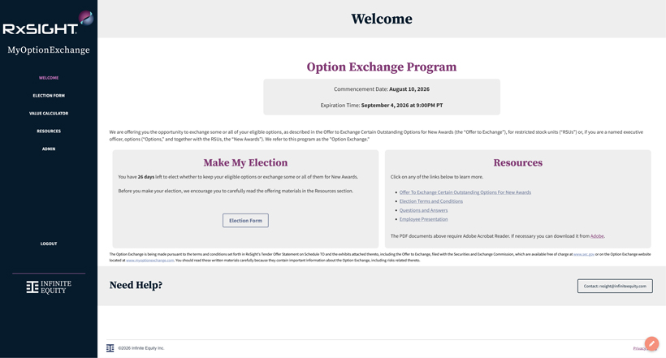
Welcome Option Exchange Program Commencement Date: August 10, 2026 Expiration Time: September 4, 2026 at 9:00PM PT We are offering you the opportunity to exchange some or all of your eligible options, as described in the Offer to Exchange Certain Outstanding Options for New Awards (the “Offer to Exchange”), for restricted stock units (“RS Us”) or, if you are a named executive officer, options (“Options;’ and together with the RS Us, the “New Awards”). We refer to this program as the “Option Exchange.” Make My Election You have 26 days left to elect whether to keep your eligible options or exchange some or all of them for New Awards. Before you make your election, we encourage you to carefully read the offering materials in the Resources section. Resources Click on any of the links below to learn more.  Offer To Exchange Certain Outstanding_Qptions For New Awards  Election Terms and Conditions  Questions and Answers  EmR)Qyee Presentation The PDF documents above require Adobe Acrobat Reader. If necessary you can download it from Adobe. The Option Exchange is being made pursuant to the terms and conditions set forth in RxSight’s Tender Offer Statement on Schedule TO and the exhibits attached thereto, including the Offer to Exchange, filed with the Securities and Exchange Commission, which are available free of charge at .www se e gQli or on the Option Exchange website located at www my_Q~ge....eom. You should read these written materials carefully because they contain important information about the Option Exchange, including risks related thereto.

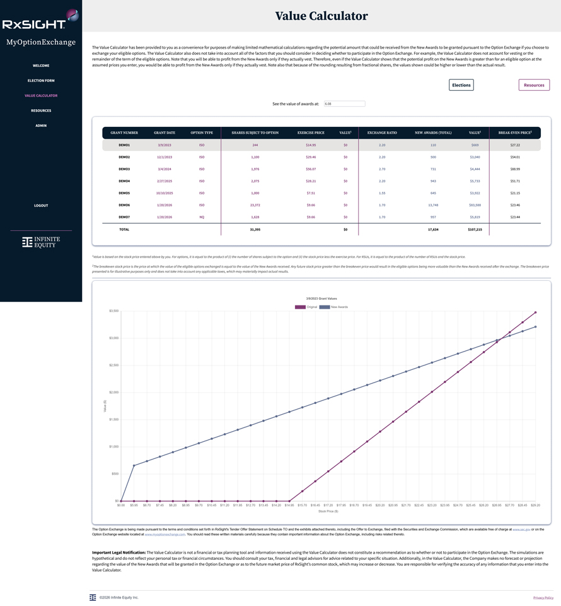
Value Calculator The Value Calculator has been provided to you as a convenience for purposes of making limited mathematical calculations regarding the potential amount that could be received from the New Awards to be granted pursuant to the Option Exchange if you choose to exchange your eligible options. The Value Calculator also does not take into account all of the factors that you should consider in deciding whether to participate in the Option Exchange. For example, the Va lue Calculator does not account for vesting or the remainder of the term of the eligible options. Note that you will be able to profit from the New Awards only if they actually vest. Therefore, even if the Value Calculator shows that the potential profit on the New Awards is greater than for an eligible option at the assumed prices you enter, you would be able to profit from the New Awards only if they actually vest. Note also that because of the rounding resulting from fractional shares, the values shown could be higher or lower than the actual result. 1 Vafue is based on the stock price entered above by you. For options, it is equal to the product of (i) the number of shares subject to the option and (ii) the stock price less the exercise price. For RS Us, it is equal to the product of the number of RS Us and the stock price. 2 The breakeven stock price is the price at which the value of the eligible options exchanged is equal to the value of the New Awards received. Any future stock price greater than the breakeven price would result in the eligible options being more valuable than the New Awards received a~er the exchange. The breakeven price presented is for illustrative purposes only and does not take into account any applicable taxes, which may materially impact actual results The Option Exchange is being made pursuant to the terms and conditions set forth in RxSight’s Tender Offer Statement on Schedule TO and the exhibits attached thereto, including the Offer to Exchange, filed with the Securities and Exchange Commission, which are available free of charge at ~g~or on the Option Exchange website located at WWWJTIY_Qptionexchang~. You should read these written materials carefully because they contain important information about the Option Exchange, including risks related thereto Important Legal Notification: The Value Calculator is not a financial or tax planning tool and information received using the Value Calculator does not constitute a recommendation as to whether or not to participate in the Option Exchange. The simulations are hypothetical and do not reflect your personal tax or financial circumstances. You should consult your tax, financial and legal advisors for advice related to your specific situation. Additionally, in the Value Calculator, the Company makes no forecast or projection regarding the value of the New Awards that will be granted in the Option Exchange or as to the future market price of RxSight’s common stock, which may increase or decrease. You are responsible for verifying the accuracy of any information that you enter into the Va lue Calculator.

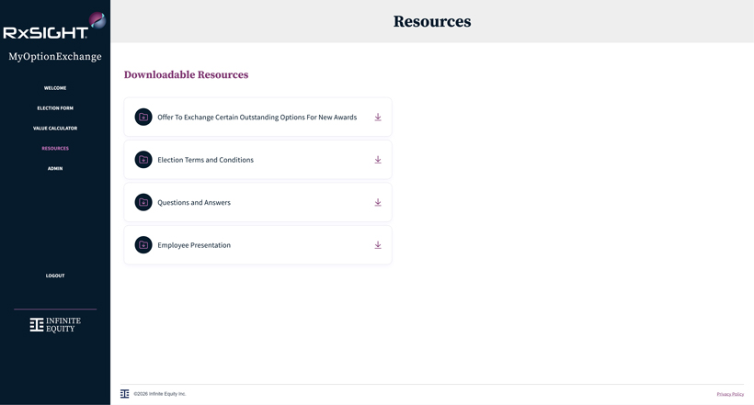
Resources Downloadable Resources  Offer To Exchange Certain Outstanding Options For New Awards  Election Terms and Conditions  Questions and Answers  Employee Presentation

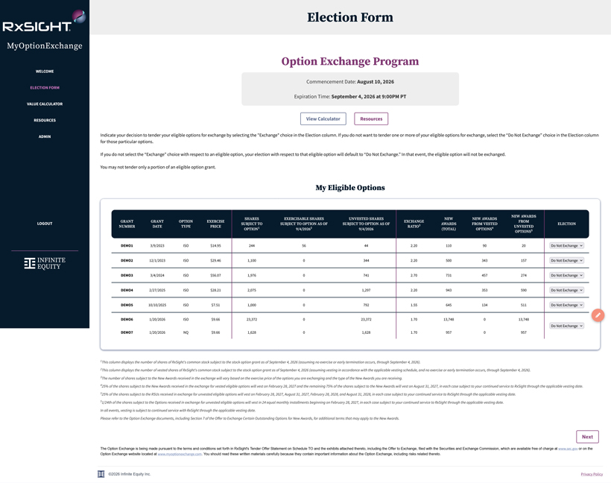
Election Form Option Exchange Program Commencement Date: August 10, 2026 Expiration Time: September 4, 2026 at 9:00PM PT Indicate your decision to tender your eligible options for exchange by selecting the “Exchange” choice in the Election column. If you do not want to tender one or more of your eligible options for exchange, select the “Do Not Exchange” choice in the Election column for those particular options. If you do not select the “ Exchange” choice with respect to an eligible option, your election with respect to that eligible option will default to “Do Not Exchange.” In that event, the eligible option will not be exchanged. You may not tender only a portion of an eligible option grant. My Eligible Options 1 This column displays the number of shares of RxSight’s common stock subject to the stock option grant as of September 4, 2026 (assuming no exercise or early termination occurs, through September 4, 2026). 2 This column displays the number of vested shares of RxSight’s common stock subject to the stock option grant as of September 4, 2026 (assuming vesting in accordance with the applicable vesting schedule, and no exercise or early termination occurs, through September 4, 2026). 3The number of shares subject to the New Awards received in the exchange will vary based on the exercise price of the options you are exchanging and the type of the New Awards you are receiving. 425% of the shares subject to the New Awards received in the exchange for vested eligible options will vest on February 28, 2027 and the remaining 75% of the shares subject to the New Awards will vest on August 31, 2027, in each case subject to your continued service to RxSight through the applicable vesting date. 525% of the shares subject to the RSUs received in exchange for unvested eligible options will vest on February 28, 2027, August 31, 2027, February 28, 2028, and August 31, 2028, in each case subject to your continued service to RxSight through the applicable vesting date. 5 1/24th of the shares subject to the Options received in exchange for unvested eligible options will vest in 24 equal monthly installments beginning on February 28, 2027, in each case subject to your continued service to RxSight through the applicable vesting date. In all events, vesting is subject to continued service with RxSight through the applicable vesting date. Please refer to the Option Exchange documents, including Section 7 of the Offer to Exchange Certain Outstanding Options for New Awards, for additional terms that may apply to the New Awards The Option Exchange is being made pursuant to the terms and conditions set forth in RxSight’s Tender Offer Statement on Schedule TO and the exhibits attached thereto, including the Offer to Exchange, filed with the Securities and Exchange Commission, which are available free of charge at ~gQ:ior on the Option Exchange website located at www my.2~g~. You should read these written materials carefully because they contain important information about the Option Exchange, including risks related thereto

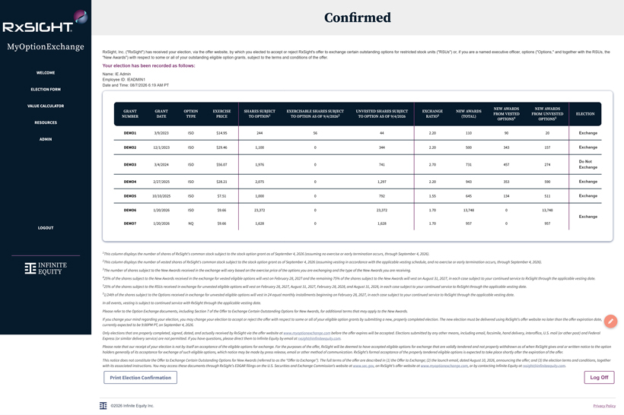
Confirmed RxSight, Inc. (“RxSight”) has received your election, via the offer website, by which you elected to accept or reject RxSight’s offer to exchange certain outstanding options for restricted stock units (“RSUs”) or, if you are a named executive officer, options (“Options,” and together with the RSUs, the “New Awards”) with respect to some or all of your outstanding eligible option grants, subject to the terms and conditions of the offer. Your election has been recorded as follows: Name: IE Admin Employee ID: IEADMIN1 Date and Time: 08/712026 6:19 AM PT 1 This column displays the number of shares of RxSight’s common stock subject to the stock option grant as of September 4, 2026 (assuming no exercise or early termination occurs, through September 4, 2026). 2 This column displays the number of vested shares of RxSight’s common stock subject to the stock option grant as of September 4, 2026 (assuming vesting in accordance with the applicable vesting schedule, and no exercise or early termination occurs, through September 4, 2026). 3 The number of shares subject to the New Awards received in the exchange will vary based on the exercise price of the options you are exchanging and the type of the New Awards you are receiving. 425% of the shares subject to the New Awards received in the exchange for vested eligible options will vest on February 28, 2027 and the remaining 75% of the shares subject to the New Awards will vest on August 31, 2027, in each case subject to your continued service to RxSight through the applicable vesting date. 5 25% of the shares subject to the RSUs received in exchange for unvested eligible options will vest on February 28, 2027, August 31, 2027, February 28, 2028, and August 31, 2028, in each case subject to your continued service to RxSight through the applicable vesting date. 5 1/24th of the shares subject to the Options received in exchange for unvested eligible options will vest in 24 equal monthly installments beginning on February 28, 2027, in each case subject to your continued service to Rx.Sight through the applicable vesting date. In all events, vesting is subject to continued service with RxSight through the applicable vesting date. Please refer to the Option Exchange documents, including Section 7 of the Offer to Exchange Certain Outstanding Options for New Awards, for additional terms that may apply to the New Awards Ifyou change your mind regarding your election, you may change your election to accept or reject the offer with respect to some or all ofyour eligible option grants by submitting a new, properly completed election. The new election must be delivered using RxSight’s offer website no later than the offer expiration date, currently expected to be 9:00PM PT, on September 4, 2026. Only elections that are properly completed, signed, dated, and actually received by RxSight via the offer website at www myQ~g~before the offer expires will be accepted. Elections submitted by any other means, including email, facsimile, hand delivery, interoffice, U.S. mail (or other post) and Federal Express (or similar delivery service) are not permitted. Ifyou have questions, please direct them to Infinite Equity by email at a.sigbl@in.fi.ni.lefil/uiJy,..mm. Please note that our receipt ofyour election is not by itself an acceptance of the eligible options for exchange. For the purposes of the offer, RxSight will be deemed to have accepted eligible options for exchange that are validly tendered and not properly withdrawn as of when RxSight gives oral or written notice to the option holders generally of its acceptance for exchange of such eligible options, which notice may be made by press release, email or other method of communication. RxSight’s formal acceptance of the properly tendered eligible options is expected to take place shortly after the expiration ofthe offer. This notice does not constitute the Offer to Exchange Certain Outstanding Options for New Awards (referred to as the “Offer to Exchange”). The full terms of the offer are described in (1) the Offer to Exchange; (2) the launch email, dated August 10, 2026, announcing the offer; and (3) the election terms and conditions, together with its associated instructions. You may access these documents through RxSight’s EDGAR filings on the U.S. Securities and Exchange Commission’s website at ~g.QJt, on RxSight’s offer website at WJN.Y.iJJ1y..a~gfil!J.JJJ., or by contacting Infinite Equity at oss.igh.t@~uiJy..aw:J.. Print Election Confirmation I Log Off I

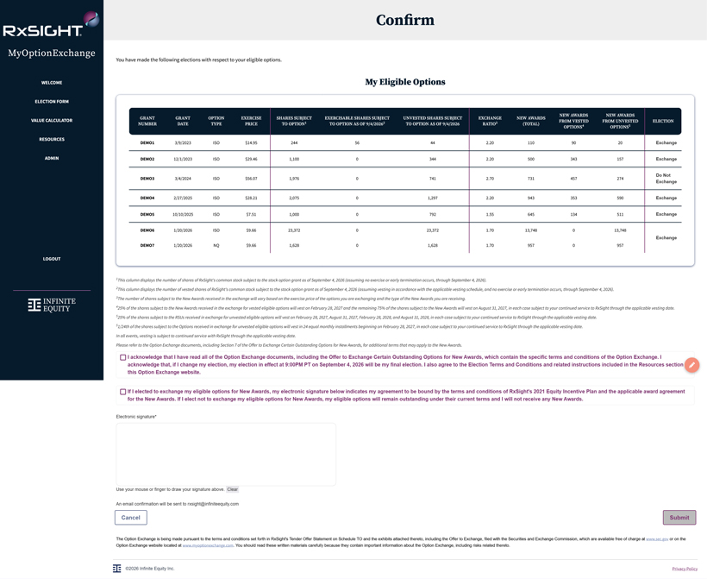
Confirm You have made the following elections with respect to your eligible options. My Eligible Options 1 This column displays the number of shares of RxSight’s common stock subject to the stock option grant as of September 4, 2026 (assuming no exercise or early termination occurs, through September 4, 2026). 2 This column displays the number of vested shares of RxSight’s common stock subject to the stock option grant as of September 4, 2026 (assuming vesting in accordance with the applicable vesting schedule, and no exercise or early termination occurs, through September 4, 2026). 3The number ofshares subject to the New Awards received in the exchange will vary based on the exercise price of the options you are exchanging and the type of the New Awards you are receiving. 425% of the shares subject to the New Awards received in the exchange for vested eligible options will vest on February 28, 2027 and the remaining 75% of the shares subject to the New Awards will vest on August 31, 2027, in each case subject to your continued service to RxSight through the applicable vesting date 5 25% of the shares subject to the RSUs received in exchange for unvested eligible options will vest on February 28, 2027, August 31, 2027, February 28, 2028, and August 31, 2028, in each case subject to your continued service to RxSight through the applicable vesting date. 5 1/24th of the shares subject to the Options received in exchange for unvested eligible options will vest in 24 equal monthly installments beginning on February 28, 2027, in each case subject to your continued service to RxSight through the applicable vesting date. In all events, vesting is subject to continued service with RxSight through the applicable vesting date. Please refer to the Option Exchange documents, including Section 7 of the Offer to Exchange Certain Outstanding Options for New Awards, for additional terms that may apply to the New Awards. O I acknowledge that I have read all of the Option Exchange documents, including the Offer to Exchange Certain Outstanding Options for New Awards, which contain the specific terms and conditions of the Option Exchange. I acknowledge that, if I change my election, my election in effect at 9:00PM PT on September 4, 2026 will be my final election. I also agree to the Election Terms and Conditions and related instructions included in the Resources section this Option Exchange website. O If I elected to exchange my eligible options for New Awards, my electronic signature below indicates my agreement to be bound by the terms and conditions of RxSight’s 2021 Equity Incentive Plan and the applicable award agreement for the New Awards. If I elect not to exchange my eligible options for New Awards, my eligible options will remain outstanding under their current terms and I will not receive any New Awards. Electronic signature* Use your mouse or finger to draw your signature above. Clear An email confirmation will be sent to rxsight@infi niteequity.com I Cancel I I Submit I The Option Exchange is being made pursuant to the terms and conditions set forth in RxSight’s Tender Offer Statement on Schedule TO and the exhibits attached thereto, including the Offer to Exchange, fi led with the Securities and Exchange Commission, which are available free of charge at ~g!lior on the Option Exchange website located at ww.w..m.y..optiQneKbange..mm. You should read these written material s carefully because they contain important information about the Option Exchange, including risks related thereto
Exhibit (a)(1)(G)
Slide 1

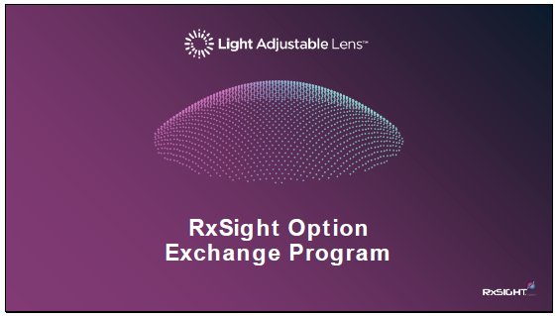

Slide 2

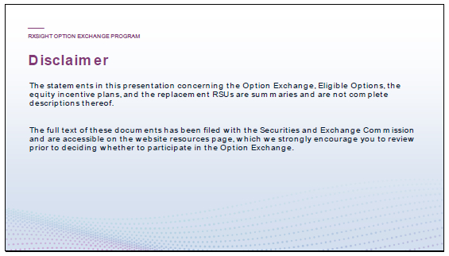
Speaker – IE Team

Please take a moment to review the disclaimer on this slide as it relates to the offer to exchange.

Slide 3

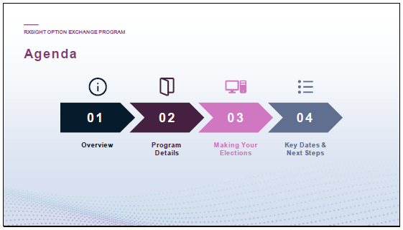
Speaker – IE Team

 |  |  | Our focus for today’s session is to provide you with key details about RxSight’s Option exchange program so that you can make an informed decision about your participation, including how to access your account and make your election to participate.

Slide 4


Speaker – IE Team

Slide 5

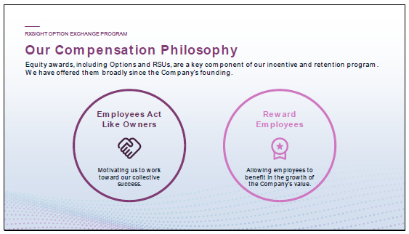
Speaker – IE Team

 |  |  | Options have been historically granted at RxSight but the company has shifted towards granting more restricted stock units, or RSUs

 |  |  | Both options and RSUs allow employees to share in the share price growth of the company and encourage employees to think and act like owners.

 |  |  | The beneficial feature of RSUs is that they will always retain value as long as the shares have value, even with a decrease in stock price.

Slide 6

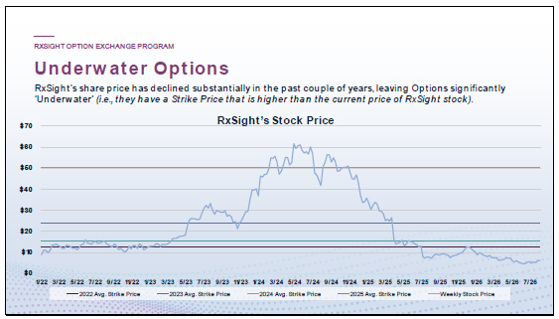
Speaker – IE Team

 |  |  | Many RxSight Stock Options are underwater.

 |  |  | Underwater Options are Options with a strike price higher than the current share price; it is not rational to exercise an underwater Option, since you could buy a share for less on the open market.

Slide 7

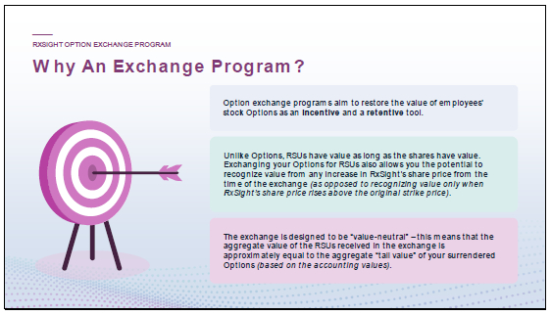
Speaker – IE Team

 |  |  | Option exchange programs aim to restore the incentive and retentive value of employees’ Stock Options by providing an opportunity to exchange underwater Options.

 |  |  | There is an opportunity here to exchange Options for RSUs.

 |  |  | The exchange changes the distribution of value. Your Options have larger upside, but also a higher chance of delivering no value. RSUs received in the exchange will deliver value as long as the shares have value but have less upside (since you have fewer awards). I’ll show you in a few pages an example of when your original Option awards might be more valuable than the new RSU awards.

 |  |  | The program is approximately “value-neutral” – meaning that the “fair value” (for accounting purposes) of your current Options would be approximately equivalent to the fair value of the RSUs received in the exchange.

Slide 8

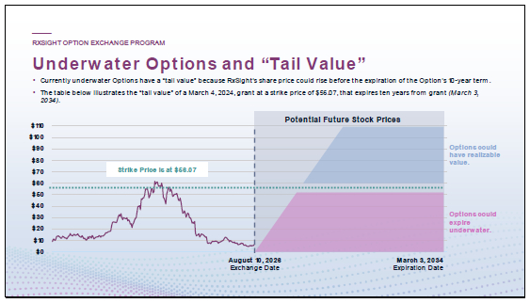
Speaker – IE Team

 |  |  | This example focuses on a grant made on March 4, 2024, at an exercise (or “strike”) price of $56.07 per share.

 |  |  | Even though underwater Options cannot be exercised for value now, the Options still have value because the share price could rise above the strike price in the future (prior to expiration of Option). We call this “tail value”.

 |  |  | However, Options could expire underwater and deliver no value if the share price does not increase above the strike price over the remaining term of the Option.

Slide 9

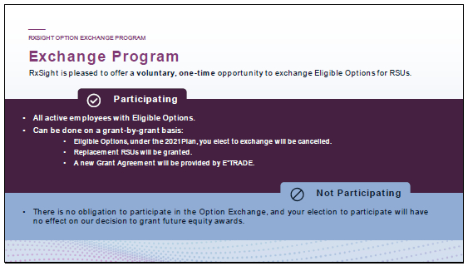
Speaker – IE Team

RxSight is offering a one-time, voluntary opportunity for eligible stock Option holders to exchange their eligible stock Options, both vested and unvested (unexercised), for RSUs, or Restricted Stock Units.

 |  | If you elect to participate in the Option Exchange, which can be done on a grant-by-grant basis, the stock Options you elect to surrender will be cancelled, RSUs will be granted, and a new grant agreement will be provided through E*TRADE.

 |  | There is no obligation to participate in the Option Exchange. It is completely your choice. If you do not choose to participate in the Option Exchange, you will continue to hold your stock Options.

Slide 10

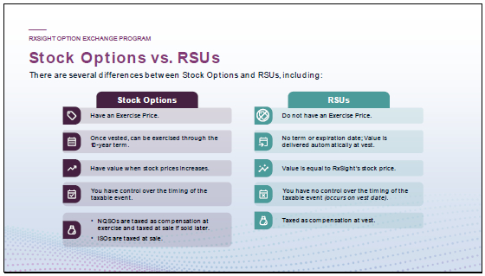
Speaker – IE Team

RSUs and Stock Options are both forms of employee equity compensation — or non-cash compensation — offered to an employee by an employer and are generally the most common forms of equity compensation.
Stock Options and RSUs differ significantly in terms of the form of compensation received, and how they are taxed.

 |  |  | The most important distinction between Stock Options and RSUs is what exactly you’re receiving.

 |  |  | When you’re granted Stock Options, you have the choice to purchase company stock at a specific price before a certain date. Whether you purchase the stock is entirely up to you.

 |  |  | RSUs, on the other hand, grant you the stock itself once the vesting period is complete. You don’t have to purchase it.

 |  |  | In addition, RSUs are distinctly different than Stock Options with respect to economic value. Any value realized from a Stock Option is dependent on the current value of the stock being higher than the Option price. Unlike Stock Options which have a cost to the employee (the Option price), employees do not pay for Restricted Stock Units, so the award always has value as long as the shares have value.

Slide 11


Speaker – IE Team

Slide 12

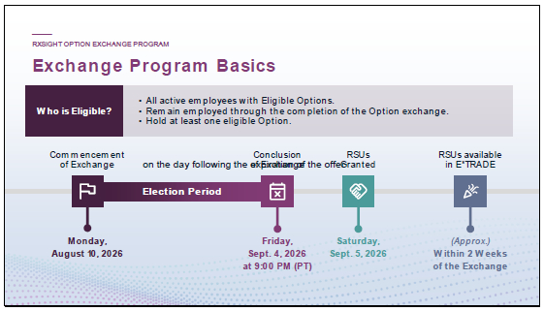
Speaker – IE Team

 |  |  | Eligibility:

 |  |  | You are eligible to participate in the exchange if you are an active U.S. based employee of RxSight.

 |  |  | The exchange window is open August 10, 2026, and is set to expire on September 4, 2026, at 9:00 pm (PT).

 |  |  | September 4, 2026, will be the last day you can exchange your Options.

 |  |  | Any exchanged Options will be cancelled on this date!

 |  |  | Following the conclusion of the Option Exchange, eligible Stock Options opted into by the employee will be cancelled, while RSUs will be granted on the first day following the expiration of the Option Exchange.

 |  |  | You will be notified if that date is extended, but basically, each RSU granted to you in the Option Exchange will be granted under a new award agreement, subject to you remaining continuously employed or engaged with RxSight through the vesting dates.

 |  |  | The RSUs will be available in your E*TRADE account within approximately 2 weeks of the conclusion of the exchange.

Slide 13

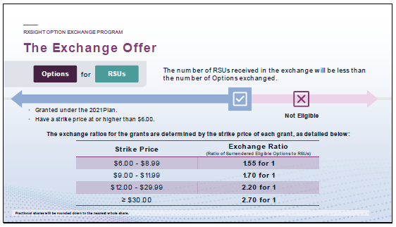
Speaker – IE Team

 |  |  | An eligible Option in the Offer will include only those Options that fall under the 2021 Plan, remain outstanding and unexercised prior to the expiration of the Option exchange, and are “underwater” (or at the money) on the expiration of the Option exchange.

 |  |  | Have a strike price at or higher than $6.00

 |  |  | Strike Prices lower than $6.00, are excluded from the exchange.

 |  |  | You may participate on a grant-by-grant basis, but for each grant, your selection must be on an all-or-nothing basis.

 |  |  | No partial exchanges are permitted.

 |  |  | The exchange ratio will vary based on the strike price of the grant.

 |  |  | For example, if the strike price for your grant falls between $12.00 and $29.99, your exchange ratio is 2.20 for 1, so you can exchange 154 options for 70 RSUs.

 |  |  | Any fractional shares will be rounded down to the nearest whole share.

 |  |  | Ratios closer to 1 mean less of a decrease in the number of RSUs received.

 |  |  | Higher ratios (such as 2.70) mean more of a decrease in the number of RSUs.

Slide 14

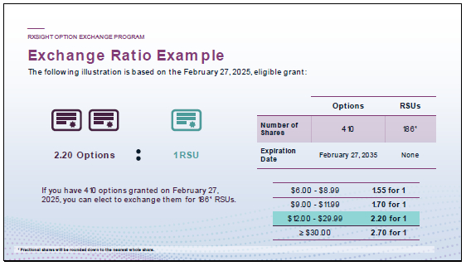
Speaker – IE Team

 |  |  | As discussed, the exchange is providing an opportunity to turn in options for RSUs.

 |  |  | Which scenario is worth more depends on RxSight’s future stock price.

 |  |  | For example, if you hold a stock option for 410 shares with a strike price of $28.21, you can elect to exchange it for 186 RSUs. The value that you can realize from the RSUs, or your existing Stock Options, depends on RxSight’s share price.

 |  |  | As we will show in the next slide, if the share price goes up significantly (above $51.63), you’d be better off having the option grant—also known as the “Break Even” point.

 |  |  | Keep in mind, the option grant is only valuable if the share price rises above the Strike price of $28.21 – if below that, the option has $0 value.

 |  |  | In contrast, the RSU will always retain value as long as the shares have value, even below the $28.21 strike price, it just will be less valuable than the Options if the stock price rises above the Break-Even price.

 |  |  | If you decide to not participate in the exchange, nothing changes with your grant, so you will retain the same number of exercisable options with the same expiration date.

 |  |  | In this example, nothing changes, and then there’s no impact to that option grant whatsoever.

Slide 15

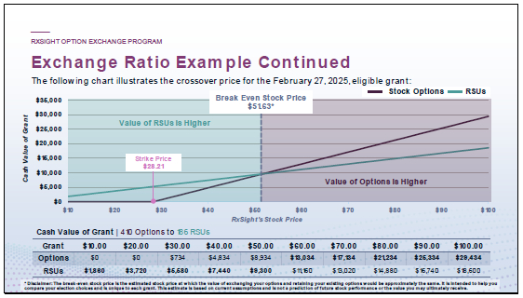
Speaker – IE Team

 |  |  | For the February 27, 2025, grant in our example, you’d hold more value by exchanging your options to RSUs if RxSight’s stock price is below $51.63. If RxSight’s stock price goes above $51.63, you’d hold more value with your options (no exchange).

 |  |  | This value chart and crossover point is unique to each grant, and you’ll be able to see the cross-over point for each grant in your election portal.

 |  |  | The break-even stock price is simply a reference point to help you compare your election options. At this estimated stock price, both choices would have approximately the same value. Because future stock prices are unknown, this figure is based on current assumptions and is intended for informational purposes only.

Slide 16

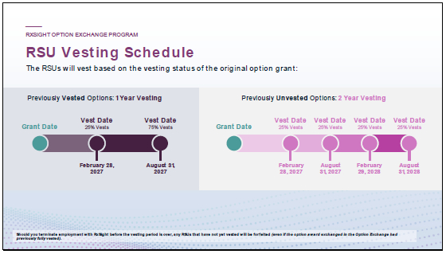
Speaker – IE Team

 |  |  | RSUs received in the exchange will vest based on the following schedules.

 |  |  | Options with tranches that have already vested within a grant will have a 1-year vesting schedule, while unvested tranches in a grant will have a 2-year vesting schedule.

 |  |  | This means that you could have one underwater option grant exchanged for 1 or 2 new RSU grants due to the options vesting state.

 |  |  | For Options that are vested and exchanged for RSUs, they will have a new vesting requirement of 1-year.

 |  |  | 25% of your award will vest on February 28, 2027

 |  |  | The remaining 75% of your award will vest on August 31, 2027

 |  |  | For Options that are unvested and exchanged for RSUs, they will have a vesting schedule of 2-years:

 |  |  | RSUs will vest on a bi-annual vesting schedule with the first tranche vesting on February 28, 2027, and every 6 months after that until August 31, 2028.

Slide 17

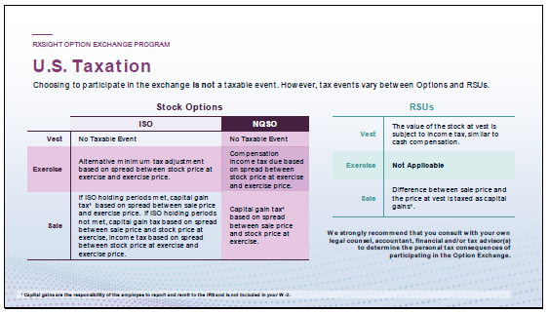
Speaker – IE Team

We realize that many of you have questions such as, what are the tax implications for me?
Choosing to participate in the exchange is NOT expected to give rise to an immediate U.S. taxable event in the ordinary course.

 |  |  | If you choose to not participate in the exchange, your tax events for your options will remain the same.

 |  |  | If you do exchange your options for RSUs, your taxation will happen at vest and at sale.

 |  |  | The FMV on the vest date is a taxable gain to you, and Federal, state, local, and social taxes must be paid on any taxable gain recognized by you.

 |  |  | RxSight is required to withhold these taxes on your behalf and will be authorized to sell or withhold a portion of the vested shares to pay these taxes.

 |  |  | At a later sale by you, you’ll generally recognize a capital gain or loss equal to the difference between the price at vest and the sale price.

 |  |  | The holding period for long-term capital gains purposes generally commences on the date of vesting.

 |  |  | Capital gains are the responsibility of the employee to report and remit to the IRS and is not included in your W-2.

 |  |  | We strongly recommend that you consult with your own tax advisor to determine the personal tax consequences of participating in the Exchange Offer.

Slide 18

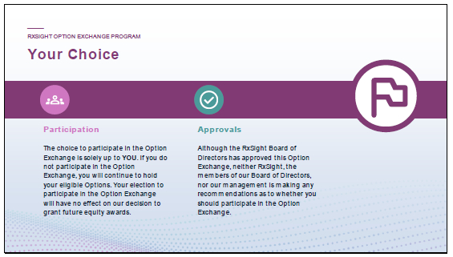
Speaker – IE Team

 |  |  | As a reminder, choosing to participate in the Option Exchange is solely up to you.

 |  |  | Although RxSight’ board has approved this offer, we will not make any recommendations as to whether you should participate in the offer. That is completely up to you.

Slide 19


Speaker – IE Team

Slide 20

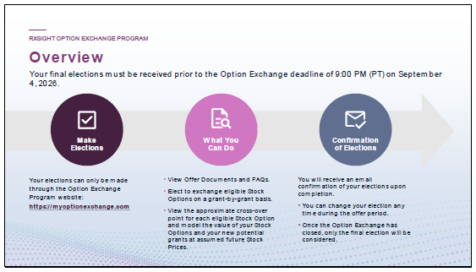
Speaker – IE Team

 |  |  | Your elections will be made through the stock option exchange program website, which is myoptionexchange.com.

 |  |  | On that site, you’ll be able to do the following:

 |  |  | You’ll be able to view all of the Offering documents, including the questions and answers that are common with this type of program.

 |  |  | You’ll be able to elect to exchange options on a grant-by-grant basis;

 |  |  | There is also a nice calculator that you can use to view what the value of your Stock Options and your RSUs are at assumed future stock prices.

 |  |  | Once you’ve made your elections, you’ll receive confirmation of your elections upon completion.

 |  |  | You can change your election at any time during the Exchange period.

 |  |  | You could change it a hundred times, if you want, but it’ll be whatever is done as of Friday, September 4, 2026, at 9 PM (PT) (unless the Offer is extended) — that will be the only election that we considered.

 |  |  | You can go in even on Friday, September 4, 2026(or later date if the Offer is extended) and make changes as long as it’s before 9 PM PT on that day.

Slide 21

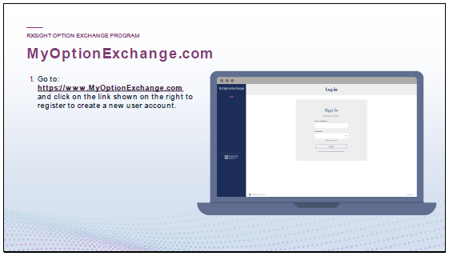
Speaker – IE Team

 |  |  | When you receive the information for this option exchange program, you should have received an email from RxSight with a link to the website: https://myoptionexchange.com.

 |  |  | Once you’ve loaded that page, click on “Register as a new user”.

Slide 22

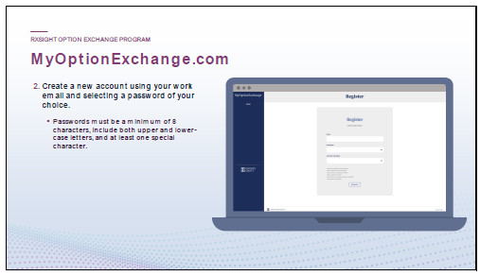
Speaker – IE Team

 |  |  | You’ll be prompted to create a new account and register.

 |  |  | You’ll put it in your RxSight email address and create a password.

Slide 23

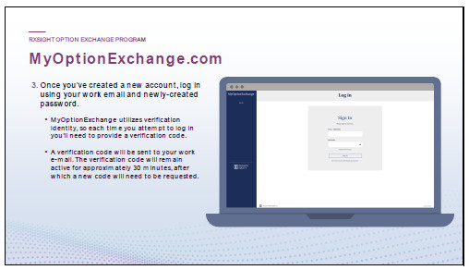
Speaker – IE Team

 |  |  | Once you’ve done that, you’ll receive another email from Infinite Equity that will give you a verification code.

 |  |  | You’ll input that code and submit, and you’ll be able to log in.

Slide 24

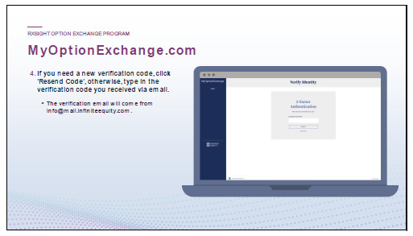
Speaker – IE Team

 |  |  | Please note that your verification code will only be valid for 30 mins. If you need a new code, simply click “Resend Code”, otherwise type in the verification code you received via email.

 |  |  | As a reminder, this is through Infinite Equity’s site, and not through E*TRADE. So, you won’t be able to make this election through your E*TRADE account.

Slide 25

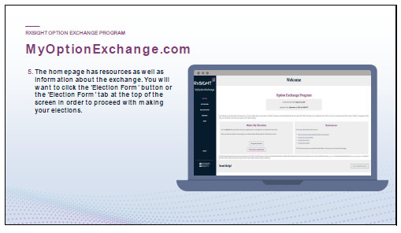
Speaker – IE Team

 |  |  | After logging in, you will be presented with this welcome screen.

 |  |  | This landing page is great because it contains all the resources you would be able to access, as well as links to any documents we have filed with the SEC.

 |  |  | This employee presentation will also be available on that site.

 |  |  | You can then proceed to the election form by clicking the blue button labeled “Election Form” when you are ready to proceed with your elections.

Slide 26

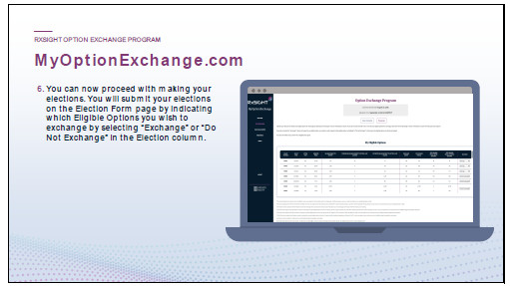
Speaker – IE Team

 |  |  | On this next page, in the chart, you will find a list of all the options that are eligible for exchange.

 |  |  | The dropdown menu on the table will allow you to select the grants for which you wish to make an election. In addition, you can see the number of Options you will receive in place of the eligible options if you elect to exchange that grant.

 |  |  | You have the option of exchanging or not exchanging.

 |  |  | It is important to remember that you can make different elections for different grants, but each grant is “all or nothing”.

 |  |  | You can either exchange all the options granted on a certain date, or you cannot exchange any of them.

 |  |  | Once you have made your selections, click “Next” to proceed to the next step.

Slide 27

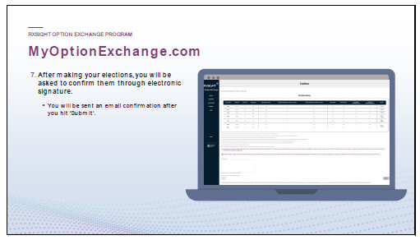
Speaker – IE Team

 |  |  | The following page will take you to the “Confirm Elections” screen.

 |  |  | The election choices you made will be displayed on this page.

 |  |  | In order to complete the process, you will need to check off two boxes acknowledging that you have read and understood the offering materials and that you have confirmed your selections.

 |  |  | After checking the boxes, you will be required to type or sign with an electronic signature, confirming that this is what you wish to exchange.

 |  |  | Once you have reviewed your election choices, click “Submit” to process your choices.

Slide 28

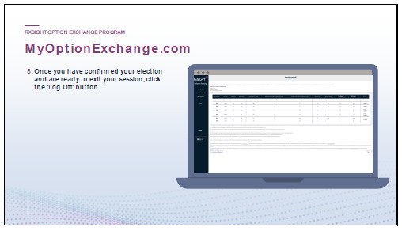
Speaker – IE Team

 |  |  | As soon as you submit your elections, you will be directed to a page that indicates that your elections were successfully submitted.

 |  |  | You will need to make sure that you reach the Elections Complete page in order to see a summary of what has been exchanged and what has not been exchanged.

 |  |  | It is imperative to note that if you do not see this screen, your elections have not been confirmed.

 |  |  | The same breakdown will also be emailed to you every time you make a change to your election once confirmed by Infinite Equity.

 |  |  | You may then log out of the platform.

Slide 29

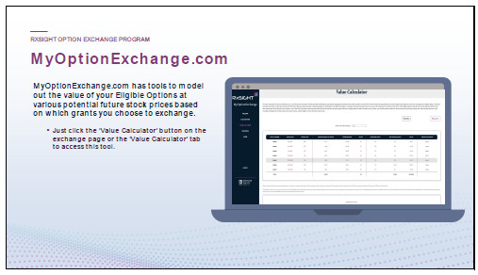
Speaker – IE Team

 |  |  | The website also has some valuable tools such as the Value Calculator tool where you can graph hypothetical scenarios to see what future values would look like.

 |  |  | The tool will show you more details about the value of your stock options, including:

 |  |  | The value of your eligible options at whatever price you input.

 |  |  | The value of your replacement options at whatever price you input.

Slide 30


Speaker – IE Team

Slide 31

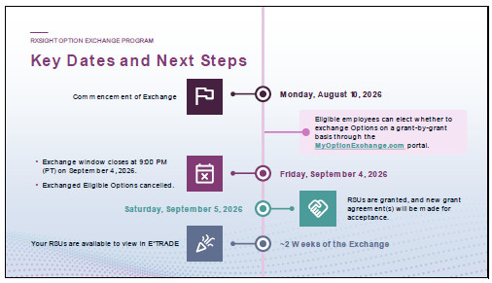
Speaker – IE Team

 |  |  | The commencement of the exchange begins Monday, August 10, 2026.

 |  |  | You will have until Friday, September 4, 2026, at 9pm (PT) to make your election choices or change them.

 |  |  | On September 4, 2026, your exchanged eligible options will be cancelled, and you will be granted RSUs on Saturday, September 5, 2026.

Slide 32

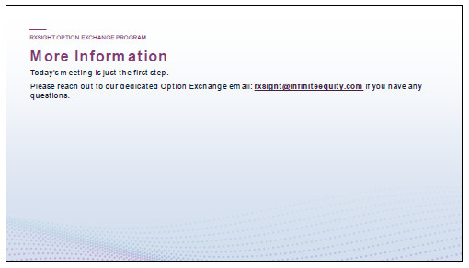
Speaker – IE Team

 |  |  | Today’s meeting is the first step in this process.

 |  |  | Please feel free to reach out to the email address included on this slide (rxsight@infiniteequity.com) if you have any questions.

Slide 33


Speaker – IE Team

Slide 34

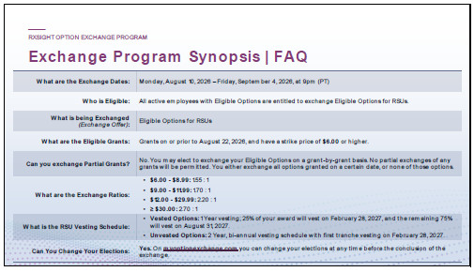
Take a moment to familiarize yourself with some of the commonly asked questions surrounding the exchange.

Slide 35

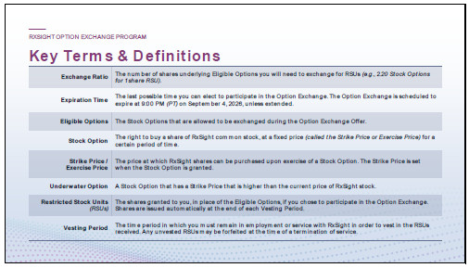
We’ve included a list of key terms and definitions to help clear up any confusion that you can reference.
Exhibit (a)(1)(H)
Slide 1

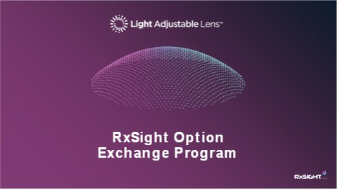

Slide 2

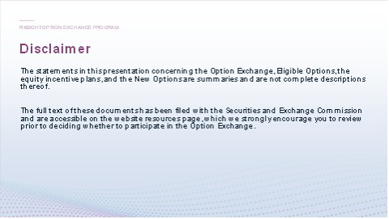
Speaker – IE Team

Please take a moment to review the disclaimer on this slide as it relates to the offer to exchange.

Slide 3

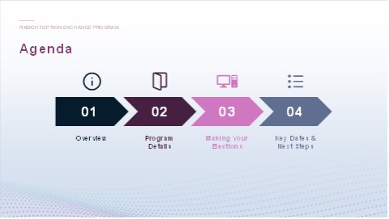
Speaker – IE Team

* | Our focus for today’s session is to provide you with key details about RxSight’s Option exchange program so that you can make an informed decision about your participation, including how to access your account and make your election to participate.

Slide 4


Speaker – IE Team

Slide 5

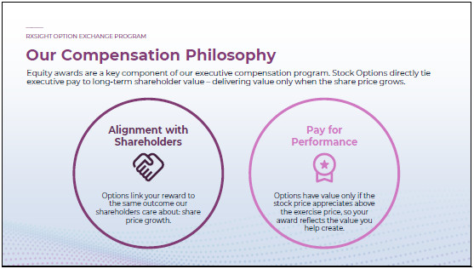
Speaker – IE Team

* | Options have been granted at our company since its founding and remain the equity vehicle for our executive team.

* | Options allow you to share directly in the growth of RX Sight’s share price and encourages you to think and act like an owner.

* | Since an option only has value when the share price exceeds the exercise price, your reward is tied specifically to increases in RX Sights value over time.

Slide 6

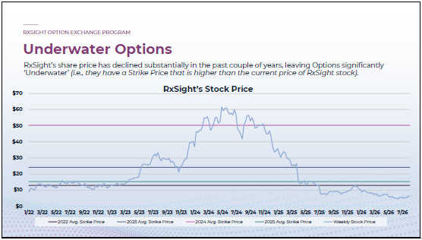
Speaker – IE Team

* | Many RxSight Stock Options are underwater.

 | * | Underwater Options are Options with a strike price higher than the current share price; it is not rational to exercise an underwater Option, since you could buy a share for less on the open market.

Slide 7

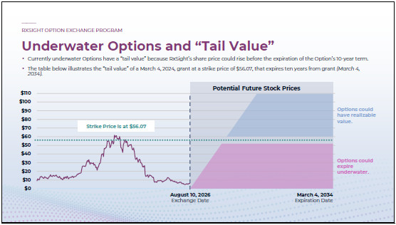
Speaker – IE Team

* | This example focuses on a grant made on March 4, 2024, at an exercise (or “strike”) price of $56.07 per share.

* | Even though underwater Options cannot be exercised for value now, the Options still have value because the share price could rise above the strike price in the future (prior to expiration of Option). We call this “tail value”.

* | However, Options could expire underwater and deliver no value if the share price does not increase above the strike price over the remaining term of the Option.

Slide 8

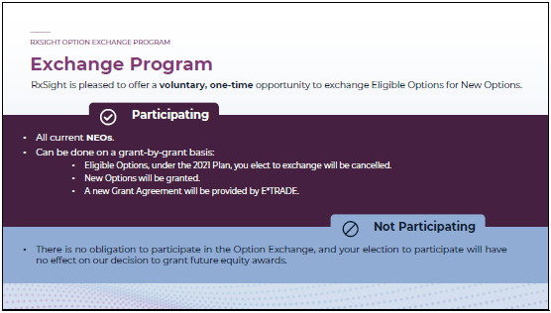
Speaker – IE Team

RxSight is offering a one-time, voluntary opportunity for eligible stock Option holders to exchange their eligible stock Options.

* | If you elect to participate in the Option Exchange, which can be done on a grant-by-grant basis, the stock Options you elect to surrender will be cancelled and a new grant agreement will be provided through E*TRADE.

* | There is no obligation to participate in the Option Exchange. It is completely your choice. If you do not choose to participate in the Option Exchange, you will continue to hold your stock Options.

Slide 9


Speaker – IE Team

Slide 10

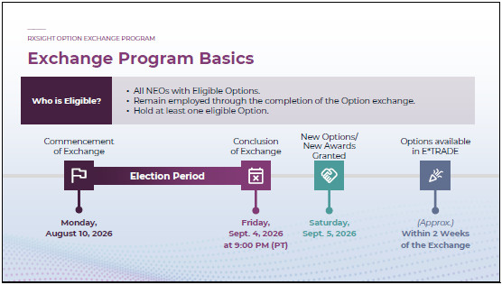
Speaker – IE Team

* | Eligibility:

 | * | You are eligible to participate in the exchange if you are an active U.S. based employee of RxSight, excluding board members.

* | The exchange window is open August 10, 2026, and is set to expire on September 4, 2026, at 9:00 pm (PT).

 | * | September 4, 2026, will be the last day you can exchange your Options.

 | * | Any exchanged Options will be cancelled on this date!

* | Following the conclusion of the Option Exchange, eligible Stock Options opted into by the employee will be cancelled, while New Options will be granted on the day following the expiration of the offer.

 | * | You will be notified if that date is extended, but basically, each New Option granted to you in the Option Exchange will be granted under a new option agreement, subject to you remaining continuously employed or engaged with RxSight through the vesting dates.

 | * | The New Options will be available in your E*TRADE account within approximately 2 weeks of the conclusion of the exchange.

Slide 11

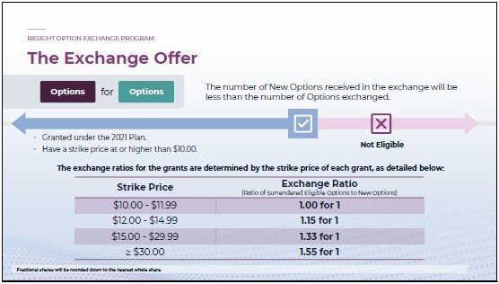
Speaker – IE Team

* | An eligible Option in the Offer will include only those Options that fall under the 2021 Plan, remain outstanding and unexercised prior to the expiration of the Option exchange, and are “underwater” (or at the money) on the expiration of the Option exchange.

 | * | Have a strike price at or higher than $10.00

 | * | Strike Prices lower than $10.00 are excluded from the exchange

* | You may participate on a grant-by-grant basis, but for each grant, your selection must be on an all-or-nothing basis.

 | * | No partial exchanges are permitted.

* | The exchange ratio will vary based on the strike price of the grant.

 | * | For example, if the strike price for your grant falls between $12.00 and $14.99, your exchange ratio is 1.15 for 1, so you can exchange 230 options for 200 New Options.

 | * | Any fractional shares will be rounded down to the nearest whole share.

 | * | Ratios closer to 1 mean less of a decrease in the number of New Options received.

 | * | Higher ratios (such as 1.55) mean more of a decrease in the number of New Options.

Slide 12

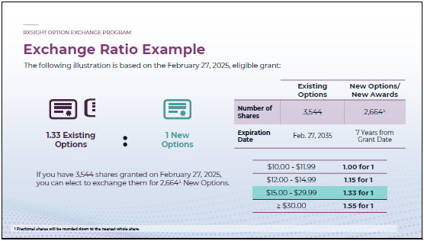
Speaker – IE Team

* | As discussed, the exchange is providing an opportunity to turn in options for New Options.

* | For example, if you hold a stock option for 3,544 shares with a strike price of $28.21, the applicable exchange ratio would be 1.33. This means you could elect to exchange your 3,544 existing options for 2,664 New Options.

* | If you decide to not participate in the exchange, nothing changes with your grant, so you will retain the same number of exercisable options with the same expiration date.

 | * | In this example, nothing changes, and then there’s no impact to that option grant whatsoever.

Slide 13

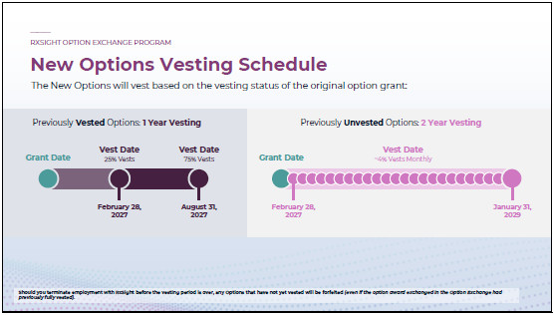
Speaker – IE Team

* | New Options received in the exchange will vest based on the following schedules.

 | * | Options with tranches that have already vested within a grant will have a 1-year vesting schedule, while unvested tranches in a grant will have a 2-year vesting schedule.

 | * | This means that you could have one underwater option grant exchanged for 1 or 2 New Options grants due to the options vesting state.

 |  |  | For Options that are vested and exchanged for New Options, they will have a new vesting requirement of 1-year.

 |  |  | 25% of your award will vest on February 28, 2027

 |  |  | The remaining 75% of your award will vest on August 31, 2027

 |  |  | For Options that are unvested and exchanged for New Options, they will have a vesting schedule of 2-years:

 |  |  | New Options will vest in equal, monthly installments over a 24-month period beginning February 28, 2027, until January 31, 2029.

Slide 14

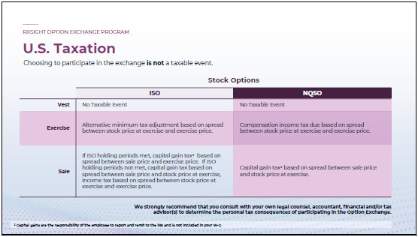
Speaker – IE Team

We realize that many of you have questions such as, what are the tax implications for me?
Choosing to participate in the exchange is NOT expected to give rise to an immediate U.S. taxable event in the ordinary course.

* | If you choose to not participate in the exchange, your tax events for your options will remain the same.

* | If you do exchange your options for New Options, your tax events for your New Options will generally remain the same as the old options, depending on if they are incentive stock options or nonstatutory stock options

 | * | At a later sale by you, you’ll generally recognize a capital gain or loss equal to the difference between the price at exercise and the sale price (although shares obtained from ISO exercise may have different tax results, depending on if you met your ISO holding periods prior to sale – make sure to ask your tax advisor).

 | * | The holding period for long-term capital gains purposes generally commences on the date of vesting.

* | Capital gains are the responsibility of the employee to report and remit to the IRS and is not included in your W-2.

* | We strongly recommend that you consult with your own tax advisor to determine the personal tax consequences of participating in the Exchange Offer.

Slide 15

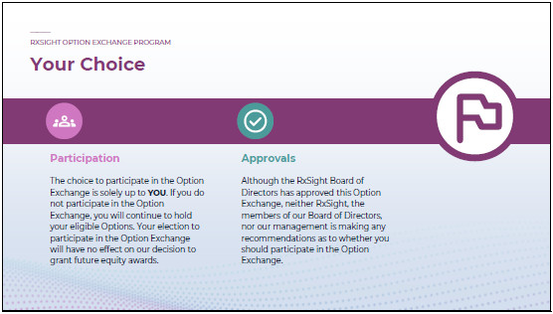
Speaker – IE Team

* | As a reminder, choosing to participate in the Option Exchange is solely up to you.

* | Although RxSight’ board has approved this offer, we will not make any recommendations as to whether you should participate in the offer. That is completely up to you.

Slide 16


Speaker – IE Team

Slide 17

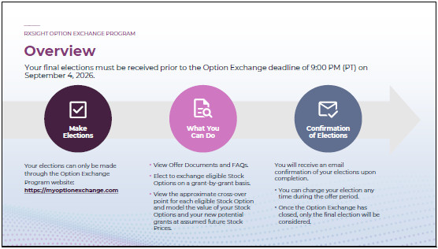
Speaker – IE Team

* | Your elections will be made through the stock option exchange program website, which is myoptionexchange.com.

* | On that site, you’ll be able to do the following:

 | * | You’ll be able to view all of the Offering documents, including the questions and answers that are common with this type of program.

 | * | You’ll be able to elect to exchange options on a grant-by-grant basis;

 | * | There is also a nice calculator that you can use to view what the value of your Stock Options and your New Options are at assumed future stock prices.

* | Once you’ve made your elections, you’ll receive confirmation of your elections upon completion.

* | You can change your election at any time during the Exchange period.

 | * | You could change it a hundred times, if you want, but it’ll be whatever is done as of Friday, September 4, 2026, at 9 PM (PT) (unless the Offer is extended) -- that will be the only election that we considered.

 | * | You can go in even on Friday, September 4, 2026 (or later date if the Offer is extended) and make changes as long as it’s before 9 PM PT on that day.

Slide 18

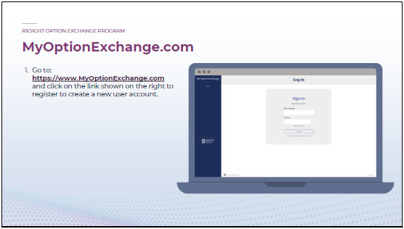
Speaker – IE Team

* | When you receive the information for this option exchange program, you should have received an email from RxSight with a link to the website: https://myoptionexchange.com.

* | Once you’ve loaded that page, click on “Register as a new user”.

Slide 19

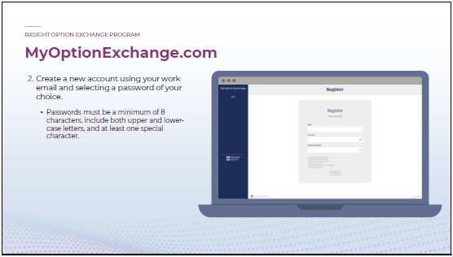
Speaker – IE Team

* | You’ll be prompted to create a new account and register.

* | You’ll put it in your RxSight email address and create a password.

Slide 20

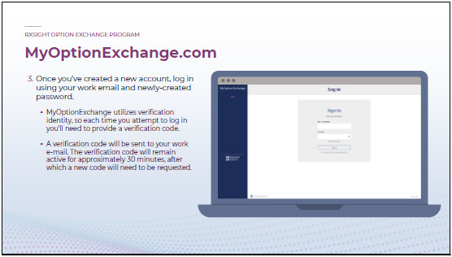
Speaker – IE Team

* | Once you’ve done that, you’ll receive another email from Infinite Equity that will give you a verification code.

* | You’ll input that code and submit, and you’ll be able to log in.

Slide 21

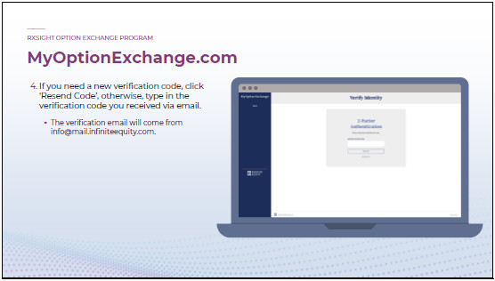
Speaker – IE Team

* | Please note that your verification code will only be valid for 30 mins. If you need a new code, simply click “Resend Code”, otherwise type in the verification code you received via email.

 |  |  | As a reminder, this is through Infinite Equity’s site, and not through E*TRADE. So, you won’t be able to make this election through your E*TRADE account.

Slide 22

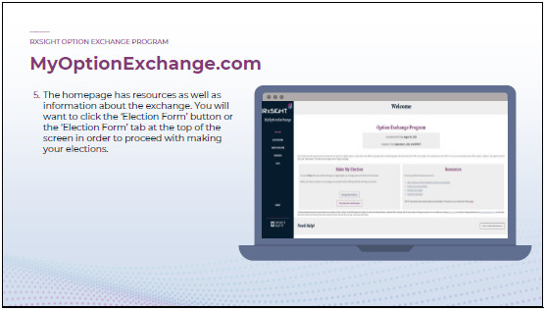
Speaker – IE Team

* | After logging in, you will be presented with this welcome screen.

* | This landing page is great because it contains all the resources you would be able to access, as well as links to any documents we have filed with the SEC.

* | This employee presentation will also be available on that site.

* | You can then proceed to the election form by clicking the blue button labeled “Election Form” when you are ready to proceed with your elections.

Slide 23

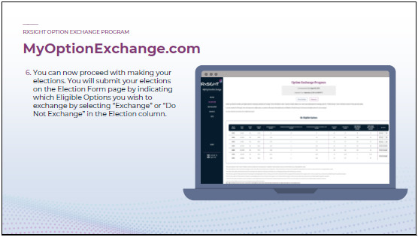
Speaker – IE Team

* | On this next page, in the chart, you will find a list of all the options that are eligible for exchange.

* | The dropdown menu on the table will allow you to select the grants for which you wish to make an election. In addition, you can see the number of Options you will receive in place of the eligible options if you elect to exchange that grant.

 | * | You have the option of exchanging or not exchanging.

 | * | It is important to remember that you can make different elections for different grants, but each grant is “all or nothing”.

 | * | You can either exchange all the options granted on a certain date, or you cannot exchange any of them.

* | Once you have made your selections, click “Next” to proceed to the next step.

Slide 24

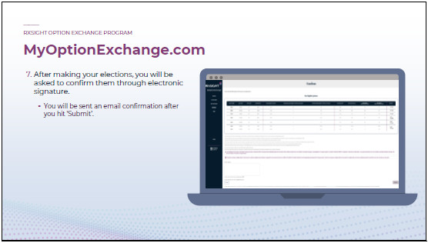
Speaker – IE Team

* | The following page will take you to the “Confirm Elections” screen.

* | The election choices you made will be displayed on this page.

* | In order to complete the process, you will need to check off two boxes acknowledging that you have read and understood the offering materials and that you have confirmed your selections.

* | After checking the boxes, you will be required to type or sign with an electronic signature, confirming that this is what you wish to exchange.

* | Once you have reviewed your election choices, click “Submit” to process your choices.

Slide 25

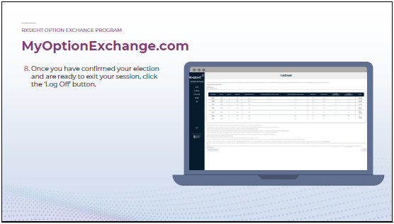
Speaker – IE Team

* | As soon as you submit your elections, you will be directed to a page that indicates that your elections were successfully submitted.

* | You will need to make sure that you reach the Elections Complete page in order to see a summary of what has been exchanged and what has not been exchanged.

* | It is imperative to note that if you do not see this screen, your elections have not been confirmed.

* | The same breakdown will also be emailed to you every time you make a change to your election once confirmed by Infinite Equity.

* | You may then log out of the platform.

Slide 26

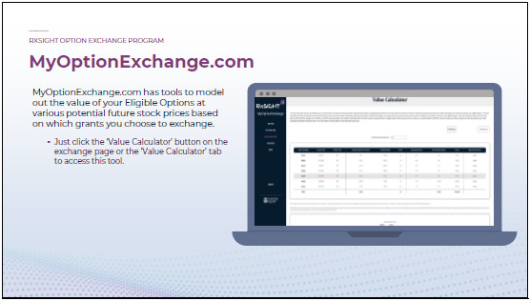
Speaker – IE Team

* | The website also has some valuable tools such as the Value Calculator tool where you can graph hypothetical scenarios to see what future values would look like.

* | The tool will show you more details about the value of your stock options, including:

 | * | The value of your eligible options at whatever price you input.

 | * | The value of your replacement options at whatever price you input.

Slide 27



Slide 28

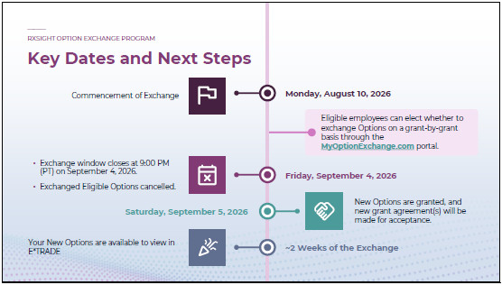
Speaker – IE Team

* | The commencement of the exchange begins Monday, August 10, 2026.

* | You will have until Friday, September 4, 2026, at 9pm (PT) to make your election choices or change them.

* | On September 4, 2026, your exchanged eligible options will be cancelled, and you will be granted New Options on Saturday, September 5, 2026.

Slide 29

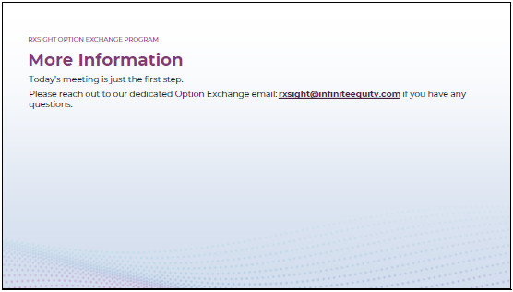
Speaker – IE Team

* | Today’s meeting is the first step in this process.

* | Please feel free to reach out to the email address included on this slide (rxsight@infiniteequity.com) if you have any questions.

Slide 30



Slide 31

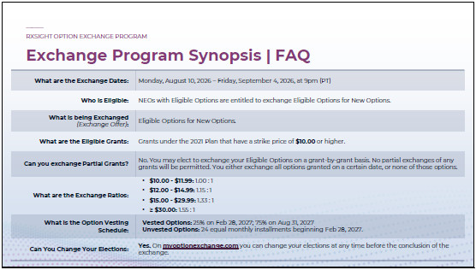
Take a moment to familiarize yourself with some of the commonly asked questions surrounding the exchange.

Slide 32

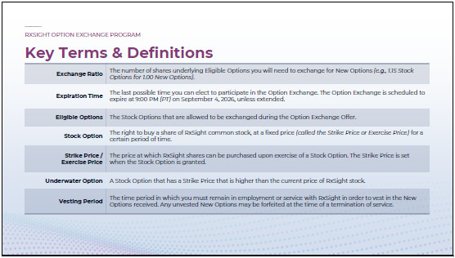
We’ve included a list of key terms and definitions to help clear up any confusion that you can reference.
Exhibit (a)(1)(I)
Team,
When I joined RxSight last month, I said that one of my first priorities would be to listen and learn, to understand what is working well, what should never change, where we can remove roadblocks, and where we need clearer focus as we look to ignite our next phase of growth. Today, I am pleased to share an important step in that direction. Our Board of Directors has approved a voluntary, one-time employee equity exchange program for eligible employees who hold substantially underwater stock options.
This is not routine. Programs like this are rare and represent a meaningful departure from typical equity compensation practices. We are taking this step because the Board and leadership team believe it is right for our employees and for RxSight’s long-term future.
RxSight’s success depends on our people. Our employees are critical to executing our strategy, supporting our customers, advancing our technology, and helping physicians improve patients’ lives. We want to ensure our compensation programs continue to support focus, retention, motivation, and long-term alignment.
Equity has always been an important component of our total compensation philosophy and how RxSight attracts, retains, and motivates talented people. Over the past couple of years, however, the decline in our stock price has left many employees holding substantially underwater options, meaning the exercise price is higher than the current market price of our common stock, severely limiting the effectiveness of these awards to motivate and retain some of our most critical team members.
The equity exchange program is designed to address that issue in a disciplined and thoughtful way. Eligible employees may voluntarily exchange certain eligible stock option grants for a specified number of restricted stock units, or, for named executive officers, options, with new vesting schedules. Participation is entirely optional. If you choose not to participate, or take no action, you will keep your existing options under their current terms.
This program does not change the fact that we must deliver on the opportunity ahead of us, and it does not guarantee any specific value. Value must still be earned through execution, performance, accountability, and results. But the program gives eligible employees a clearer and more meaningful opportunity to participate in the value we are working to build together, while reinforcing the expectation that we remain focused, accountable, and committed to delivering results.
In the coming days, employees who hold awards eligible for exchange will receive detailed materials explaining the program terms, including eligibility, exchangeable awards, exchange ratios, the vesting schedules, the election process, and the deadline. Eligibility and program terms will be described in the formal offer materials. Please read those materials carefully. They will include important information about the program’s benefits, risks, and conditions.
This equity exchange program reflects confidence in our people and our future. Let’s work together to build RxSight’s future.
Thank you for your continued commitment to RxSight, our customers, and the patients whose lives are improved by our work. I also want to thank the leadership team for advocating for this program and helping prepare it thoughtfully and responsibly. I am excited about what we can accomplish together.
Aziz

Important Legal Notice
The equity exchange program will be made only pursuant to the terms and conditions set forth in the Tender Offer Statement on Schedule TO, including the Offer to Exchange and related materials that RxSight will file with the Securities and Exchange Commission and make available to eligible employees. Eligible employees should read those materials carefully when available because they will contain important information about the program. This communication is for informational purposes only and does not constitute an offer to buy or sell securities or a recommendation as to whether any eligible employee should participate in the program.

Calculation of Filing Fee Tables
Table 1: Transaction Valuation
 |  | Transaction Valuation | Fee Rate | Amount of Filing Fee
Fees to be Paid | 1 | $ 17,192,347.53 | 0.0001381 | $ 2,374.26
Fees Previously Paid
 | Total Transaction Valuation: | $ 17,192,347.53
 | Total Fees Due for Filing: |  |  | $ 2,374.26
 | Total Fees Previously Paid: |  |  | $ 0.00
 | Total Fee Offsets: |  |  | $ 0.00
 | Net Fee Due: |  |  | $ 2,374.26
Offering Note
1 | (1) Estimated solely for purposes of calculating the amount of the filing fee. The calculation of the Transaction Valuation assumes that all stock options to purchase shares of the issuer's common stock that may be eligible for exchange in the offer will be exchanged pursuant to this offer. This calculation assumes stock options to purchase an aggregate of 4,083,693 shares of the issuer's common stock, having an aggregate value of $17,192,347.53 as of August 4, 2026, calculated based on a Black-Scholes model, will be exchanged or cancelled pursuant to this offer. (2) The amount of the filing fee, calculated in accordance with Rule 0-11(b) of the Securities Exchange Act of 1934, as amended, equals $138.10 per $1,000,000 of the aggregate amount of the Transaction Valuation (or 0.01381% of the aggregate Transaction Valuation). The Transaction Valuation set forth above was calculated for the sole purpose of determining the filing fee and should not be used for any other purpose.
Table 2: Fee Offset Claims and Sources | ☑Not Applicable
 |  | Registrant or Filer Name | Form or Filing Type | File Number | Initial Filing Date | Filing Date | Fee Offset Claimed | Fee Paid with Fee Offset Source
Fee Offset Claims
Fee Offset Sources

